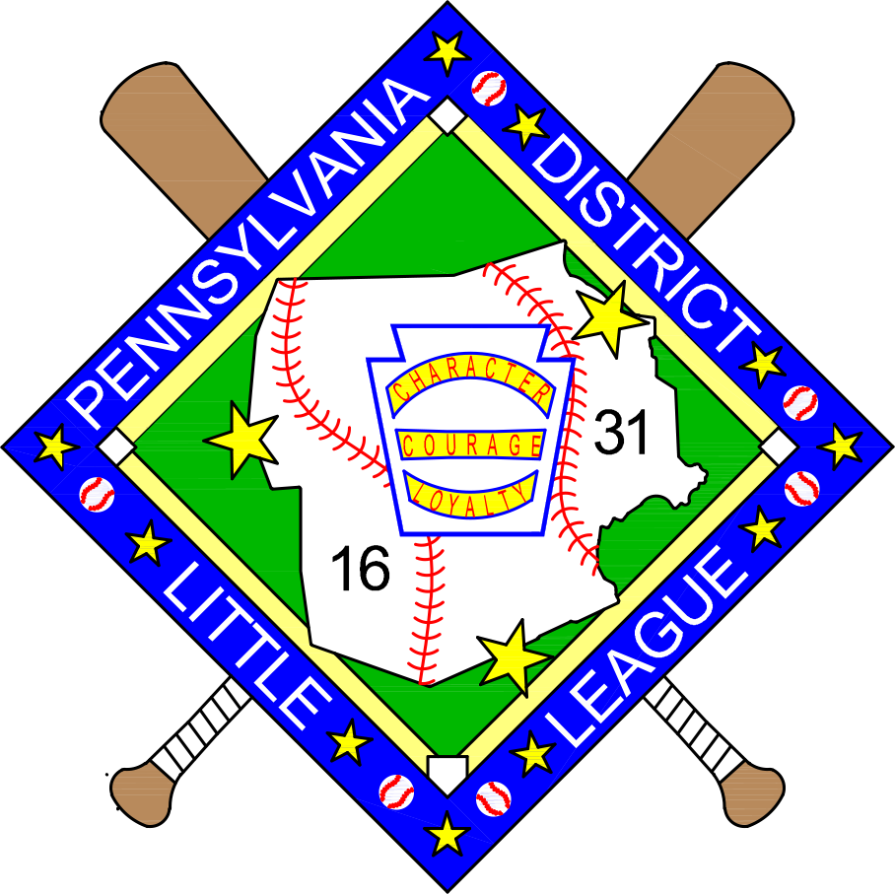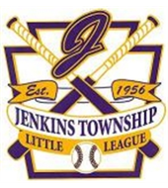

9 & 10 Year Old Softball
2017 East Region Invitational Tournament
July 29th-August 5th

Hosted by Pennsylvania District 16/31 Little League
Jenkins Township Little League
Jenkins Township, Pennsylvania

District 16/31 Administrator & Tournament Director
Robert Bertoni

Jenkins Twp. Little League President
Paul McGarry

Assistant Tournament Directors District 16/31 Umpire-In-Chief
Phil Schoener Dave Katyl
Greg Kohli

District & Tournament Web Site
www.padistrict16-31.com

Dear Manager,

Congratulations to you, your players and coaches on winning your State, Section and District Championships. Pennsylvania District 16/31 and Jenkins Twp. Little League look forward to hosting your in the East Region 9 & 10 Softball Championship tournament.

You will find everything you need on our District website www.padistrict16-31.com

- Information Packet
- Team Registration/Coaches Meeting Information
- How to download the Tournament APP
- Directions from the Woodlands Resort to the Jenkins Twp Little League Field
- Special Events Schedule
**We will be adding more information about the tournament each day so please check it a few times every day.
If you have any questions concerning the packet of information or how to the tournament will be conducted, please do not hesitate to contact the Tournament Director, Assistant Tournament Directors or the President of the Jenkins Twp Little League. (Contact information in the Information Packet)

No team will be permitted to compete without first submitting all documentation (properly completed affidavit, boundary map, residency documentation, and any necessary waivers) for review and approval by the Tournament Director. Please see your District Administrator immediately if you are unclear on any matters relating to the required documentation.

Pennsylvania District 16/31 and Jenkins Twp. Little League believe strongly that all games are to be decided on the field by the players’ according to the Little League Official Regulations and Playing Rules. In particular; rule XIV (a)- Field Decorum will be strictly enforced:
- The actions of players, managers, coaches, umpires, and league officials must be above reproach. Any player, manager, coach, umpire or league official who is involved in a verbal or physical altercation, or an incident of unsportsmanlike conduct at the game site or any other Little League activity is subject to disciplinary actions by the local league board or directors.

Any unsportsmanlike actions by players, manager, coaches, or fans from the opposing team to disrupt the play of any player, especially the pitcher, will be dealt with immediately. PA District 16/31 and Jenkins Twp Little League expect the manager and coaches to control their fans.

Thank You- Have Fun, Play Hard----------District 16/31

Contacts

District 16-31 DA & Tournament Director
Robert Bertoni
Rab4um@aol.com
Phone- 570-574-5075

Assistant Tournament Director
Phil Schoener
pschoener@hotmail.com
Phone- 570-905-6902

Greg Kohli
Hall4pete@comcast.net
Phone- 570-574-1504

Umpire-In-Chief
Dave Katyl
Davekatyl@msn.com
Phome- 570-709-4422

Jenkins Twp. Little League President
Paul McGarry
Pmcg723@gmail.com
Phone- 570-430-9387

Tournament Rules and Procedure Highlight
- The East Regional will be a pool play tournament.
- Playing rules will be per Little League Minor Softball Tournament Rules. All rules will be strictly enforced by the Tournament Staff and Umpires.
- All teams will submit their eligibility affidavits to the Tournament Director prior to the stat of the tournament. These affidavits must be verified (and signed) immediately following each game and will be returned to each team at the end of the tournament.
- The tournament director and staff reserve the right to change game dates and starting times due to inclement weather.
- The home team for each game will be determined by the toss of a coin at the Coaches Meeting at the start of the tournament.
- The home team for each game will have 15 minutes of fielding practice 60 minutes prior to the start time of the game. The visiting team for each game will have 15 minutes of fielding 45 minutes prior to the start time of the games. These times may be shortened in order to stay with the scheduled game times.
- The team manager is responsible for uniforms and equipment and all players must be in uniform with the Little League approved patch.
- Players, managers, and coaches that become involved in any misconduct, on or off the field, or at their lodging, may be dismissed from the tournament. The activity and person will be reported to Little League Headquarters Tournament committee, the parent league DA and the League President.
- Only Managers, Coaches and Players listed on the official tournament eligibility affidavit are permitted in the dugout or playing field. Under no circumstances will coaching (or assistance to coaches) be permitted from anyone outside of the dugout area during games.
- Game balls will be supplied by the Host District.
- Both team will line up as directed by the tournament director when introduced and remain there for the National Anthem and Little League Pledge.
- Both teams will meet at the home plate area immediately at the conclusion of the game and shake hands.
- At the conclusion of the tournament, the East Region Champ will be awarded the East Regional Tournament Championship Flag.
Immediately Following the State Tournament Win

Once your team has won the State Tournament, please contact Robert Bertoni (rab4um@aol.com) (Phone- 570-574-5075 with the following information:
- Team Phone with your state Championship Banner
- Complete Team Registration Form
- Completed Background Checks for Manager and Coaches
- Team Roster with Names and Jersey Numbers
Please complete the following forms and submit to Robert Bertoni as soon as possible:
- Banquet Registration Form
- SWB RailRiders Game Form

Team Arrivals
*Teams arrive at hotel on FridayJuly 28th
*Managers and coaches meeting at field 9:00am Return Banquet and RailRiders Forms with check if not emailed prior.
*Each team will be assigned a host for the tournament to answer any logistical questions you may have during your stay.

TOURNAMENT HOST HOTEL

The Woodlands Inn and Resort
1073 HWY 315
Wilkes-Barre, PA 18702
Phone- 1-800-762-2222
www.thewoodlandresort.com

The Woodland will be offering discounted pricing to all Little League teams and families (avg. rate $139). Just mention what state you are with. They will be hosting events for teams and their families all week long. They have a number of on site restaurants and within 1 mile from malls and eating! The resort is located only 7.1 miles from the field. All activities fro the players will be held at the Woodland Inn. All officers and staff from the district will be on site 24 hours a day.

All reservations will be made through the Woodlands Inn. Once they are filled they will place in one of the other high quality hotels.

TEAM REGISTRATION FORM

STATE- _____________________ SECTION- ________ DISTRICT-___________
LEAGUE NAME-_________________________________________________________
(PLEASE TYPE OR PRINT)

PLAYER’S NAME PLAYER’S #
1.

2.

3.

4.

5.

6.

7.

8.

9.

10.

11.

12.

13.

14.

15.

MANGER- ______________________________________________ CELL PHONE- _______________
COACH- _______________________________________________ CELL PHONE- _______________
COACH- ______________________________________________ CELL PHONE- _______________
LEAGUE PRESIDENT- _____________________________________ CELL PHONE- ______________
DISTRICT ADMINSTRATOR- _______________________________ CELL PHONE- ______________

CHAMPIONSHIP BANQUET REGISTRATION FORM

PA DISTRICT 16-31 LITTLE LEAGUE WILL BE HOSTING A CHAMPIONSHIP BANQUET ON SUNDAY JULY 30th 7PM AT THE WOODLANDS INN AND RESPORT. THIS IS MANDATORY FOR ALL PLAYERS, MANAGERS, AND COACHES.

PLAYERS AND MANAGER, PLUS 2 COACHES ARE FREE. FAMILY MEMBERS WISHING TO ATTEND ARE $25.00.

CHAMPIONSHIP BANQUET:
TEAM NAME: ________________________________
ATTENDESS ADMITTED FREE OF CHARGE:
NUMBER OF PLAYERS: _______
MANAGER/2 COACHES: _______
TOTAL: _______
ADDITIONAL ATTENDEES:
TOTAL NUMER OF ADDITIONAL TICKETS = ________
@25.OO PER TICKET
TOTAL AMOUNT DUE FOR BANQUET = ________

MAKE CHECKS OUT TO PA DISTRICT 16-31 LITTLE LEAGUE
**EMAIL FORM TO ROBERT BERTONI Rab4um@aol.com
**Bring form and check to Team Check_in at the field on Saturday July 29th 9am

TUESDAY AUGUST 1st SWB RAILRIDERS VS BUFFALO BISONS

PARADE OF CHAMPIONS
RAILRIDERS GAME TICKET
ORDER FORM

*This is to help defray the cost of the tournament and 100% participation is requested. Coast of the ticket is $10.00 per player and family.

*Players will be brought down to the field, parade before the game and introduction of the teams in the new Triple A NY Yankees farm team stadium.

*Please email total number of tickets to rab4@aol.com and present the check at team sign in at the field on Saturday July 29th 9am

Total number of Tickets
@ $10.00 per ticket = ____________

Total Due =$ ___________

HOST SITE: JENKINS TWP LITTLE LEAGUE
Established in 1956, Jenkins Township Little League Baseball and Softball strives to teach our youth the principles of good sportsmanship, instill self-esteem while teaching the fundamentals of the game of baseball and softball.

Our mailing address is: 2 May Street Jenkins Township, Pennsylvania 18640
GPS address is: 2 May Street Jenkins Township, Pennsylvania 18640
Website: http://www.jenkinstwplittleleague.com
Email Us: info@jenkinstwplittleleague.com
Jenkins Twp. Little League President
Paul McGarry
Pmcg723@gmail.com
Phone- 570-430-9387

AREA ATTRACTIONS AND RESTAURANTS
  - Wyoming Valley Mall
  - Mohegan Sun Casino and Racetrack
  - SWB RailRiders Baseball Team
  - Buffalo Wild Wings
  - Longhorns
  - Outback
  - Olive Garden
  - Five Guys
  - Dairy Queen
  - TGIF
  - Chuckie Cheese
  - Red Robin
  - Logans

Please Check Out: www.tournepa.com for more Info on NEPA

Things to See and Do in Northeastern Pennsylvania

Plan to visit Luzerne County in scenic Northeast Pennsylvania when looking to take a short getaway or just get out and do something. Whether you plan to visit Wilkes-Barre, Hazleton or points- in-between there is always something going on. Outdoor recreation is bountiful and offers various scenery and activities for different skill levels. History is all around Luzerne County from the various monuments to the many living reenactments. Area hotels offer various packages when you want to visit and stay overnight in Luzerne County. Packages typically include overnight accommodations, attractions, activities or events while visiting Wilkes-Barre, Hazleton and various smaller communities. Festivals around the region are occurring year round with an emphasis from spring to fall.
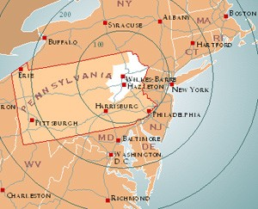
Visit Wilkes-Barre, PA, Luzerne’s county seat, continues to revitalize the downtown with restaurants, pubs and a new urban park. The River Common offers 12 miles of trails for bikers, joggers, walkers, and roller bladers along the Susquehanna River. It is not uncommon to see kayakers paddling by the city. The River Common is host to many local events including Riverfest in June when 100’s of kayakers adorn the banks of Nesbitt Park.

Visiting Wilkes-Barre and Hazleton in Luzerne County is easy; conveniently located within easy driving distance to many cities in the Northeast and Mid-Atlantic. Reach Luzerne County via Interstates 81, 80, 84, 476 (Pennsylvania Turnpike) and Routes 309 and 115.

Medical Facilities

Geisinger Wyoming Valley Medical Center

1000 E. Mountain Blvd Wilkes-Barre, PA

570.808.7300

Wilkes-Barre General Hospital
575 North River Street
Wilkes-Barre, PA 18764
Phone: (570) 829-8111

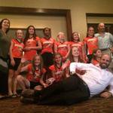
Special Events
Sunday July 30th
7:00pm-to-9:00pm
Championship Banquet at Woodlands Inn and Resort Ballroom
*East Region Pins handed out to players
*Family Style Meal
*Causal Dress- Dress Shorts OK, No Jeans Please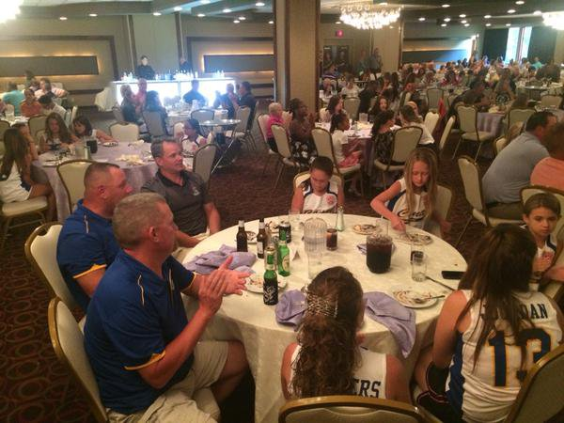

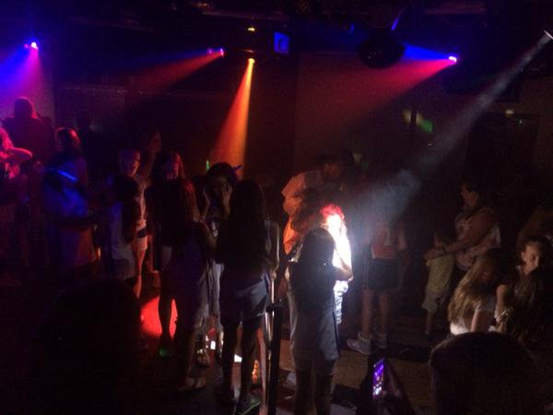

Sunday July 30th 9:00-to-10:30pm
Players Dance at Evolution Night Club Inside the Woodland Inn and Resort

*The East Region Tournament Teams will take over the Evolution Night Club for a dance party just for them
*The best music and light show 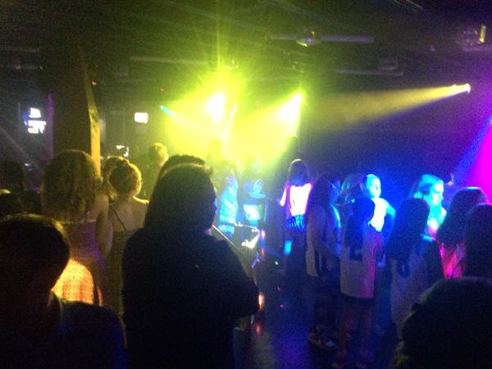

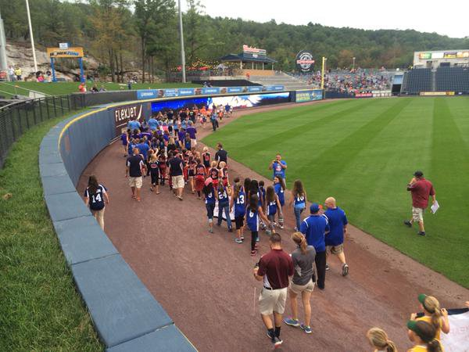
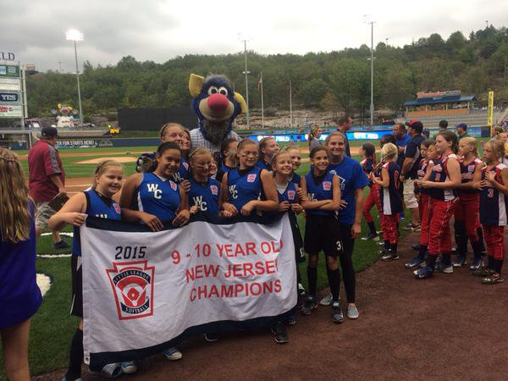
Tuesday August 1st
5:45 to 10:00 RailRiders Baseball Game
*Players wear your Jersey and bring your State Championship Banners, you will be part of a Parade of Champions on the field before the game
*You will be on the field and line-up for pre-game with the RailRiders and Iron Pigs Players
*Managers of each team will throw out the first pitch (so have your arm ready!!)
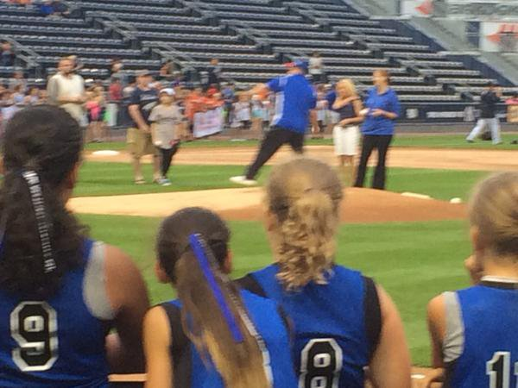
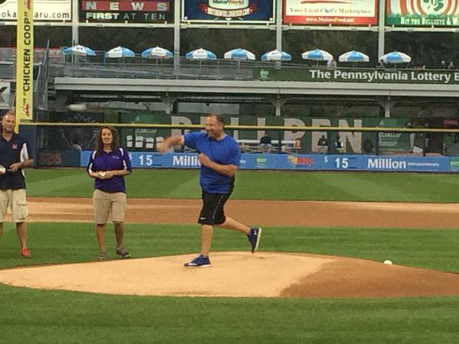 $2 Taco’s and $2 Tall Boy Beer

Wednesday August 2nd
8:00-to-10:00pm
ICE CREAM SOCIAL AT WOODLANDS INN AND RESORT

Ice Cream with Toppings Bar
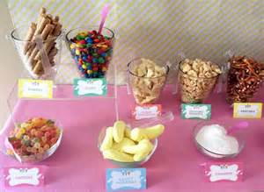

REGISTRATION/COACHES MEETING/OPENING CEREMONY
Registration for the East Regional Tournament will be held on Saturday July 29th, 2017 at 9am at the Jenkins Twp. Little League Complex.

The following will be part of the registration/meeting process:

9AM- Registration (At Jenkins Twp Little League Complex)
- Each team will be required to present their official tournament affidavit, complete residency verifications, boundary map, copies of birth certificates, medical release forms and required waivers. (You will leave your book to be reviewed by the District 16/31 Staff)
- Return Championship Banquet Orders and RailRiders Ticket Orders with checks made out to PA District 16/31 Little League
- You will be assigned a host for the tournament to answer any logistical questions you may have during your stay.
9:30AM- Managers/Coaches Meeting (At Jenkins Twp Little League Complex)
- Each team will be provided with additional information regarding the tournament logistics, rules, etc.
- Each team will have equipment checked before each game! (Equipment will NOT be checked at this meeting)
- You will sign up for Practice times and fields for the week.
11:00AM- Opening Ceremony (At Jenkins Twp Little League Field)
All teams will participate in the tournament opening ceremony to take place at the Jenkins Twp Little League Field. During the opening ceremony, each team will be introduced and other important announcements will be made. The Opening Ceremony will last about a half-hour. PLEASE BRING YOUR STATE BANNER TO TAKE OUT ON THE FIELD WITH YOUR TEAM FOR A TEAM PICTURE.
12:30PM- The Games Start- 4 Games 12:30/3:00/5:30/7:00

Frequently Asked Questions and Answers

- Do we bring equipment to the Coaches meeting Saturday Morning?
  - No, Each team will have equipment checked before each game.
- When can my team sign up for Practice time on the field? You will sign up for practice times and fields for the week at the coaches meeting Saturday morning at 9:30am
- What’s going on with Opening Ceremony? All teams will participate each team will be introduced and other important announcements will be made. The Opening Ceremony will last about a half-hour. Bring your state banner and be in uniform.
- What is the dress for the Championship Banquet? Causal Dress- Dress Shorts OK, No jeans please
- What’s going on with the RailRiders Baseball Game? Players wear your jersey and bring your State Championship banner. You will be part of a Parade of Champions before the game on the field. You will be on the field and line-up for pre-game with the RailRiders . Managers of each team will throw out the first pitch. It’s Two Dollar Taco Night
- Some of my family can’t make the trip how can they follow the tournament? Each game of the East Region Championship Tournament will have live scoring. Go to the District 16/31 website www.padistrict16-31.com and click on the LIVE SCORING tab. Also get the District 16/31 APP
- How far is the hotel to the field? 7.1 Miles, 15 Minutes

8)What do I need for registration on Saturday Morning? Each team will be required to present their official tournament affidavit, complete residency verifications, boundary map, copies of birth certificates, medical release forms and required waivers. (You will leave your book to be reviewed by the District 16/31 Staff) Return Championship Banquet Orders and RailRiders Ticket Orders with checks made out to PA District 16/31 Little League
You will be assigned a host for the tournament to answer any logistical questions you may have during your stay.

9I have questions about the rules of the tournament when can I get them answered? Coaches Meeting Saturday Morning 9:30, that’s the time too ask questions about the games, fields etc.

10)Looking for more things to see and do in Northeastern PA? Go to www.tournepa.com

- Will a Championship T-Shirt be sold? Yes, Jenkins Twp Little League will have official tournament T-shirts for sale at the field.

- Will my team have a host? Yes, each team will have a host from the Jenkins Twp. Little League or District 16/31 staff to answer any logistical questions you may have during your stay. Each team will be assigned a host at Registration Saturday Morning.

DOWNLOAD OUR AWESOME NEW APP NOW AND STAY UP TO DATE WITH ALL THE LATEST INFORMATION!

INSTALL THE PA DISTRICT 16-31 APP ON YOUR SMARTPHONE OR TABLET NOW!

FOLLOW THESE STEPS:

1. DOWNLOAD TEAM APP FROM THE APPLE OR GOOGLE PLAY APP STORE

2. SIGN UP TO TEAM APP. YOU WILL BE SENT AN EMAIL TO CONFIRM YOUR REGISTRATION

3. LOG INTO APP AND SEARCH FOR "PA District 16-31"

4. CHOOSE YOUR APPLICABLE ACCESS GROUP (S).

5. IF YOU DON'T HAVE A SMARTPHONE GO TO padistrict1631.teamapp.com TO SIGN UP AND VIEW THIS APP ONLINE

HOTEL TO FIELD DIRECTIONS

15 MIN
7.1 MILES
GPS Address- 2 May Street Jenkins Township, PA 18640
-------------------------------------

1073 PA-315, Wilkes-Barre, PA 18702

Take PA-315 to Thompson St in Jenkins Township
10 min (5.5 mi)

Head northeast on PA-315 toward Laird St

3.7 mi
Slight left onto Pittston Ave

0.8 mi

Slight left onto Stout St

0.4 mi

Continue onto Yatesville Rd

0.4 mi

