Player/Parent Informational Packet
2014 Season

Directors and Staff
Ernie Colombe- 18u Head Coach/Director of Baseball Operations
E.COLOMBE@MCHSI.COM
630-664-2223
Steve Colombe- 18u Assistant Coach/Assistant Director of Baseball Operations
scolombe22@yahoo.com
630-664-2058
Mike McGreevy- 18u Assistant Coach
mrmcgre@ilstu.edu
815-592-1875
Brian Kubilius- 18u Assistant Coach
kubiliusb@dupage.edu
630-319-1342
Oney Guillen- 17u Head Coach
oney@triplecrownagency.com
561-289-3659
Ozzie Guillen Jr- 17u Assistant Coach
Jon Basinski- 17u Assistant Coach
basijona@my.dom.edu
Randy Jones- 16u Head Coach
rsjnjones@att.net
630-991-3744
Kevin Turner- 16u Assistant Coach
hrdwre1@aol.com
630-392-1764
15U Staff TBD

Program Overview
The goal of the Kane County Phantoms baseball program is to develop and prepare players for college baseball. Our strength lies in our player’s desires to play at the next level. We design our program to have the demands similar to that of a college program. As a team, we try to make one another better on and off the field. With this formula we succeed in winning games and tournaments while getting our players prepared as they move on to the next level.
The Phantoms seek out serious baseball players who have the desire to play at the college level. Over the past 4 years, all of our graduating Seniors have moved on to play at the college level. Also, our program has included 63 All Area/All Conference players. Our player’s awards and commitment list can be found at: www.kanecountyphantoms.com.
The program will include four teams (15u, 16u, 17u, 18u). Each team will participate in 7 weekend tournaments. These tournaments usually run Thursday-Sunday and take place at local colleges and high schools. Each team will participate in 1 out of state/out of town tournament.
More information regarding rosters, fees, schedules, and practices can be found throughout this packet. Please feel free to contact us with any other questions.

Roster Format
Ideal Roster
- 14 position players
- Additional Pitchers added as a Pitcher Only (POs)
What is a Pitcher Only?
- Pitcher only will not play a position in the field
- Pitcher only will not be guaranteed at bats
- At bats may be given in certain circumstances (injury, players missing)
What is a Position Player?
- Position players will play a position in the field
- Position players can also Pitch

Fees
Season Fee
- Position Players- $550
- Pitcher Only- $325
- Season fee covers tournaments, insurance, and equipment
Uniforms
- Each player should budget around $85 for uniforms
- Each player will be required to order 2 jerseys and 1 hat
- Additional items such as cage jackets and additional hats can be ordered, but are not required

Letter of Acceptance
If a player accepts his spot on a Phantoms team he will be sent a Letter of Acceptance and a Payment Contract. The Letter of Acceptance simply states that the player is committed to playing for the Phantoms and accepts his role on the team.
The Payment Contract offers 3-4 different payment plans that families can choose from. These payment plans break the season fee into 2-4 deposits. If a deposit is not sent to the Phantoms on time without notice the player can lose their roster spot. As long as the player turns in the Letter of Acceptance and follows the chosen payment plan their roster spot will be held. Deposits are non-refundable.
The Letter of Acceptance and Payment Contract allows the players to commit to our team and allows our team to commit to the player. For example, we add a player to the team as a Catcher. When he turns in his Letter of Acceptance and payments on time he is proving to us that he is committed to playing for our team. In turn, we commit to him by not adding several other players that play the same position as him.
It is important for each player to follow the Payment Contract they have chosen. Each team will be paying for tournaments, insurance, and equipment. It is important that we can pay for these expenses on time. Reminders will be sent 7-10 days prior to a player’s next payment due date. If a player cannot make a payment on time he must let us know before the payment is due. We can hold his roster spot if he notifies us of a late payment.
On the next two pages you can find an example Letter of Acceptance and Payment Contract.

Letter of Acceptance Form-Example

I, ___________________________have chosen to have my son, _______________________ become a member of the Kane County Phantoms. The cost for the 2014 summer season will be $550 for a position player. ($325 for a Pitcher Only)
I understand that if the player has to leave the team for any reason, or at any time, all of the money that has been collected is the property of the Kane County Phantoms and is non-refundable.
Food, lodging, transportation costs throughout the entire year are the responsibility of the player.
A hat and jersey will be purchased at a later timer and will not be a part of the original fee. You may order as many of those items as you want, but all will be required. There will also be helmets and pullovers available to order, but those are not required.
I, the parent or guardian of the above named baseball player give my permission for emergency medical treatment in the event that I cannot be reached and hereby waive, release, absolve, indemnify, and agree to hold harmless the Kane County Phantoms, Ernie Colombe, and the coaching staff for any claim arising out of any injury to the above named player.

PLAYER SIGNATURE AND DATE:
______________________________________________________________________________
PARENT SIGNATURE AND DATE:
______________________________________________________________________________
COACH’S SIGNATURE AND DATE:
______________________________________________________________________________

Payment Contract-Example
The season fee for the 2014 Phantoms will be $550 for Position Players. In order to secure a spot you will have to choose a payment option and make a payment by August 17, 2013.
--Please circle the payment plan that best fits for you and follow the due dates
Option 1
First Payment of $125 due by 8/17/13
Second Payment of $200 due by 10/31/13
Third Payment of $200 due by 1/15/14
Option 2
First Payment of $275 due by 8/17/13
Second Payment of $275 due by 12/1/13
Option 3
First payment is the full $550 due by 8/17/13

PLEASE SIGN THIS FORM AND RETURN WITH PAYMENT AND SIGNED LETTER OF ACCEPTANCE

CHECKS PAYABLE TO: KANE COUNTY PHANTOMS

MAIL TO: ERNIE COLOMBE
C/O KANE COUNTY PHANTOMS
1345 SLATER ST.
SUGAR GROVE, IL 60554

PARENT SIGNATURE AND DATE:
______________________________________________________________________________
Schedules
Each team will participate in 7 tournaments on weekends. Each team will participate in at least 1 out of state tournament. Most tournaments run Thursday-Sunday. We select our tournament schedule in February/March. Most tournaments are hosted by colleges and High Schools. It is an easy way for college coaches to see talented High School players showcase their skills.
Over the past few years we have played at the following colleges:
North Central College Judson University Waubonsee Community College
South Suburban College Northern Illinois University University of Iowa
Lewis University Valparaiso University Carthage College
Concordia University- Chicago Western Michigan University
Kankakee Community College Western and Eastern Kentucky University
Kishwaukee Community College Elgin Community College
Rock Valley College
The next page gives an example of what a summer tournament schedule looks like. We expect to set a similar tournament schedule in 2014.
Schedule Information
Even though the Phantoms are a summer baseball team, we expect players to have regular attendance at games. Obviously, there will be circumstances in which players will have to miss a game or practice. However, players should not be missing for long periods of time. If you see yourself having multiple conflicts in the 2014 summer our program may not be the best fit for you. Coaches are allowed to reduce playing time for players who miss often.
Each team will have a few practices after the High School spring season and before our Summer Tournaments. High School players are not allowed to practice with travel teams during the IHSA Spring Baseball Season. Once tournament play begins teams will not practice during the week due to IHSA Summer Baseball.

Schedule Example-2013 Season
15/16u
May 31- June 2 Chicago Area Showcase @ North Central College, Judson University
June 6-9 NIU Midwest Madness
June 14-16 Kenosha Classic @ Carthage College
June 20-23 NIU Invite
July 4-7 Elite Baseball Valparaiso University
July 18-21 Western Kentucky University Invite
July 26-28 Road Ranger Stadium Tournament
17u
June 6-9 Chicago Invite @ North Central College, Judson University, South Sub College
June 20-23 NIU Invite
June 27-30 Force Elite Baseball Classic @ St. Charles North High School
July 4-7 Elite Baseball Valparaiso University
July 12-14 Lombard Wood Bat Tournament @ Montini High School
July 18-21 Chicago Invite @ North Central College, Judson University, South Sub College
July 26-28 Double Play Tournament NIU
18u
June 6-9 NIU Midwest Madness
June 13-16 Rockford Invite @ Rock Valley College
June 20-23 Chicago Invite @ North Central College, Judson University, Waubonsee CC
June 27-30 Chicago Invite @ Kankakee CC, Judson University, South Sub College
July 4-7 Elite Baseball Valparaiso University
July 12-14 Lombard Wood Bat Tournaments @ Montini High School
July 18-21 Chicago Invite @ North Central College, Judson University, Kankakee CC

Off-Season Practices
Each team will have Winter Practices at an indoor facility. These practices will allow players to fine tune their skills before the High School season. It will also allow for players and coaches to get acclimated to one another.
Winter training practices are optional as they will be an additional cost. We also understand that players participating in Winter Sports may not be able to make Winter Practices. Players are encouraged and recommended to participate if they can.
Individual practices/training can also be provided to players upon their request. At any time if a player needs to work on a certain skill he can meet with a coach to practice. Individual work would focus on specific skills such as Hitting, Pitching, Fielding, Throwing, or Catching. Upon the players request a Coach can meet with player at a field or facility to work with the player on their game. Individual training is also optional as it would be an additional cost. It is up to each player if they would want to schedule a session/lesson.
More information on off season winter training and individual training will be provided upon your addition to one of our rosters.

Results
These results are as of July 29, 2013:
Program Record Since 2010: 126-54
2013 Summer
18u Team- 25-8 Record
NIU Midwest Madness Champions
Chicago Invite Champions
Elite Baseball Valparaiso University Champions
2nd Place Lombard Wood Bat Summer Slam
17u Team- 26-6 Record
Force Elite Baseball Classic Champions
2nd Place Chicago Invite
2nd Place Elite Baseball Valparaiso Uiversity
3rd Place Chicago Invite
2012 Summer
18u Team- 26-5 Record
Chicago Invite Champions
Team Exposure Wood Bat Champions
2nd Place DeKalb Invite
2nd Place Chicago Invite
2011 Summer
18u Team- 21-6 Record
Valparaiso University Wood Bat Champions
Carthage College Kenosha Classic Champions
Legends of the Summer Champions
2010 Summer
18u Team- 21-10
2nd Place South Bend Irish Classic
2nd Place St. Louis Super Showcase
2nd Place DeKalb Invite

Phantoms Baseball
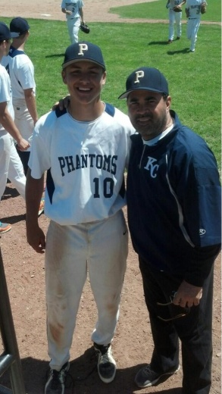
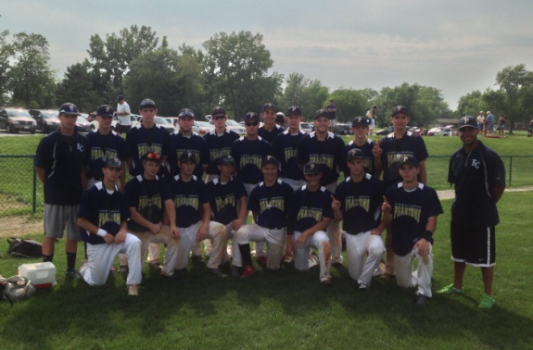
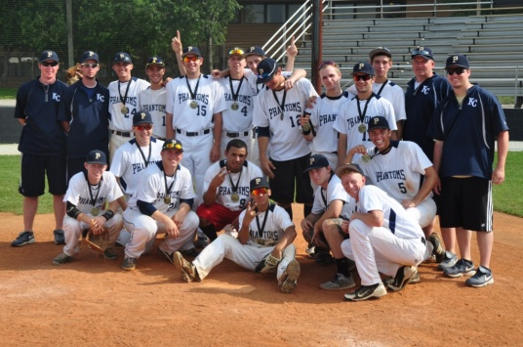
17u Phantoms 2nd Place Elite Baseball Valpo University
18u Phantoms Elite Baseball Valpo University Champs
17u Phantoms Force Elite Baseball Classic Champs

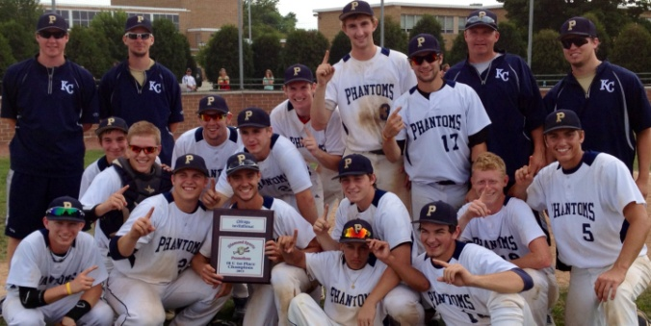
18u Phantoms Chicago Invite Champs

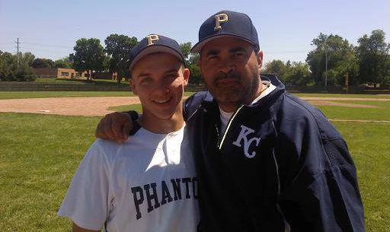

Former Sox Manager, Ozzie Guillen, with 17u Phantoms players. Oney, Ozzie’s Son, Manages the 17u Phantoms.

Kane County Phantoms Baseball
www.kanecountyphantoms.com
Follow on Twitter @KCPhantoms

