Order Form
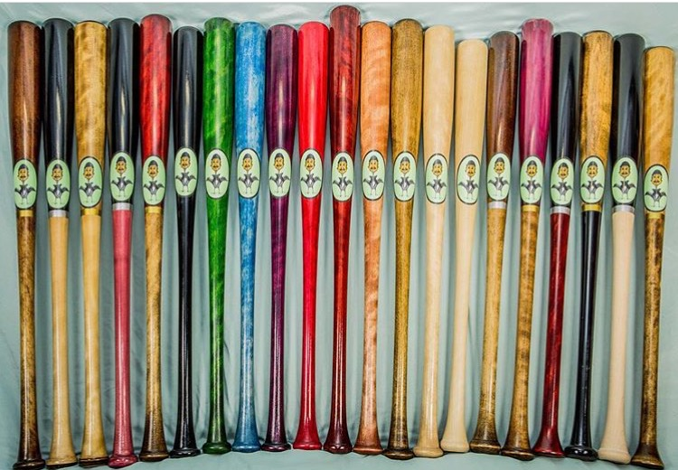
Pro Crafted Wood Bats
Prices:
Youth Bats (sizes 27-32) $95
Buy 2 Bats $85 per bat
Choose Handle Color: Black_____ Honey_____ Natural_____
Choose Barrel Color: Black_____ Honey_____ Natural_____
Pro Model#_____________

Personalize your custom wood bat
Additional Charges:
Personalized Color: _________________________________________ $10
Engraving, up to 25 Charaters :
(please print legiable)___________________________________________ $5
2nd Line:_____________________________________________________ $3
Name: _________________________________
Contact #: ______________________________
Bomb Knob $10
Total Due: $____________
Cash Check #____________
□ Credit/ Debit Card to run
Cardholder Name: __________________________
Card #: ___________________________________
( ) Visa ( ) MasterCard ( ) AMEX ( ) Discover
Exp #: ____________________________________
CSC, 3 Digit Code: _________________________
Billing Zip Code: ___________________________
Phone#: ___________________________________

_________________________________________________ _______________
Credit/ Debit Authorization and Parent Signature Date

