Sponsorship Form – 2014 Baseball Program
Carolina Vipers Baseball Academy, Inc
8001 Avanti Drive
Waxhaw, NC 28173
mpolito@tprsolutions.com
704-578-3468
www.goviperbaseball.com

January 1, 2014

Dear Sponsor:

The Carolina Vipers Baseball Academy, Inc. (d/b/a the “Union County Vipers”) is a non- profit 501 (c)(3) Travel baseball organization that is focused on Total Player Development. We strive to provide our players with superior training, knowledge and the highest level of competition possible. It is our goal to be a premier Travel baseball team and to be competitive with the strongest teams across the county.

Our goal is to create an environment that will allow our players to realize their capabilities as baseball players; to develop confidence, self esteem and poise as athletes; to understand that their achievements are a direct result of their efforts; to cultivate friendships among their teammates; and to understand that sportsmanship, not showmanship, is the major ingredient in playing with class and respecting the great game of baseball.

We are currently trying to raise funds to send our team to several national and regional baseball tournaments this spring.

The following are the various level of team sponsorship:

Titanium Sponsor - $1000

In return for your Titanium Sponsorship our team will provide the following:
- Website - Home Page Sponsor Banner
- Website - Rotating Sponsor Banner and Ad on Sponsors Page
- Logo / Name on our team banner which is displayed at all our tournaments and media photo opportunities. (9U-12U)
- Full banner advertisement at the Athletic Barn

Platinum Sponsor - $600

In return for your Platinum Sponsorship our team will provide the following:
- Website - Home Page Sponsor Banner
- Website - Rotating Sponsor Banner and Ad on Sponsors Page.
- Logo / Name on our team banner which is displayed at all our tournaments and media photo opportunities. (9U-12U)
- 1/2 banner advertisement at the Athletic Barn
Gold Sponsor - $450

In return for your Gold Sponsorship our team will provide the following:
- Website - Rotating Sponsor Banner and Ad on Sponsors Page
- Logo / Name on our team banner which is displayed at all our tournaments and media photo opportunities. (9U-12U)
- 1/4 banner advertisement at the Athletic Barn
Silver Sponsor - $300

In return for your Silver Sponsorship our team will provide the following:
- Website - Ad on Sponsors Page
- Logo / Name on our team banner which is displayed at all our tournaments and media photo opportunities. (9U-12U)
- 1/6 banner advertisement at the Athletic Barn
Bronze - $150

In return for your Bronze Sponsorship our team will provide the following:
- Website - Ad on Sponsors Page
- Logo / Name on our team banner which is displayed at all our tournaments and media photo opportunities. (9U-12U)
- 1/8 banner advertisement at the Athletic Barn

Your consideration to sponsor our boys is greatly appreciated. Please feel free to contact me via email at mikepolito@goviperbaseball.com if you should have any questions.

Sincerely,

Michael J Polito
President
Carolina Vipers Baseball Academy, Inc.
704-578-3468
www.goviperbaseball.com

Union County Vipers 2012 Sponsors
Please Support Our Sponsors
 | 
 | 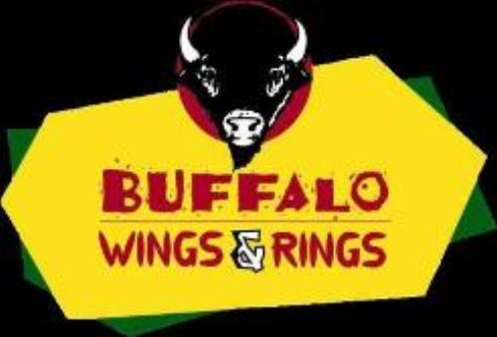
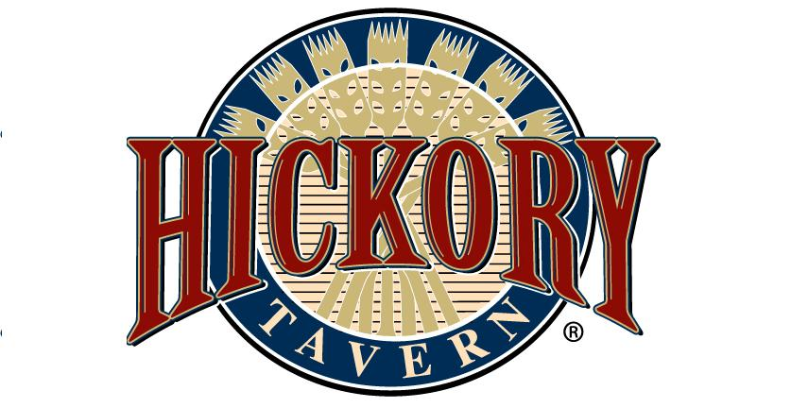 | 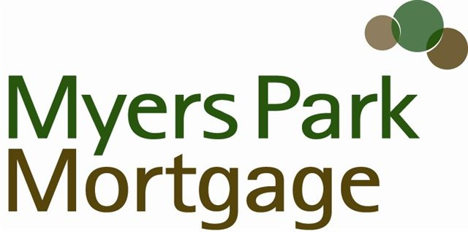
 | 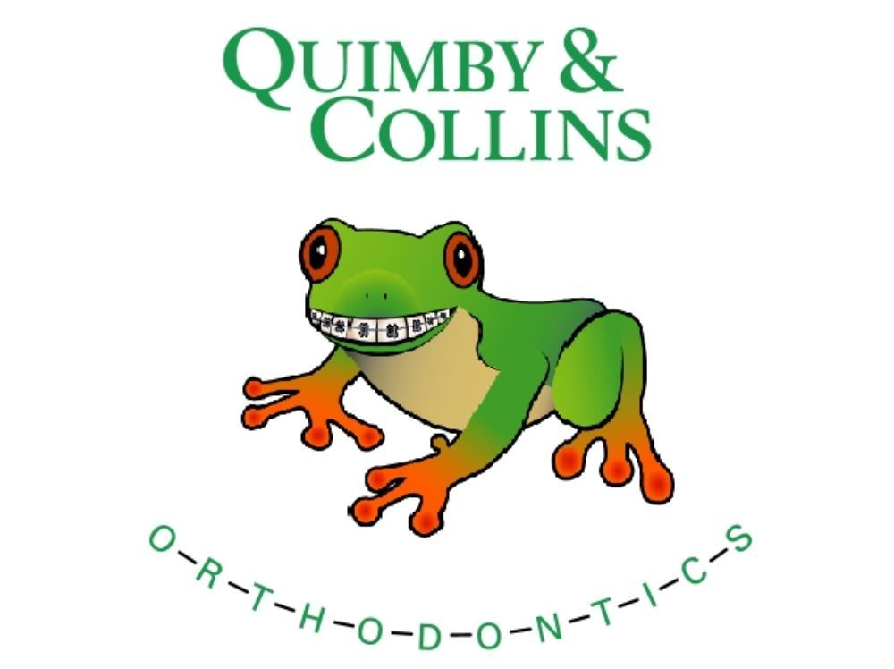
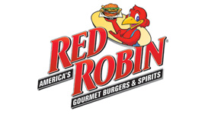 | 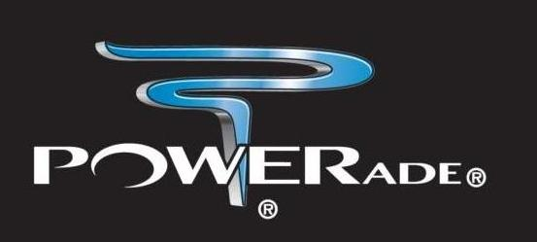
 | 
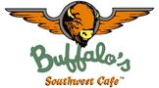 | 
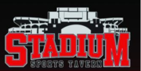 | 
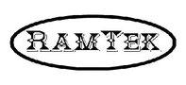 | 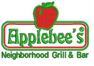
 | 

