|  |
| --- |
| **PENNSYLVANIA STATE UNIVERSITY** |
| **VISITING TEAM INFORMATION PACKET** |
| 2014 - 2015 |
| C:\Users\Eric Bress\Pictures\Penn State\IMG_0524.JPG |
|  |
|  |

**ICE HOCKEY**

**Arena & Game Information**

**Game Site:** Pegula Ice Arena

**Seating Capacity:** 6,014

**Parking:** (maps attached)

Team buses need to drop off team players and officials at Gate C Entrance. Check in with Pegula Ice Arena Management to park bus. Buses will be parked in loading docks and fire lanes. Any bus parked in fire lanes will need to have the driver stay with the bus. Need to have a list of schools bringing buses by 3pm Friday, March 20th.

Players coming in cars will need to be dropped off at Gate C but cars must park at Stadium West or the Bryce Jordan Center Lots (see map below).

Coaches, trainers traveling by car will be allowed to park in Pegula Yellow H (the lot south of the building) but only if they are on the parking list. Please submit all names to Chris Whittemore ([ciw2@psu.edu](mailto:ciw2@psu.edu)) by 3pm Friday, March 20th. Only 4 cars (coaches, trainers) per team will be allowed to park in the lot.

**Entrance**: Referees should enter at Gate C on the South side of the building, just off the circle. A Referee Liaison will meet you at the door and escort you to the locker rooms.

**Locker Rooms:** Enter through Gate C and go to the Guest Relations Desk. The locker room policy is attached. You will need collateral for the key to the locker room. Locker rooms will not be available until 90 minutes before the start of the game.

The Team Locker Rooms are as follows:

Bayer Rustin – Varsity Visiting Locker Room (VV) Mars – Locker Room 1

Downingtown East – Event Locker Room (EV) Erie Cathedral Prep – Locker Room 4

Holy Ghost Prep - Varsity Visiting Locker Room (VV) Canon McMillian – Locker Room 6

For any team wanting ice on Friday, please enter through Gate C and go to Guest Relations Desk for locker room assignment. Same policy applies. No team will be allowed to keep their equipment overnight.

**Tickets**: Tickets are $10.00 for an all day pass, Youth 10 and under are free and Penn State Students with ID are $5.00.

**Admission:** The Gate A Ticket Booth will be provide to take admissions. The East will supply at least two individuals to handle admissions. All parents and fans will enter through Gate A. Penn State will supply the ticket takers.

ADA entrance will be at Gate A. Please see parking map for places to park.

**Re-Entry Policy:** No re-entry policy is in effect. Anyone leaving the concourse or in Gate C Lobby will be considered out of the building.

**Limited Bag Policy:** Please note: We do have a Limited Bag Policy for our patrons. Please share this with your guests if you have anyone coming in for the game so that they are not inconvenienced at the door.

**Game Protocol:** Need Protocol Sheets by 3pm Friday, March 20th. Corrections can be made only through Ken Haas.

**Ice Time**: Your ice time is confirmed as follows:

* **Friday, March 20, 2015 = 5:15 p.m. – midnight ~ Varsity Rink**
* **Saturday, March 21, 2015 = 11:00am; 1:30pm; 4:00pm**

**Officials**: Officials for home games are assigned by the East.

**Rules**: US Hockey Rules apply

**Uniform**: Home team - East

**Press Box**: Will be available only to those credentialed. All media, video, and press approval must go through Steve Mescanti (skets@comcast.net).

**Medical:** EMT’s will be present. One crew will be for the teams and located between the benches and one crew for the patrons will be in the First Aid room on the concourse.

**Radio/Streaming:** All requests will go through Ken Haas. All media will be credentialed that is approved. Need approved list to Pegula Ice Arena Management by 3pm Friday, March 20th. We have two radio spots and one Video/Streaming spot in the Press Booth. Any special needs for video or radio must be made by 5pm, Thursday, March 19th.

**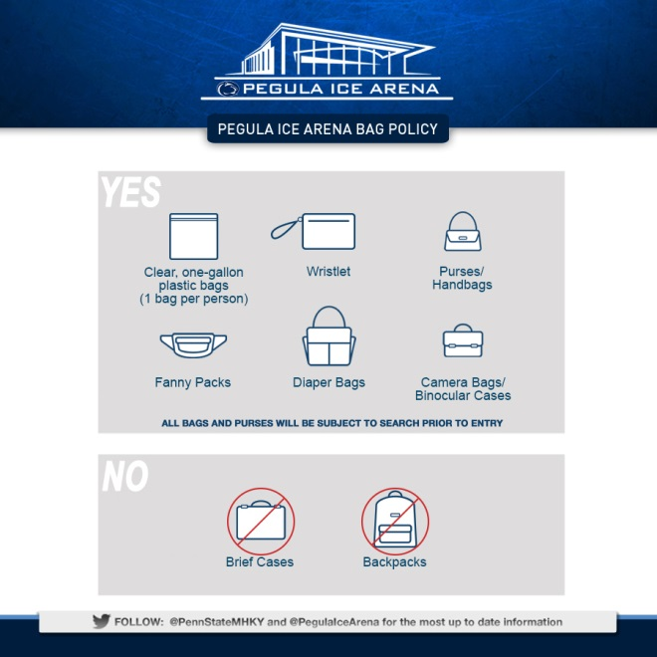**

**Contact Information**

**Jennifer James** Office: (814) 863-3471

Assistant Athletic Director/Event Manager for Ice Hockey Cell: (814) 777-3471

Email: [JQW7@](mailto:JQW7@)PSU.EDU

**Michelle Spaide** Cell: (570) 262-0413

Events Assistant/Event Manager for Ice Hockey Email: [MMS242@HOTMAIL.COM](mailto:MMS242@HOTMAIL.COM)

**Chris Whittemore** Office: (814) 865-4102

Pegula Ice Arena Operations Manager Cell: (814) 777-3580

Email: [CIW2@PSU.EDU](mailto:CIW2@PSU.EDU)

**Arena Information**

**Pegula Ice Arena**

University Drive

University Park, PA 16802

(At the corner of University Drive and Curtin Road)

**Map and Directions**

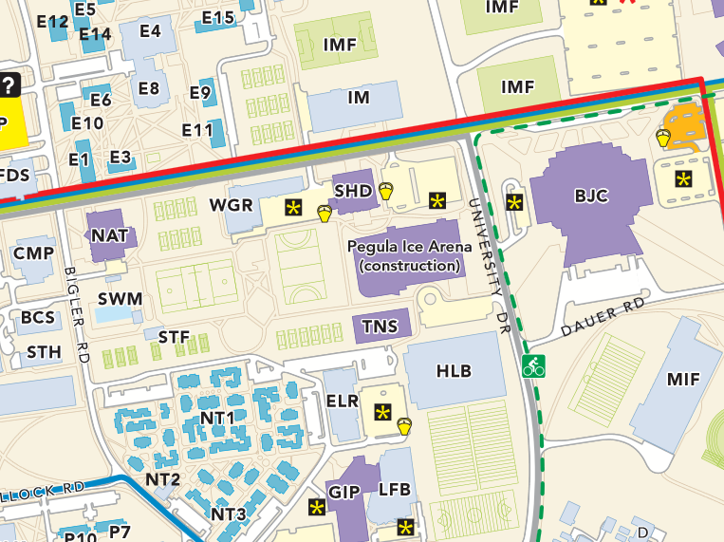

Enter at the Team Entrance on the South side

of the building

Parking will be in the Yellow-H South lot immediately South of Pegula and accessed off of University Drive

PEGULA ICE ARENA

**Directions**

**Directions from Dubois (Northwestern PA):**

* Take Interstate 80-East to Exit 123 at Woodland.
* Take Route 322-East to Phillipsburg/State College.
* Route 322 and Route 220 merge at Port Matilda, Continue on 322-220 to State College.
* Stay on Route-322 (Mt. Nittany Expressway) at 322-220 split.
* Take Penn State University Exit, Exit 73, and Turn Right onto Park Avenue.
* At the 4th stoplight, turn left onto University Drive.
* After first stoplight, Pegula Ice Arena will be on your right.

**Directions from Williamsport (Northeastern PA):**

* Take Interstate 80-West to Exit 161 at Bellefonte.
* Take Route 220-South to State College.
* Take Innovation Park/Penn State University Exit (Exit 74).
* After passing under expressway, proceed to 5th stoplight, and turn left onto University Drive.
* After first stoplight, Pegula Ice Arena will be on your right.

**Directions from Altoona (Southwestern PA):**

* Take Interstate 99-North (Route 220-North) towards Tyrone/State College.
* Route 220 and 322 merge at Port Matilda, Continue on 322-220 to State College.
* Stay on Route-322 (Mt. Nittany Expressway) at 322-220 split.
* Take Penn State University Exit, Exit 73, and Turn Right onto Park Avenue.
* At the 4th stoplight, turn left onto University Drive.
* After first stoplight, Pegula Ice Arena will be on your right.

**Directions from Harrisburg (Southeastern PA):**

* Take Route 22-322-West towards Lewistown/State College.
* Stay on Route-322 West after Lewistown, Continue on to State College.
* Take Route 322-West to Route 26-College Avenue Exit, Exit 73. Turn left onto College Avenue.
* Take Ramp towards University Drive. Turn right onto University Drive.
* After first light, Pegula Ice Arena will be on your left.

**Transportation**

***University Park, PA Car Rental Information at this Airport:***

|  |  |
| --- | --- |
| Alamo | (814) 237-1771 |
| Avis | (814) 237-9750 |
| Hertz | (814) 237-1728 |
| National Car Rental | (800) 227-7368 |

**University Park Airport**

2535 Fox Hill Road

State College, PA 16803

(814) 865-5511

www.UniversityParkAirport.com

***Pittsburgh, PA Car Rental Information at this Airport***

|  |  |
| --- | --- |
| Alamo | (800) 327-9633 |
| Avis | (412) 472-5200 |
| Budget | (800) 527-0700 |
| Dollar | (800) 800-4000 |
| Enterprise Rent-A-Car | (412) 472-3490 |
| Hertz | (800) 654-3131 |
| National Car Rental | (412) 472-5045 |
| Payless | (412) 472-3100 |
| Thrifty | (412) 472-5288 |

**Pittsburgh International Airport**

1000 Airport Blvd.

Pittsburgh, PA 15231

(412) 472-5500

www.flypittsburgh.com

(Approx. 3 hours from State College)

***Philadelphia, PA Rental Car Information***

|  |  |
| --- | --- |
| Alamo | (800) 327-9633 |
| Avis | (800) 331-1212 |
| Budget | (800) 527-0700 |
| Dollar | (800) 800-4000 |
| Enterprise Rent-A-Car | (800) 261-7331 |
| Hertz | (800) 654-3131 |
| National Car Rental | (800) 227-7368 |

**Philadelphia International Airport**

8800 Essington Avenue

Philadelphia, PA 19153

(215) 937-6937

www.phl.org

(Approx. 3 hrs. and 45 min from State College)

***Harrisburg, PA Rental Car Information***

|  |  |
| --- | --- |
| Alamo | (717) 948-0390 |
| Avis | (717) 948-3721 |
| Budget | (717) 944-4019 |
| Enterprise Rent-A-Car | (717) 948-0390 |
| Hertz | (717) 944-4081 |
| National Car Rental | (717) 948-0390 |

**Harrisburg International Airport**

1 Terminal Drive

Middletown, PA 17057

(888) 235-9442

www.flyhia.com

(Approx. 2 hrs. from State College)

**Lunch/Dinner**

***American Ale House***

821 Cricklewood Drive

State College, PA 16803

(814) 237-9701

***Applebee’s***

12 Colonnade Way

Off of N. Atherton St.

(814) 235-3890

***Chili’s***

139 South Allen St.

Downtown State College

(814) 234-5922

***Champs Sports Grill***

1611 North Atherton Street

State College, PA 16803

(814) 234-7700

***Damon’s Bar & Grill***

1101 East College Ave.

Half mile from Downtown

(814) 237-6300

***Gingerbread Man***

***(over 21 after 7pm)***

130 Heister St.

Downtown State College

(814) 237-0361

***Olive Garden***

1945 Waddle Rd.

Near Rt. 220 & N. Atherton

(814) 861-1620

***Rotelli (Italian)***

252A E. Calder Way

Downtown State College

(814) 238-8463

***The Corner Room***

100 West College Ave.

Downtown State College

(814) 237-3051

***The Deli Restaurant***

113 Heister Street

Downtown State College

(814) 237-5710

***T.G.I. Friday’s***

1215 N. Atherton St.

Downtown State College

(814) 861-5540

***Texas Roadhouse***

1885 Waddle Road

Off N. Atherton St.

(814) 238-5089

**The Tavern**

220 E. College Ave.

State College, PA 16801

(814) 238-6116

**Zola New World Bistro**

324 W. College Ave.

State College, PA 16801

(814) 237-8474

**Points of Interest**

***The Nittany Lion Shrine***

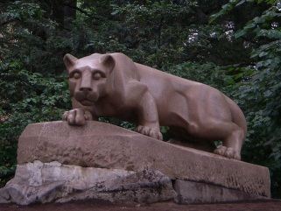Located on the corner of Curtin Rd. and Borrows Rd. across from Rec Hall on the west side of campus. The statue of the Penn State mascot was a gift from the Class of 1940 and is sculpted from Indiana limestone. It is tradition for students at Penn State to get their picture taken on the Lion during their first day as a freshman and then again in their cap and gown on graduation day.

***The Penn State “Berkey” Creamery***

The Berkey Creamery is the largest university creamery in the nation. Each year

approximately 4.5 million pounds of milk pass through the Creamery's stainless steel

holding tanks. About half comes from a 225-cow herd at the University's Dairy

Production Research Center.

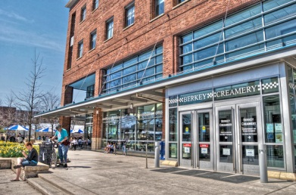

Getting ice cream at the Creamery has been a tradition since 1896. On football weekends salespeople dip several thousands of cones, and on a summer day, lines extend out the doors. Creamery ice cream is so fresh that only four days, on the average, elapse between the cow and your newly dipped cone. Visitors are advised not to miss this important stop.

***The HUB Robeson Center***

The HUB is Penn State’s famous student center located in the heart of campus. Existing since 1953 and expanded and remodeled in 1997 the 4-floor building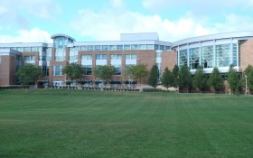 contains eateries, coffee shops, a bank and travel agency, multiple large seating areas, a big-screen TV, an aquarium, study rooms, computers, a copy center, a ceramic studio, an art gallery, 3 large auditoriums and almost one hundred offices for student organizations and university departments. The HUB, open 24 hours, is the most popular meeting place and one of the most popular places for students to study*.*

***Old Main***

Originally built in 1863 and then re-built in 1930 following a devastating fire, Old

Main is arguably Penn State’s most famous symbol. The limestone used to build it in

the 1800’s was carried in part by a mule named Old Coaly (which served as PSU’s

unofficial mascot prior to the Nittany Lion), whose bones were subsequently

preserved and are currently on display in the HUB (1st level).

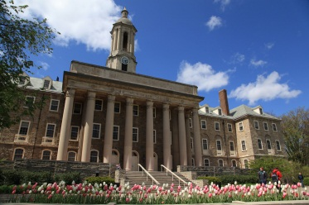Located in the center of campus the historic building houses the President’s office and other administrative offices. Its bell tower now contains digital chimes that play “Hail to the Lion” on the hour. Students typically set their watches by the Old Main clock. The building is surrounded by a large lawn and can be seen well from College Ave.

***The Pattee and Paterno Library***

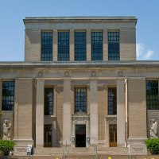The 13th largest library in the Western Hemisphere sits on Curtin Road just down the street from the Nittany Lion statue. Joe and Sue Paterno, committed to enhancing the future of all students, raised over $14 million in the 1990’s to add on to the existing Pattee Library making it one of America’s finest library’s with over 5 million items, 3500 maps, subject-specific floors and wings, computer labs, and a coffee shop.

