PAYING BY CHEQUE

Enclosed please find registration deposit of $ ________
(Minimum of $75.00 per registrant)

Post-dated cheque for $ ________
(Balance of my registration fee)
The school will not consider the applicant registered after June 1^{st,} 2014 unless a full payment and a signed agreement have been received.

INDEMITY / REFUND

The applicant agrees that Riverdale Community Recreation Complex Hockey Camp and its agents will not be held responsible for any accident or loss, however caused, and agrees to release its agents from all claims or damages which may arise as a result of or by reason of such accident or loss. The camp will not be held responsible for any acts of God (floods, lightning, power failures, tornados etc.) which may result in the termination of the school itself during Aug. 3rd - Aug. 7th, 2015.

The applicant agrees to the following refund policy: Refunds will be issued up to June 30th, 2015 less a $50 administration fee. In the event of an injury or accident prior to or during the camp, the appropriate portion of the registration fee will be refunded if the request is accompanied by a doctor’s certificate. No refund will be given if a player leaves by his/her own accord or is expelled by the camp.

_____________________________________________
Guardian Signature

Date ____/____/____
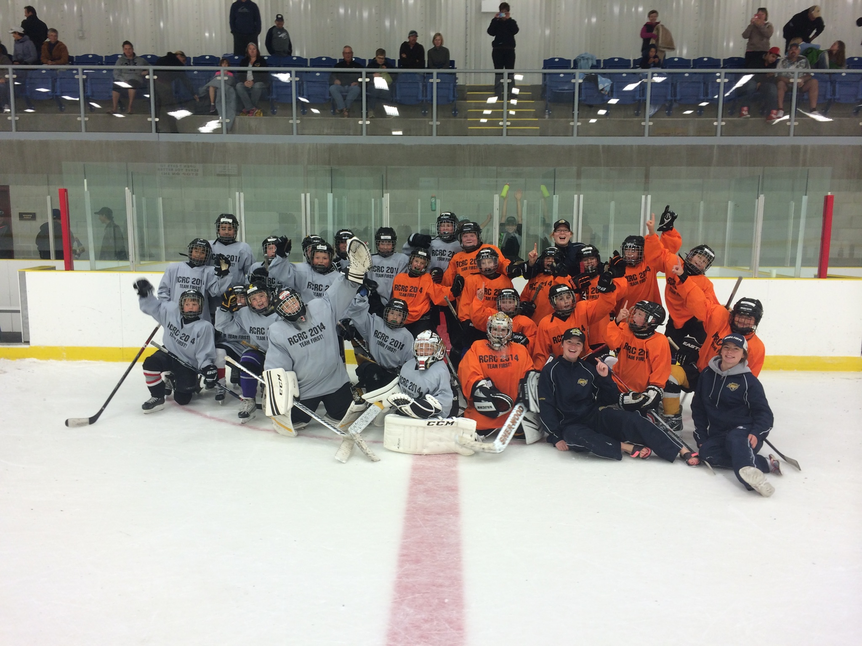

CAMP DIRECTOR

DEREK LAXDAL
- Head Coach of the Texas Stars AHL
- Head Coach of the Edmonton Oil Kings WHL 2014 MEMORIAL CUP CHAMPIONS
- 2013 WHL Eastern Conference Champions
- 2014 WHL Scott Munroe Regular season winners
- 2014 WHL Ed Chenoweth Champions
- 2010 Kelly Cup Play Finalists!
- ECHL Coach of the Year 2010
- 2010 ECHL Regular Season Champions!
- Head Coach Idaho Steelheads ECHL (Affiliate of the Texas Stars AHL & Dallas Stars NHL)
- 2007 ECHL Kelly Cup Champions!
- Played for Toronto Maple Leafs & New York Islanders
- Calder Cup Champion AHL (Springfield Indians) 1989-90
- Drafted by the NHL’s Toronto Maple Leafs
1984 (8th Rd.)
- LEVEL 4 NCCP (NATIONAL COACHES CERTIFICATION PROGRAM)
- 25 years Pro experience
- 28 years Hockey School experience
- 1986 CANADIAN NATIONAL JR. TEAM SILVER MEDALIST
- Memorial Cup Champion WHL (Portland Winterhawks) 1982-83

INSTRUCTORS

- Derek Laxdal
- Craig Anderson
- Dave Andrews
- Troy Hickman
- Bruce Willows
- Tyson Ramsay
- Michael St. Croix

RCRC
(Riverdale Community Recreation Complex)
4th ANNUAL HOCKEY CAMP

FEATURING
DEREK LAXDAL
HEAD COACH OF THE TEXAS STARS
CAMP DIRECTOR



♦ Boys & Girls ♦ 5 to 14 Years Old ♦

ADVANCED GROUP 10-13

Riverdale Community Recreation Complex
AUG. 3rd to Aug. 7th, 2015
QUALITY INSTRUCTION:
SKATING, PUCK CONTROL
OFF ICE TRAINING & CONDITIONING
SKILL DEVELOPMENT

WELCOME HOCKEY PLAYERS

RCRC Hockey Camp Director, Derek Laxdal, would like to extend an invitation to you to participate in our RCRC Hockey Camp.

RCRC Hockey Camp will maintain an excellent instructor-to-student ratio. We are committed to offering a quality program that emphasizes skill enhancement, group interaction and personal growth, regardless of your age or skill level. RCRC Hockey Camp is committed to offering you a very enjoyable and invigorating hockey experience!

The Riverdale Community Recreation Complex Hockey Camp is operated in order to support the new sports complex in the town of Rivers, Manitoba.
CAMPING IS AVAILABLE AT LAKE WAHTOPANAH PROVINCIAL PARK

ABOUT THE INSTRUCTORS

Our staff has been selected for their hockey knowledge, leadership, and teaching ability, as well as their passion and dedication to hockey! Our emphasis on life skills within a hockey environment will be beneficial to the success of Riverdale Community Recreation Complex Hockey Camp. Our goal is to start a tradition where students experience success as players, teachers and coaches in their lives.

RCRC Hockey Camp strives to attract quality instructors. Much of their experience can be attributed to being members of such quality programs.

Camp Questions
Contact:
DEREK LAXDAL
DLaxdal@dallasstars.com
coachlaxdal@gmail.com

SCHOOL INFORMATION

- Participants will be grouped according to D.O.B.
- Each group is limited to 25 players & 3 goalies.
- A waiting list will be established for each group!
  - Group 1-Boys & Girls 6-9
  - Group 2-Boys & Girls 10-14
  - Advanced 10-13
- Players may be moved between groups based upon skill level and travel requirements.
- Requests for group changes will be considered, but not guaranteed (they need to be submitted in writing with the participant’s form).

DAY SCHOOLS ♦ AGES 6-14

- Five Day Camp-$400
- 10% OFF for 2 or more registrants per family!
- School jersey included
- 8:00 am drop-off & 4:30 pm pick-up
- Minimum ten 1 1/4-hour ice sessions (12 1/2 hours for the week)
- Hockey specific conditioning (parachutes)
- Goaltender instruction
- Off-ice shooting and stick handling sessions
- GAME (Friday Afternoon)
- Excellent supervision
- Participants are responsible for their own lunches during the camp!
- Quality instruction from top level instructors
SIGN ME UP!

Detach this form/waiver & mail with payment to:
RDCC Hockey Camp
C/O Don Marriott
PO Box 278
Rivers, Manitoba R0K 1X0
Please keep a copy of this form!

Participant’s Name (Please print):

Circle One: M / F

Date of Birth (DD/MM/YY): _____/_____/_____

Parent’s Name:

Mailing Address:

Street:

Town:

Prov. __________ Postal Code:

E-mail:

Phone # ______-________-__________

Work Phone # ______-________-__________

Position (Check one): Skater  Goalie 

Jersey Size (Check one):
Adult Small  Adult Large 
Adult X-Large  Adult XX-Large 

Provincial Health Care Number: ___________

Medical Concerns:

Registration $400 

