Dear Mandeville High School Lacrosse Players,

The following is your summer strength and conditioning program for 2014. It is a 14 week program broken up into 4 phases which contains plyo-metric strength training, conditioning, and rest days. It is very important that you do not miss a workout. These workouts are built to de-load you from the long in‐season you are just coming off of and to get you prepared for the fall and upcoming competitive season. It is imperative that you follow the program, 1: so you do not over train, 2: so you maintain fitness levels gained in the fall and spring seasons to build upon in the upcoming season, 3: so when you return in the fall we can begin with more sports specific strength exercises and conditioning drills as a team.

This 14 week program is broken into 4 phases. During these phase, there will be strength training sessions 3 days per week and speed‐agility‐quickness‐conditioning sessions 3 days a week with rest days in between. Strength days should typically happen M/W/F (option 1) with SAQC days T/Th/Sat (option 1). If any of these options do not work for you, please do not hesitate to contact me to help you organize your training week to both optimize your training to fit your schedule.

|  |  |  |  |  |  |  |  |  |
| --- | --- | --- | --- | --- | --- | --- | --- | --- |
|  |  | SAQc | **SPEED-AGILITY-QUICKNESS-CONDITIONING** | | | | |  |
|  |  | OSW | **OPTIONAL SWIMMING WORKOUT** | | | |  |  |
|  |  | ODT | **OPTIONAL DISTANCE TRAINING** | | | |  |  |
|  |  | STRT | **STRENGTH TRAINING** | | |  |  |  |
|  |  | CON T | **CONDITIONING TRAINING** | | |  |  |  |
|  |  |  |  |  |  |  |  |  |
| **Option 1** - PREFERRED ROUTINE | | |  |  |  |  |  |  |
|  |  |  |  |  |  |  |  |  |
|  | Sunday | Monday | Tuesday | Wednesday | Thursday | Friday | Saturday |  |
| MANDATORY | REST | STRT | SAQc | STRT | SAQc | STRT | SAQc |  |
| WORKOUTS |  |  | CON T |  | CON T |  | CON T |  |
|  |  |  |  |  |  |  |  |  |
| OPTIONAL | REST | OSW | REST | OSW | ODT | OSW | REST |  |
| WORKOUTS |  |  |  |  |  |  |  |  |
|  |  |  |  |  |  |  |  |  |
|  |  |  |  |  |  |  |  |  |
| **Option 2** - SECONDARY ROUTINE (Only IF PREFRRED METHOD NOT AVAILABLE) | | | | | | |  |  |
|  |  |  |  |  |  |  |  |  |
|  | Sunday | Monday | Tuesday | Wednesday | Thursday | Friday | Saturday |  |
| MANDATORY | REST |  | SAQc |  | SAQc |  | SAQc |  |
| WORKOUTS |  |  | CON T |  | CON T |  | CON T |  |
|  |  |  | STRT |  | STRT |  | STRT |  |
|  |  |  |  |  |  |  |  |  |
| OPTIONAL | REST | OSW | REST | OSW | ODT | OSW | REST |  |
| WORKOUTS |  |  |  |  |  |  |  |  |

Additionally, I have built in optional swimming and distance training to help build a different aspect of your physical fitness. These are strictly optional workouts, and should not be done in place of the others unless you have spoken with me.

Everything in this workout plan is designed for you to complete without access to a weight room or training facility. However, the two exceptions are pull-up bars and the use of a foam roller wheel. Both of these can be found at almost any sporting goods store or online (see the following links):

<http://www.amazon.com/Bars-Strength-Training-Equipment/b?ie=UTF8&node=3408471>

<http://www.amazon.com/b?ie=UTF8&node=3407871>

You should not spend more than $25.00 on a foam roller as that is unnecessary. Although this exercise is listed as optional, it will help tremendously in your rest & recovery as well as injury prevention. As for the pull-up bar, if you do not have access to one, you can easily find one for no more than $30.00.

I encourage you to work in small groups on this plan. This will serve to benefit you for several reasons: 1. It will help eliminate the overall costs if you go in together on the missing items; and 2. By working as a group, you will push each other to compete and work harder, thus benefitting you in the long run.

Finally, although I will not be there to make sure you are completing the workouts as required, it is imperative and to your benefit that you do. We are going to hit the ground running in the fall, and it will be readily apparent you worked out during the summer. I am confident that you all will rise to the challenge and take this first step towards success for next season.

If you have any questions regarding the summer program, please do not hesitate to email me at William.Callegari@stpsb.org.

Have a great summer,

Will Callegari

Head Coach, MHS Lacrosse Program

The following outlines the various aspects of each portion of your summer workout:

1. **Warm Up**

It is imperative that you, as an athlete, engage in a proper and thorough warm up before strenuous physical activity, such as speed/agility and conditioning or strength training. The following protocols will be followed for each session.

A. **Foam Roll:** Foam rolling pre‐workout provides our tissues a myofascial release. This means that by applying gentle sustained pressure into the myofascial connective tissue we help to eliminate pain and restore motion.

B. **Dynamic Warm Up**: This will consist of dynamic movements to help us stimulate blood flow to active muscle groups, increase core temperature, increase joint viscosity, enhance neurological and biomechanical efficiency, and stimulate sport specific movements.

**C. Static Stretch**: This is just your basic stretching routine that we do daily at practice. It will help prevent injury and limber up muscle tendons and fibers, thus increasing flexibility and speed. It is crucial to do this both before and AFTER workouts.

**Dynamic Warm Up for SAQ** **and** **Conditioning Sessions**

(Perform each exercise for a total 10yds):

1st 10yards

5 squats + jog

A skips

Fence skips fwd

Side shuffle + lat arm swings R

High knees / buttkicks

High knee carioca R/L

High knees 5 + burst

Lateral bounding Jumps

Knee hugs / quad pulls

Groin lat stretch + crossover IT stretch

Rocking Groiner

Inchworm

High knees 5 + burst

2nd 10 yards

5 squats + jog

B skips

Fence skips bwd

Side shuffle + lat arm swings L

High knees / buttkicks

Lateral high knees

High knees 5 + burst

Back pedal / backward cycle reach

Lunge + back stretch bwd lunge + twist

High kicks + SL RDL

Lunge +elbow inside / hip twist

Toe touches

High knees 5 + burst

Stride build ups 50% (50 yards)

Stride build ups 60% (50 yards)

Stride build ups 70% (50 yards)

Stride build ups 80% (50 yards)

Stride build ups 90% (50 yards)

1. **Plyometric Training**

Plyometric exercises are quick, powerful movements using a prestretch or countermovement that involves the stretch‐shortening cycle. The purpose of these exercises are to increase the power of the movements by using the natural elastic components of muscle and tendon and the stretch reflex.

These exercises should be performed after properly going through the warmup regimen and prior to strength training exercises of this program. Please be sure to focus on using proper mechanics and generating maximal effort into each rep performed. These exercises are about maximal power training not as cardio respiratory conditioning exercises.

1. **Speed/Agility and Conditioning**

Speed and Agility are two major components of any sport that must be trained; just like strength and power in the weight room.

You should perform your speed and agility work and conditioning in the same session, but on a different day as your lifting session. If, due to your schedule, you absolutely need to do a running workout the same day as a lifting workout; perform speed and agility BEFORE strength training and perform conditioning AFTER strength training.

• BEFORE strength training

o 4‐cone Drills, W‐Drills, Pro Agility, Resisted Sprints, various 40yard sprints

• AFTER strength training

o Pyramid Runs, Raintree Runs, Half Gassers, Chaos 15’s, Repeating 100’s and

200’s

Please pay close attention to all sets, reps, target times and rest times. Use a stop watch/ phone/ clock to time proper work to rest times to obtain the proper training effects. Make sure you are fully recovered for all speed and agility drills unless timed rest periods are given to you.

1. **Rest and Recovery Methods**

Be sure to take at least 1 day each week completely off from training and rest. Two days would be better.

Recovery, Regeneration and Massage Methods

I. Cryotherapy: Decreases muscle spasm

B. Direct application of ice packs/bags

C. Cup massage (use paper ups and fill with water and freeze, peal like popsicle and massage in circular motion away from heart)

II. Thermotherapy: Decreases joint stiffness, reducing pain and inflammation

A. Immersion in whirlpools/hot tubs

B. Direct application of moist heat with massage

III. Hydrotherapy: Pool exercises

IV. Russian Shower: Take a shower and alternate between warm and cool (NOT hot or cold) water for 5 minute increments anywhere between two to five times

V. Foam roll: If you don’t have a foam roller, use a PVC pipe, lacrosse ball or softball.

Get an adequate amount (7 ½ to 9 ½ hours per night) of sleep. Stay hydrated.

1. **Exercise Explanations: Warm-Ups/Cool-Down**

**Dynamic Warm-Up:**

|  |  |  |  |  |  |  |  |
| --- | --- | --- | --- | --- | --- | --- | --- |
| STRT, SAQc & CONT T | | | 1st 10yards | | | 2nd 10 yards | |
| Dynamic Warm-Up: | |  |  |  |  |  |  |
|  |  |  | 5 squats + jog | | | 5 squats + jog | |
|  |  |  | A skips | | | B skips |  |
|  |  |  | Fence skips fwd | | | Fence skips bwd | |
|  |  |  | Side shuffle + lat arm swings R | | | Side shuffle + lat arm swings L | |
|  |  |  | High knees / buttkicks | |  | High knees / buttkicks | |
|  |  |  | High knee carioca R/L | | | Lateral high knees | |
|  |  |  | High knees 5 + burst | | | High knees 5 + burst | |
|  |  |  | Lateral bounding Jumps | | | Back pedal / backward cycle reach | |
|  |  |  | Knee hugs / quad pulls | | | Lunge + back stretch bwd lunge + twist | |
|  |  |  | Groin lat stretch + crossover IT stretch | | | High kicks + SL RDL | |
|  |  |  | Rocking Groiner | | | Lunge +elbow inside / hip twist | |
|  |  |  | Inchworm | | | Toe touches | |
|  |  |  | High knees 5 + burst | | | High knees 5 + burst | |

Some of the previously listed items can be seen demonstrated at the following link:

<http://www.youtube.com/user/SalisburyStrength>

**Foam Rolling Warm-Up/Cool-Down:**

|  |  |  |  |
| --- | --- | --- | --- |
| Foam Rolling | |  | Calf |
| Warm-Up/Cool-Down: | | | Quad |
|  |  |  | IT Band |
|  |  |  | Groin |
|  |  |  | Glute |
|  |  |  | Lumbar |
|  |  |  | Hamstring |
|  |  |  | Lat |
|  |  |  | Pec |

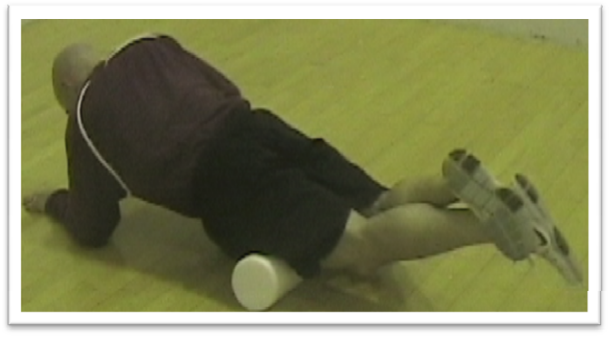 **Calf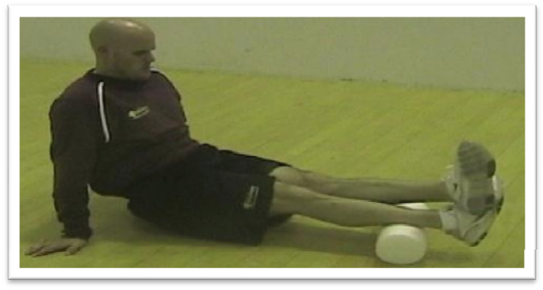 Quad**

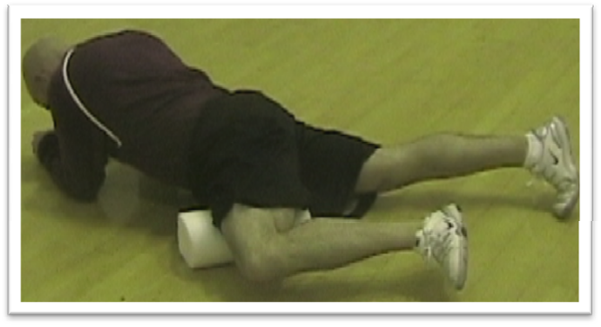 **IT Band Groin**

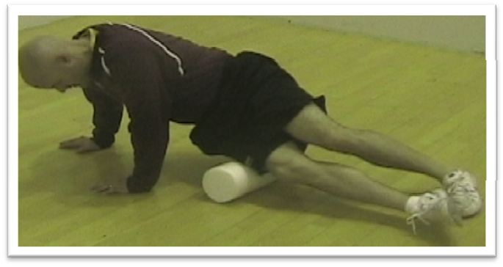**Groin**

**IT Band**

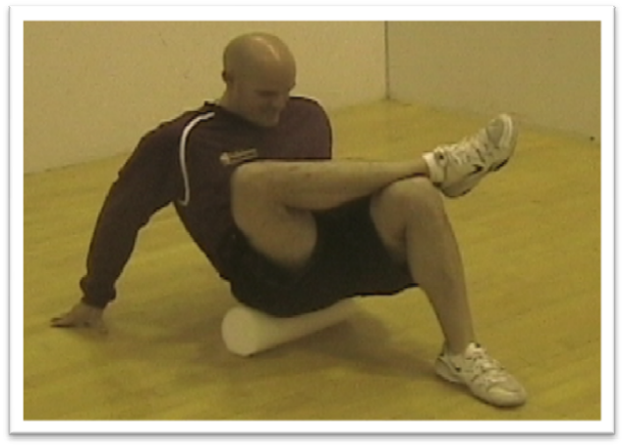

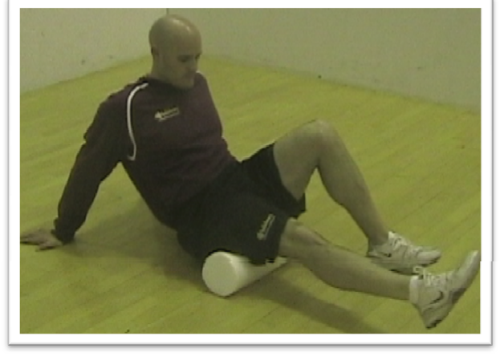

**Glute**

**Hamstring**

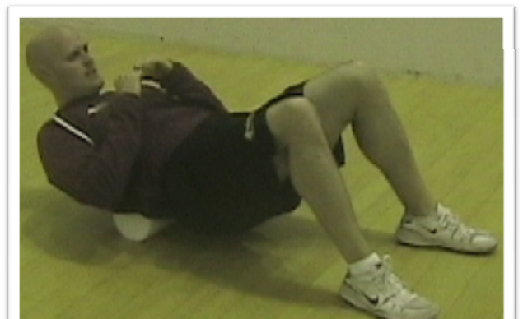

**Lat**

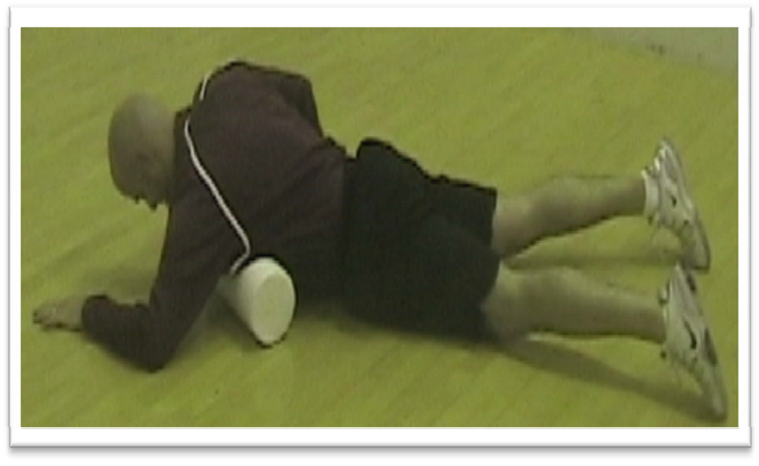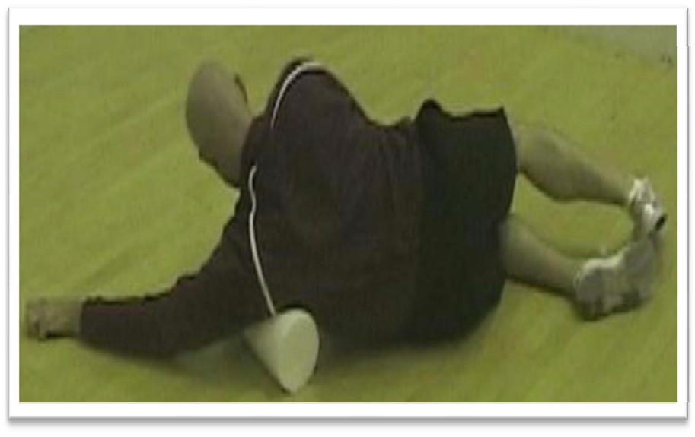**Pec**

**Lumbar**





**Static Stretch Warm-Up/Cool-Down:**

Complete EACH Stretch for a slow, 20 seconds.

* Feet together hamstring stretch
* Right over left hamstring stretch
* Left over right hamstring stretch
* Groin stretch to the middle
* Groin stretch to the right
* Groin stretch to the left
* Hip series left leg:
  + forward lunge
  + ducked stretch
  + earth pose
* Hip series right leg:
  + forward lunge
  + ducked stretch
  + earth pose
* Calf stretch right
* Calf stretch left
* Down dog stretch
* Saigon squat
* Left leg crossover stretch
* Right leg crossover stretch
* Right arm across
* Left arm across
* Arm circles (10 seconds forward, 10 seconds backwards)

1. **Strength Training:**

* Lunge Walks
* Squat Jumps
* Split Lunge Jumps
* Knee Jumps
* Push-Ups:
  + Shoulder Width (Normal)
  + Wide (Arms Spread)
  + Diamond (Close together)
* Dips
* Pull-Ups (All Dead Hang)
  + Wide (Hands far apart)
  + Close Grip/Narrow (Hands in close)
  + Shoulder (Hands Normal)
  + NEGATIVES
* Mountain Climbers
* Sidewinders
* Backwards Lunge
* Chin-Ups:
  + Wide (Hands far apart)
  + Narrow (Hands in close)
  + Shoulder (Hands Normal)
  + NEGATIVES
* Skiers (lateral side jump)
* Ankle Flips
* Frog Jumps

**Demonstration Videos:**

Lunge Walks: <https://www.youtube.com/watch?v=JbnW3RTLEvs>

Squat Jumps: <https://www.youtube.com/watch?v=utQShuge6Vk>

Split Lunge Jumps: <https://www.youtube.com/watch?v=vDmQ0-qd_ik>

Knee Jumps: <https://www.youtube.com/watch?v=BDA3DERQKFk>

Shoulder-Width Push-Ups: <https://www.youtube.com/watch?v=da5DVKdk2I4>

Wide Push-Ups: <https://www.youtube.com/watch?v=G05EwTHYxLU>

Diamond Push-Ups: <https://www.youtube.com/watch?v=J0DnG1_S92I>

Dips: <https://www.youtube.com/watch?v=jox1rb5krQI>

Normal Grip Dead Hang Pull-Ups: <https://www.youtube.com/watch?v=C_xPKEaHlmk>

Wide Grip Dead Hang Pull-Ups: <https://www.youtube.com/watch?v=2ffWOErbhnM>

Close Grip Dead Hang Pull-Ups: <https://www.youtube.com/watch?v=0XR2ABJ1Yu8>

Negative Dead Hang Pull-Ups: <https://www.youtube.com/watch?v=Opr72q6NKTc>

Mountain Climbers: <https://www.youtube.com/watch?v=nmwgirgXLYM>

Sidewinders: <http://www.stack.com/2012/06/06/exercise-of-the-week-sidewinder-band-walks-and-sled-pull-series/> (DO WITHOUT ELASTIC BANDS)

Backwards Lunge: <https://www.youtube.com/watch?v=sBCbU02uZy0>

Normal Grip Dead Hang Chin-Ups: <https://www.youtube.com/watch?v=UgNNieYJaec>

Wide Grip Dead Hang Chin-Ups: <https://www.youtube.com/watch?v=GG9YcPHPJvk>

Close Grip Dead Hang Chin-Ups: <https://www.youtube.com/watch?v=lWjy5CPNSx4>

Negative Dead Hang Chin-Ups: <https://www.youtube.com/watch?v=QTWQqXcL45g>

Skiers: <https://www.youtube.com/watch?v=1MNy6YuN07s>

Ankle Flips: <https://www.youtube.com/watch?v=MrG-jdnVKtM>

Frog Jumps: <https://www.youtube.com/watch?v=hJx6qsdsoAw>

1. **SAQ and Conditioning:**

**Phase 1 and 2 SAQ and Conditioning**

*Pyramid Run:*

800m (2 laps) – Rest 60secs

400m (1 lap) – Rest 60secs

200m (½ lap) – Rest 60secs

100m (¼ lap) – Rest 60secs

100m (¼ lap)

Time each run the first time you do this in week 1 and record the times for each distance. Each week after that (week 2‐6), your goal is to improve the different sections by 5sec, 3sec, 1.5sec, and 0.5sec respectively. A total improvement of 10secs.

*Raintree Runs:*

30sec sprint 60sec jog

35sec sprint 55sec jog

40sec sprint 50sec jog

45sec sprint 45sec jog

40sec sprint 50sec jog

35sec sprint 55sec jog

30sec sprint 60sec jog

2min rest

This run is done the same way for all six weeks of Phase 1 and 2. It is a continuous run with sprint intervals of increasing and decreasing length. Begin by sprint 30 seconds and then slow down to a jog for 60 seconds. Then sprint 35 seconds followed by a 55 second jog. This progression continues until you reach 45 seconds sprint and 45 seconds jogging and then you reverse the process to go back down.

*15 x 60m:*

15 x 60m (sideline to sideline) Sprint in under 10sec : Rest 30sec

Begin by sprinting from one sideline to the opposite sideline in under 10 seconds. When you completely cross the line start your rest period of exactly 30 seconds. As soon as your rest period is finished repeat your sprint from the sideline to the opposite sideline in under 10 seconds and repeat the drill with the same rest period.

Note: these should **not** be 100% sprints; run at about 85‐90% effort.

**Phase 3 SAQ and Conditioning**

*Half Gassers:*

Week 7: 8 w/ 60 sec rest

Week 8: 10 w/ 60 sec rest

Week 9: 12 w/ 60 sec rest

Week 10: 10 w/ 45 sec rest

Starting on one sideline, run across the field to the other sideline, touch the line, and run back to where you started. Sideline to sideline and back is one rep. Follow the appropriate rest periods and reps for the training week you are on.

*Y‐Cone Drill/Pro Agility and Chaos 15’s:*

Y‐Cone Drills (week 7 and week 9)

x2 all sprint, breakdown at each cone going right at 2nd cone

x2 all sprint, breakdown at each cone going left at 2nd cone

x2 sprint, shuffle right, sprint, shuffle left, sprint back to start

x2 sprint, shuffle left, sprint, shuffle right, sprint back to start

x2 sprint, shuffle right, shuffle left, back drop right, backpedal to start

x2 sprint, shuffle left, shuffle right, back drop left, backpedal to start

x2 backpedal, back drop right, shuffle left, sprint right, sprint to start

x2 backpedal, back drop left, shuffle right, sprint left, sprint to start

Set up cones 10 yards apart in a ‘Y’ shape. Move around the cones using the movements shown above. This is a speed/agility/quickness drill so make sure you fully rest between each run to ensure you are efficient in your movement patterns. This is maximal effort.

3

**1**

**2** 10 Yards

10 Yards

**4**

*Pro Agility 5‐10‐5 Drill (week 8 and week 10):*

x2 turn and sprint all starting to the Right

x2 turn and sprint all starting to the Left

x2 shuffle all starting to the Right

x2 shuffle all starting to the Left

x2 turn and sprint 5, backpedal 10, sprint 5 starting to the Right

x2 turn and sprint 5, backpedal 10, sprint 5 starting to the Left

x2 turn and backpedal 5, sprint 10, backpedal 5 starting to the Right

x2 turn and backpedal 5, sprint 10, backpedal 5 starting to the Left

10 yds

5 yds

*Chaos 15’s (Week 7-10):*

15sec jog, 15sec sprint, 15sec jog, 15sec walk (5mins)

1min rest between sets

Pick a smaller area (ex: attack box) and begin by jogging for 15sec in any direction within the designated area, followed by a 15sec sprint in any direction, a 15sec jog, and finally a 15sec walk. Repeat this in order five more times for a total of five minutes. After completing this drill for five minutes take a one minute rest and repeat. The chaos in this drill implies running in a closed space with other people running all around you, so if possible run in a even smaller area or with others.

*Repeating 200’s and repeating 100’s:*

**Repeating 200’s (week 7 and week 9)**

1 every minute for 10 minutes

1‐5reps (2min rest between) 6‐10reps

**Repeating 100’s (week 8 and week 10)**

1 every 30 seconds

3 sets of 5 sprints

2mins rest between sets

For Weeks 7 and 9, do 200 yard runs for 15 minutes. After each run is completed start a timer and rest for one minute, at the minute mark begin your next 200 yard run. After your 7th rep rest for two minutes and then continue your remaining reps with one minute rest in between each, like before.

Note: these should **not** be 100% sprints; run at about 85‐90% effort.

For Weeks 8 and 10, do 100 yard runs for three sets of five sprints each set. After each run is complete start a timer and rest for 30sec, at the 30sec mark begin your next 100 yard run. After each set of five sprints rest for one minute and then continue your remaining reps with 30sec rest in between each, like before.

Note: these should **not** be 100% sprints; run at about 85‐90% effort.

**Phase 4 SAQ and Conditioning**

*Resisted sprints:*

Add some form of resistance to your sprint for this day. It can be anything including, but not limited to; prowler, sled, weight vest, sandbag, bands, parachute, or just running up a steep hill. The duration of all sprints will be 5 seconds. The sprints are run in sets of 4 with 20secs rest

after each of the first 3 sprints and 90secs rest after every 4th sprint. Each sprint is maximal

effort.

**Week 11:** 12 sprints (3 sets of 4 sprints)

**Week 12:** 16 sprints (4 sets of 4 sprints)

**Week 13:** 20 sprints (5 sets of 4 sprints)

**Week 14:** 12 sprints (3 sets of 4 sprints)

*40 yard dash progression:*

**Week 11:** 4 x 40 (60secs rest each)

7 x 20 (30secs rest each)

10 x 10 (15secs rest each)

**Week 12:** 6 x 40 (60secs rest each)

5 x 20 (30secs rest each)

6 x 10 (15secs rest each)

**Week 13:** 8 x 40 (60secs rest each)

2 x 20 (30secs rest each)

4 x 10 (15secs rest each)

**Week 14:** 10 x 40 (60secs rest each)

*4‐Cone Drill/W‐Drill and Chaos 15’s:*

**4‐Cone Drills (week 11 and week 13)**

x2 all sprint, breakdown at each cone Right

x2 all sprint, breakdown at each cone Left

x2 sprint, shuffle, backpedal, shuffle Right

x2 sprint, shuffle, backpedal, shuffle Left

x2 “X” pattern Right

x2 “X” pattern Left

x2 “N” pattern Right

x2 “N” pattern Left

Set up cones 10 yards apart in a box shape. Move around the cones using the movements shown above. This is a speed/agility/quickness drill so make sure you fully rest between each run to ensure you are efficient in your movement patterns. This is maximal effort.

10 yds 10 yds

10 yds

**W‐Drills (week 12 and week 14)**

x2 all sprint break down at each cone Right

x2 all sprint break down at each cone Left

x2 side shuffle all Right

x2 side shuffle all Left

x2 sprint w/ backpedal at cone then sprint Right

x2 sprint w/ backpedal at cone then sprint Left

x2 sprint w/ full circle around cone Right

x2 sprint w/ full circle around cone Left

10 yds

5 yds

**Chaos 15’s (Week 11‐14)**

15sec jog, 15sec sprint, 15sec jog, 15sec walk (5mins)

1min rest between sets

1. **AB Workouts:**

**Series 1 Workout:**

* Weighted Toe Touches (30 seconds; 2 sets)
* Heel Touches (30 seconds)
* Hip Thrusts (30 seconds)
* V- Ups (30 seconds)
* Frog Crunch (30 seconds)
* Side Planks Left (30 seconds)
* Side Planks Left Hold (30 seconds)
* Side Planks right (30 seconds)
* Side Planks right hold (30 seconds)
* Leg Lift ABC’s (10 reps)
* Ab Stretch

**Series 2 Workout:**

* Weighted Russian Twists (30 seconds; 2 sets)
* Flutter up and down (30 seconds)
* Flutter over and under (30 seconds)
* Bicycles (30 seconds)
* Russian Twists (30 seconds)
* Side Crunch left (30 seconds)
* Double Sided Crunch Left (30 seconds)
* Side Crunch Right (30 seconds)
* Double Sided Crunch Right (30 seconds)
* Dead man holds (5 reps)
* Ab stretch

**Series 3 Workout:**

* Reverse Hypers (30 seconds)
* Superman Right Arm Left Leg (30 seconds)
* Superman Left Arm Right Leg (30 seconds)
* Alternating Superman Crunch (30 seconds)
* Full Superman Crunch (30 seconds)
* Full Superman Crunch hold (30 seconds)
* Bird Dog (20 reps each leg)
* Bird Dog Hold (20 seconds each leg)
* Bows and Toes (1 minute)
* Child’s Pose

**Series 1 Explanation:**

* Weighted Toe Touches: <https://www.youtube.com/watch?v=-A_bjeh3A10>
* Heel Touches: <https://www.youtube.com/watch?v=bHNgRvTk5PA>
* Hip Thrusts: <https://www.youtube.com/watch?v=SEdqd1n0cvg>
* V- Ups: <https://www.youtube.com/watch?v=aviRfr_y4N4>
* Frog Crunch: <https://www.youtube.com/watch?v=jB4AwMTO8U8>
* Side Planks Left: <https://www.youtube.com/watch?v=6cRAFji80CQ>
* Side Planks Left Hold: <https://www.youtube.com/watch?v=rXARnSxcahc>
* Side Planks right: <https://www.youtube.com/watch?v=2EPKjJ8hANQ>
* Side Planks right hold: <https://www.youtube.com/watch?v=44t7O_tcRt4>
* Leg Lift ABC’s: <https://www.youtube.com/watch?v=zQTYiWpYSM0>
* Ab Stretch: <https://www.youtube.com/watch?v=55wb146T7mw>

**Series 2 Explanation:**

* Weighted Russian Twists: <https://www.youtube.com/watch?v=CTLbL44ymb0>
* Flutter up and down: <https://www.youtube.com/watch?v=BRsTv-0l92E>
* Flutter over and under: Same as above, but feet move left to right (crisscrossing)
* Bicycles: <https://www.youtube.com/watch?v=wqoD0Bdggto>
* Russian Twists: <https://www.youtube.com/watch?v=wkD8rjkodUI>
* Side Crunch left: <https://www.youtube.com/watch?v=5laCNeFnKdE>
* Double Sided Crunch Left: <http://www.youtube.com/watch?v=uaTM1pzZkw0>
* Side Crunch Right: <https://www.youtube.com/watch?v=5laCNeFnKdE>
* Double Sided Crunch Right: <http://www.youtube.com/watch?v=uaTM1pzZkw0>
* Dead man holds: <https://www.youtube.com/watch?v=Qw6UydgEHUY>
* Ab stretch: <https://www.youtube.com/watch?v=55wb146T7mw>

**Series 3 Explanation:**

* Reverse Hypers: <https://www.youtube.com/watch?v=YW7pMg29SYg>
* Superman Right Arm Left Leg: <https://www.youtube.com/watch?v=6lTrSxTZ0nA>
* Superman Left Arm Right Leg: <https://www.youtube.com/watch?v=6lTrSxTZ0nA>
* Alternating Superman Crunch: <http://www.youtube.com/watch?v=Gui5TqiKjZI>
* Full Superman Crunch: <http://www.youtube.com/watch?v=u6URsk0OmTE>
* Full Superman Crunch hold: <http://www.youtube.com/watch?v=z6PJMT2y8GQ>
  + Basically, just holding superman crunch with arms and legs off ground for allotted time.
* Bird Dog: <https://www.youtube.com/watch?v=wgOuR7YrwtM>
* Bird Dog Hold: <https://www.youtube.com/watch?v=iaL3U1OH0Vs>
* Bows and Toes: <https://www.youtube.com/watch?v=DUzTtsEIo2Y>
* Child’s Pose: <http://www.youtube.com/watch?v=V22xxybieHk>

1. **Swimming Workouts:**

**Strokes & Techniques**:

* Breaststroke: <https://www.youtube.com/watch?v=nG25HeugAmU>
* Freestyle Stroke: <https://www.youtube.com/watch?v=3ugLmlrUkMY>
* Dolphin Stroke: <https://www.youtube.com/watch?v=xx2ed-ACQqs>
* Side Stroke: <https://www.youtube.com/watch?v=69Lx6LWlees>
* Treading Water (Full Body): <https://www.youtube.com/watch?v=GvAd3s5869Y>
* Treading Water (Legs Only): <https://www.youtube.com/watch?v=fFGTfjKdd2A>
* Explosions:

**SPORTS NUTRITION INFORMATION**

**Coach’s Note:**

The following section regarding sports nutrition is not something that will be regulated, nor something that absolutely must be followed. However, it is here to provide you with additional knowledge regarding nutrition in an effort to help make you aware of the effects and benefits involved in eating healthy. The information was all complied by the Salisbury University Strength and Conditioning Program and is all great information. I highly encourage all of you to avoid fast food, soft drinks, and other unhealthy food items that could hamper your hard work this summer. Furthermore, make sure you ALL STAY HYDRATED, HEALTHY and SAFE.

**Introduction:**

Although many athletes and coaches are aware of the importance of nutrition, they don’t know how to apply what they know. For example, they know that carbohydrates are the primary fuel for exercising muscle. But when it comes to making food choices, they have no idea what high carbohydrate food is or how much they should eat. Yet deficiencies in consumption of energy, nutrients, electrolytes and/or water can hinder athletic performance.

The off-season is the time when good nutritional habits are developed allowing one’s body to be ready to perform at its highest level possible come season time. Poor eating habits both out of season and in season will hinder the body’s athletic performance possible resulting in poor performance on the field of play. You as an athlete should make your nutritional intake a priority in terms of looking to improve your overall athletic ability and performance.

Below is a planned overall view looking at sports nutrition. This is very valuable to you because it can help eliminate any misconceptions you may have as well as allow you to design appropriate eating habits.

1. **TARGET SPORTS DIET**

- 60 to 70 % Carbohydrates

- 20 to 25 % Fat

- 10 to 15 % Protein

1. **CARBOHYDRATES**

- Carbohydrates are one of the primary fuels used by muscles during exercise

- High intensity exercise use mainly carbohydrates as their energy source

- Carbohydrates are stored as glycogen which is stored in the liver and muscles

- During long intense workouts, large amounts of these glycogen stores are depleted. You should replace these glycogen stores after completing your workouts within 2 hours after exercise with complex carbohydrates.

Two kinds of Carbohydrates

* + - Simple Carbohydrates:
      * Fruits, juice, soda, fruit drinks, cookies, milk, frozen yogurt, jellies, syrups
    - Complex Carbohydrates
      * Rice, breads, cereal, muffins, rolls, waffles, potatoes, corn, peas, pasta, low fat milk

- Try and stay away from simple carbohydrates prior to working out or play as they can lower your blood sugar levels making you feel tired and unable to perform at your best.

1. **PROTEIN**

- The main role of protein in the body is tissue repair and growth. Smaller amounts are required for many metabolic reactions. Only about 5 to 15% of energy used for exercise is supplied by protein. If your diet is high in carbohydrates, less protein is used for energy. This is preferred since tissue repair and growth will need to occur at optimal levels during our phases of training.

NEEDS

* + - Adults = 0.4 to 0.6 grams per 1lb of body weight
    - Adult Building Muscle = 0.6 to 0.9 grams per 1 lb of body weight
  + Types of foods that supply protein:
    - Cheese, eggs, tuna, red meat, chicken, milk, whole grain cereal, past, rice with beans
    - Choose lean protein – low fat lean meats

1. **FAT**

* Provides energy
* Protects Carbohydrate Stores
* Two Kinds of Fat:
  + Saturated Fat:
    - Chocolate, oils, fried foods, sour cream
    - Major contributor to heart disease
  + Unsaturated Fat:
    - Canola
* Quick Facts on Fats:
  + Margarine is not any better than butter
  + Avoid Hydrogenated Fat ( Pre-Packaged Meals)
  + Remove Skin and all Visible Fat from Meats
  + Avoid Fried Foods
  + Choose foods that are baked, boiled, steamed, poached, or roasted

* The key to gaining muscle mass is to consume enough total calories from a diet high in carbohydrates to cover energy needs, so dietary protein is spared for muscle growth.

1. **CALORIC NEED**

Body Weight x 23

* + Number of Calories needed per day

1. **FLUID INTAKE**

Body Weight x .67

* + Number of fluid ounces need per day
  + When to Drink Fluids (H20):
    - 16 ounces before bed
    - 16 ounces as soon as you get up
    - 17 ounces 2 hours prior to workout/practice
    - 8-16 ounces 15 minutes prior to workout/practice
    - 4-8 ounces every 15 minutes during exercise
    - Post exercise/workout: 24 ounces for every pound lost during exercise

1. **DAILY EATING SCHEDULE**

|  |  |  |
| --- | --- | --- |
| MEAL  Meal 1** | TIME  8:00am | DESCRIPTION  Breakfast List |
| Meal 2 | 10:00am | Snack List |
| Meal 3 | 12:00pm | Lunch List |
| Meal 4 | 3:00pm | Snack List |
| Meal 5 | 6:00pm | Dinner List |
| Meal 6 | 9:00pm | Snack List |

**\*\* Breakfast is the most important meal of the day**

- 6 meals a day will help to elevate your metabolism while maintain a high level of energy of the course of the day

1. **MEAL LIST**

Breakfast List

Proteins Carbohydrates

Egg Whites or Substitute Whole Wheat Bread or Bagel

Low-Fat Cottage Cheese Non-Fat Yogurt

Lean Ham or Steak Orange, Apple, Melon, or Berries

Protein bar or Drink Whole Wheat Cereal

Skim Milk Oatmeal

French Toast, Pancake, or Waffle

Juice

Low-Fat Muffin

|  |  |  |
| --- | --- | --- |
| Lunch and Dinner List  Proteins | Carbohydrates | Vegetables |
| Chicken Breast | Baked Potato | Broccoli |
| Turkey Breast | Sweet Potato | Asparagus |
| Lean Fish (Salmon, Tuna, Sworfish,etc) | Steamed Rice | Lettuce |
| Lean Seafood (Crab, Lobster, Shrinp) | Pasta | Carrots |
| Lean Beef (Ground, Sirloin, Filet) | Beans | Cauliflower |
|  | Corn | Green Beans |
|  | Wheat Bread  Squash | Green Peppers  Mushrooms |
|  | Mashed Potatoes | Spinach |
|  | Non-Fat Crackers | Peas |
|  | Pasta or Potatoes Salad | Onion |
| Snack List |  |  |

Snack List:

(Protein/Carbohydrate/Vegetable)

Meal Replacement Shake

Protein Bar

Low-Fat Muffin

Cup or Piece of Fruit

Vegetables

Non-Fat Yogurt

Non-Fat Crackers

1. **MEAL SCHEDULE EATING PROTOCOL**
2. Serving size is equal to the palm of your hand or a clenched fist
3. Select one serving from the protein and carbohydrate list for each meal
4. Select one serving of vegetable from the list for at least two meals.
5. Follow Daily Fluid Intake schedule
6. Plan or prepare meals in advance
7. Make a grocery list from the meals you plan to make
8. Try and eat at the scheduled eating times
9. Eat whatever you want on your free day – once per week