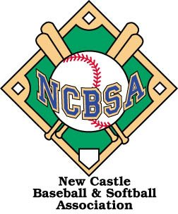

PRACTICE PLAN

Dynamic warm-up
Use movement preparation to prepare for game conditions.
( Lunges, Butt kickers, Frankensteins, Arm Circles, High Knees are some good examples)

Form Throwing
Start on one knee, and work up to a regular standing throw. Most throwing warm-ups are not supervised carefully and are therefore mindless. Have the players develop proper throwing and catching mechanics. Proper habits developed now will last a lifetime and really pay off down the road.
Wrist throws (on one knee or standing) - glove hand is stretched across your chests- it holds up throwing arm at a 90• degree angle and just the wrist throws the ball.
Bent knee drill- must make sure players’ throwing arm finishes on the outside of their bent knee. Players’ should place their throwing side knee on the ground and they should be focused on twisting at their hips prior to throwing to generate torque and simulate the actual throwing motion of twisting the hips prior to throwing.
Practice at home- Use a towel and wrap it around your throwing arm. Simulate the same throwing motion in full speed. This drill should be done both on one knee and standing up. This drill will strengthen the rotator and teach kids that they can simulate throwing at home despite not having a throwing partner or daylight or inclement weather.
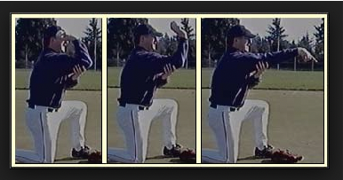

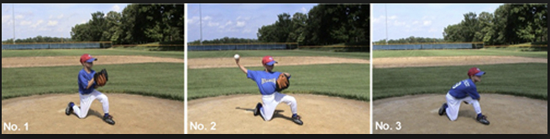

The first few weeks all these drills should be done with tennis balls and it should be stressed that when players have a catch that all throws should be to glove side. Once the hand eye coordination is solid then move to hard balls and progress to throwing to chest and center and lastly to back hand. If kids are substantially behind in hand eye coordination and throwing mechanics the catch and throw drills should be handled with a coach one on one.
Players should also start off all of these drills for the first several weeks practicing the separation of glove and throwing hand. Kids will start the throwing process with their hands together (glove and throwing hand together) separating glove and throwing hand at the same time and stop when glove is pointing at target and arm is high above shoulders with the ball facing away from target and stop at this position before they throw. Once this is mastered and the kids can consistently get their arm and glove to the right throwing positions it is imperative that the players are now taught to never stop their arm once it starts moving. The foundation of getting the arm to the right position is crucial and when this is mastered the player must understand that once his hands separate that his arm never stops moving until he releases the ball.
Throwing drills can include - pushing off towards target by marking lines on grass for follow through leg
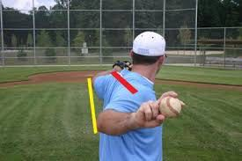

Fielding Ground balls – Safety First
No hitting ground balls in the beginning. Coaches can just practice rapid fire throwing drills at close range simulating glove side, centered rollers, short hops, slow rollers, back hands, side to side shuffling feet drills as the kids underhand flip back to coach. Emphasize wide knees, butt out and glove ready, glove down only happens once the ball is rolled and emphasize staying down. As they master these drills you can back up and they can work on the proper throwing techniques. Start by teaching the players to have their throwing side leg step forward once the grounder is caught and simultaneously as they start to stand up to throw they step forward which allows the kids to get in the proper throwing position while getting closer to their target. Also you can practice rapid fire side to side drills once kids have mastered the basics. The emphasis is to start slow and help the kids not only develop the basic skills but also the confidence to know they can do these things.
Once the kids are ready to field ground balls that are hit, setup as follows- Two coaches on each side of field - 3rd base line and 1st base line (4 total coaches - One hits and one catches). All players field ground balls. Kids are separated evenly out to each infield position. The coach on the 3rd base side will hit to 3rd and to SS only. Have the players throw to the coach at the 3rd base line. The same thing is going on at the 1st base line with the players lined up at 2nd base and 1st base . Once a player catches a ball he goes to the back of the line and after 3 catches the group rotates right until all players have fielded 3 balls at each position.
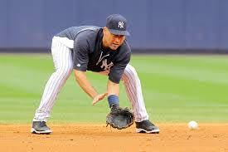
FLY BALLS
Fly balls at this age should be hit with a tennis ball or wiffle ball until kids have mastered glove side, back hand side and center above head. Use a wiffle ball or tennis ball without a glove first. Then use a glove with a tennis ball until they are ready to use a hard ball.
Always start glove side and always tell the kids which side you’ll be throwing to. Once a player is fluent in catching fly balls you can work in over the head and back hand drills.

Game Time Ready for Fielding
Once simulated t-ball and coach pitch games begin, the goal is to have every kid ready to field live ground balls. The goal is to make sure kids are not clustered around the pitching mound and fighting each other to make the play. Place each player at a position. There should be a pitcher, 3rd base, SS, 2nd Base, 1st base, short center (right in front of the actual 2nd base, and the remaining players should be spread out wide in the outfield (actually in the outfield). The recommendation is to start the game by putting the more confident/ seasoned players in the outfield and the less seasoned players in the infield. There should be a coach in the outfield and a coach in the infield instructing players what to do when the ball is hit to them or what to do if the ball is hit to the player to the left or right of them. Once a player makes a play he should move to the outfield and the outfielder can move to an open infield position. Players should rotate once they make a play to give every single player an opportunity to make a play.

Proper Hitting Mechanics
Turning the back foot drill prior to the hands moving forward. On your toes with your heel off the ground, push down with your weight, turn your foot, open your hips and squash the bug with your back toes.
Practice front leg stride (small and short stride, not big and long), make sure the landing leg is strong and doesn’t allow the torso to lean forward, it acts as a stopping point for upper body to allow the momentum to transfer from legs to arms and generates power to striking the ball. When the striding leg hits the ground, the hitter should be landing on his big toe not on his heel and rotating his front foot open which also will allow his hips to open.
We hit with our hands not our arms. Practice keeping hands inside the baseball. Bottom of bat (knob) should go directly towards pitcher not first base when hitting. Practice this in slow motion to help correct swings. This can be practiced by having kids line up facing a fence. They will take the bat and put one end against their belly button and the other end against the fence and it should not fall. That’s how far away from the fence they should stand for this drill. It will seem like they are way too close and will hit the fence on a full swing. However if they are keeping their hands inside the baseball and pulling and pushing the knob directly at the pitcher or toward 3rd base if they’re a righty and1st base if they’re a lefty they can swing full speed without hitting the fence. This drill should be done in slow motion until they are doing it properly. (Stay away from pipes on fences so that if they do strike the fence which most of them will, it won’t hurt)
Loading hands drill- hands come back as our weight shifts back on our back leg before they go forward to hit. Our upper body never moves and never leans, it’s just legs and arms and our arms should only move maximum of 6 inches. This means kids need to start with their hands in close proximity to their back shoulder when they are in their hitting position before they start loading their hands. Hands go directly back, make sure they don’t twist hips during the load and make sure the hands do not go behind their head/ body towards 3rd base if they’re a righty or towards 1st base if they’re a lefty (wrapping your hands is a very bad habit).

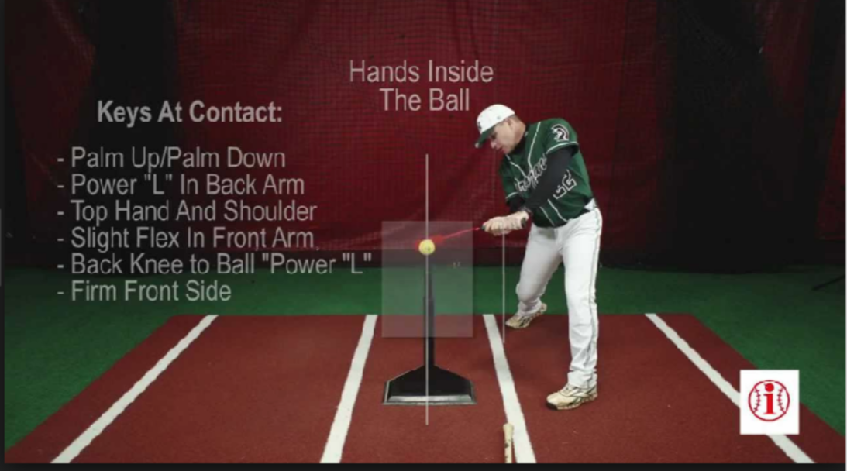

Breaking down the swing into steps
Loading hands and weight onto back leg then pause.
- Turing our back foot, opening hips and squashing the bug while our back heel is off the ground. - Hands move forward towards the pitcher leading with the knob of the bat. - Power L at the point of contact. - Follow through with both hands on the bat and finish swing against your back.
It is essential to teach kids that once they start the load they should never stop moving until they hit the ball.
Key points to preach- Head never moves when we hit - We need to see the ball to hit the ball. Upper body never leans forward because the ball comes to us.

Conditioning
Include some fun conditioning drills at the end of practice. The kids like it, and they receive great benefit as well. Some examples are sprinting competitions, football passes, relay races, and push up competitions. Keep it upbeat, and keep it fun!

Keep them moving. Players should not be standing around. They should always be moving or learning.

Always focus on positives. There is never a good reason to yell or be negative during practice. If a kid needs to be disciplined, that's another story, but yelling should still not be involved.

Rules of practice for youth baseball
Fun! If practice is fun, the players will be focused. They will give 100 percent, and they certainly will look forward to each and every practice.

