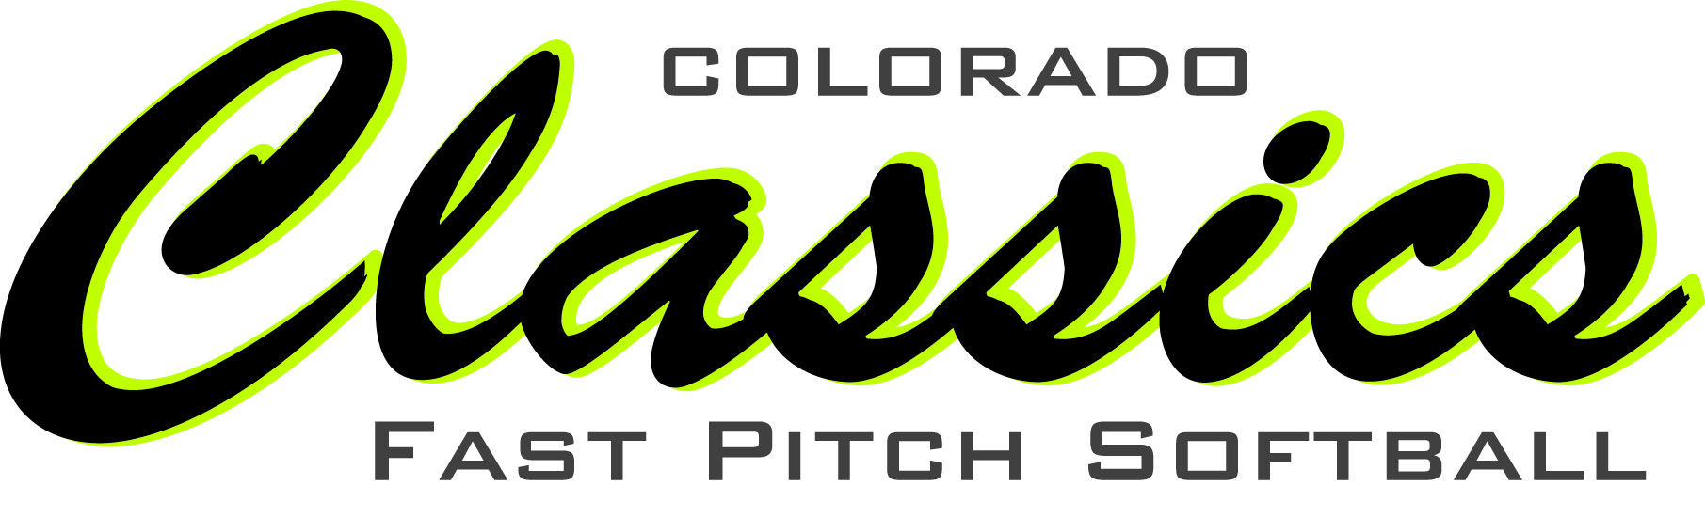

Fundraising

We intend to offer a variety of fundraising opportunities throughout the year. You can choose to participate in all, some or none of them. Remember, monies fundraised cannot be returned to you directly at the end of a season. Fundraise wisely!

Sponsorship Campaign: September ’14-February ‘15
Players may find local businesses to sponsor the organization. Sponsors may not use this as a tax deduction. All sponsorships are used for the benefit of the organization, which helps offset team costs such as insurance, equipment, facility rentals, etc. Sponsorships can be sold between September and February. All payments are due by February 15th. There are specific sponsorship forms to use (see pages 5 & 6 of this booklet).
Sponsors will receive a variety of benefits based on sponsorship amount. Sponsors will be promoted at ALL events no matter what amount of sponsorship they give. Those that give at the highest level are listed on our team banners with their logo. They are also promoted on our website.
Sponsorship levels are at $100, $200, $300 and $500+. We can provide a letter to you to send thanking them for their support.
Contact: Ceri Anderson (227-9737 canderson@thegroupinc.com)

King Soopers Cards: All Season
These gift cards are $5 each and come pre-loaded with $5. You visit the service desk inside the store to “load” your card. You can do this with cash, a debit or credit card, a check, etc. Each time the card is loaded, 5% of that amount is credited back to the organization. Get cards for your family members and friends. All of their purchases count as well! You can also use these cards to purchase gas.
Contact: Your team manager
Scrips: All season
This program offers a wide variety of gift cards you can purchase that offer rebates back to the organization. Hundreds of retailers are available to choose from like Safeway, Starbucks, Lowe's, Home Depot, Kohl's, Dick's, Marriott Hotels, etc. Each retailer offers a rebate that varies. For instance, Bath and Body Works offers a rebate of 7% for each $25 gift card purchased, whereas, Chili's offers rebates of 11% for each $25 purchased. The rebate amounts vary throughout the year and they tend to increase as the holiday season comes. Gift cards can be ordered at www.shopwithscrips.com. After creating an account, the families can start shopping. To purchase the gift cards, the families can either elect to have the total balance due drafted from their checking account for a fee of $.39 or drop off a check to the program's administrator which the administrator then releases the order after the funds are deposited. The administrator can choose how often to release orders. To make it simple, orders may be placed every 2 weeks, except when it gets closer to Christmas and orders may be placed every week to help with the holiday shopping. The order is delivered to Colorado Classic's programs administrator who then disburses the cards to the families. A monthly statement is also sent showing the credits to the organization. The only fee associated with this program is the shipping cost which is $7.95 for ground delivery. That fee would be passed on to the families placing the order. If there were 8 families placing an order, the fee would be split up between them that way the organization does not incur any fees for this benefit, which if you have a $500 order with a rebate of $50, it's still worth the order. Reloadable gift cards and e-cards are also available.
Contact: Melissa Tremelling (jrhunterbill@msn.com)

Broncos Regular Season Football Pool
During Pre-Season, sell pool squares (there are 100 total to sell) for $50 to yourself, your family, friends, and neighbors. Each week, $100 is paid for the winning square based on the final score of the Bronco game. Numbers change each week and are posted at www.coloradoclassicssoftball.com. Of the $50 charged, $34 is credited to the player’s budget who sells the square. Easy!
Contact: Ceri Anderson (canderson@thegroupinc.com)

Texas Hold ‘Em Poker Tournament: Tenatively Feb 2015
This fun night of poker playing will be held in early 2015. There will be an opportunity to earn money by selling tickets for players. The 2013 and 2014 fundraiser was held at The Garden Room in Loveland. More details will be forthcoming. A committee will be needed to organize this event.

Blackhawk/Central City Casino Bus Trips: Nov 29, 2015
These trips are an easy way to raise money! We hope to have one organized for November. Typically riders pay $25 to ride the bus to Central City or Blackhawk. That money is credit to the player account. Once there, gambling time lasts approximately 4 hours.

Dear Friends, Family, and Business Owners:
The mission of Colorado Classics Club Softball Corporation (known as the Corporation or CCCSC in this document) is to provide a positive experience on and off the field for young ladies of Northern Colorado.
The purpose is to provide quality instruction and coaching to Northern Colorado girls interested in the sport of fast pitch softball. We strive to have a positive environment that allows teams to excel and individuals to build skills that will further their careers to the high school and collegiate levels. Excellence is expected from the coaches, players and parent of all Colorado Classics Club Softball teams.
Club sports provide great opportunities for all girls, but playing them comes with a hefty price tag. There are many expenses including the cost of uniforms, practice facilities and fields, team insurance, tournament fees and more. For many families, this cost is sometimes too large to overcome. In an effort to alleviate some of the financial burden, we are holding our Colorado Classics Sponsorship Campaign. I’m hoping you might be able to provide a 2015 season sponsorship.
The Single: $100
The “Single” sponsor will be line listed in our literature at any event we hold. This sponsor will be line listed and promoted on our website for the 2015 season.
The Double: $200
The “Double” sponsor will be line listed in our literature at any event we hold. They will also be line listed and promoted in larger font than “Single” sponsors on our website for the 2015 season.
The Triple: $300
The “Triple” sponsor will be showcased as a major sponsor at any of our events. They will be listed in all Colorado Classics materials and listed with a logo on our website for the 2015 season.
The Homerun: $500
The “Homerun” sponsor will be showcased as a major sponsor for every event we have during the 2015 season. They will also be promoted with their logo on our website for the season. In addition, “Homerun” sponsors will have their company logo/name listed on all team banners for the 2015 season.

It’s a lot to ask, but I hope you will consider supporting the Colorado Classics Club Softball Organization for the 2015season. The sponsorship form is included with this letter. There is no tax deductibility allowed for your donation.
Thanks for your support!
Sponsorship Campaign 2015 Season
Yes! I will be Colorado Classics Club Softball Sponsor for the 2015 Season. The level of my sponsorship shall be:
_____The Single ($100)
_____The Double ($200)
_____The Triple ($300)
_____The Homerun ($500+)

I understand I will be contacted for my logo if applicable to my sponsorship (The Triple and The Homerun).
________________________________________________
Company Name

________________________________________________
Contact Name

________________________________________________
Address

________________________________________________
City, State, Zip

Email Address_____________________________________

Phone Number____________________________________

