Ramona Girls Softball
Booster Program
RGS Booster $75
includes booster sticker, spirit wear t-shirt and choice of visor or flex fit hat.

RGS Super Booster $100
includes booster sticker, spirit wear hoodie and choice of visor or flex fit hat
All booster proceeds go to field maintenance and improvements.
pledge amount: ________
Name: _________________________ Cell #:__________________________

Player’s Name:__________________________________________________

T-shirt size :___________ Visor: Adult Youth

Hoodie size : _________ Flex Fit Hat: S/M L/XL
Spirit Wear order Form
Name:____________________________________
Contact #:________________________________
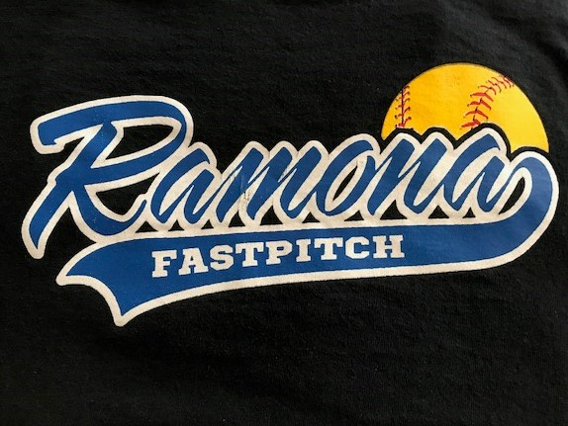
T-Shirts:
Size:______ qty:______

Size:______ QTY: ______ total: ______x$15=____

Pull over hoodie:
size:_______ qty:______

Size:_______ qty:______ total:_____x$25=_____

Flex Fit Hat: S/m:_____ l/xl:____ total:_____x$25=_____

Visor: Adult:_____ Youth:_____ total:_____x$15=_____

Order total:___________________
for more information contact: Contact Name @ telephone

