**Home Team Online (HTO)**

**Home Team Online User Guide – Bradford Sluggers Softball 30+ League**

Login

Captains Notes

Quick Notes

Coaches & Staff Access

Add players

Updating Scores

Standings

League Website

Subscribe to your Calendar

Player information -See separate guide

[**www.sluggerssoftballbradford30plusleague.com**](http://www.sluggerssoftballbradford30plusleague.com/)

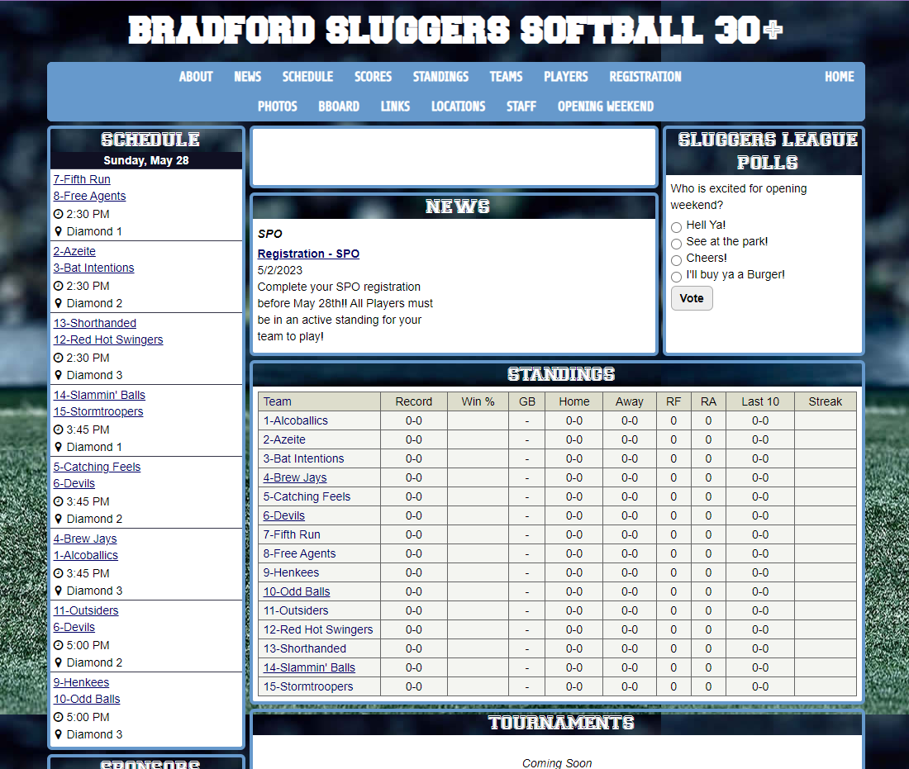

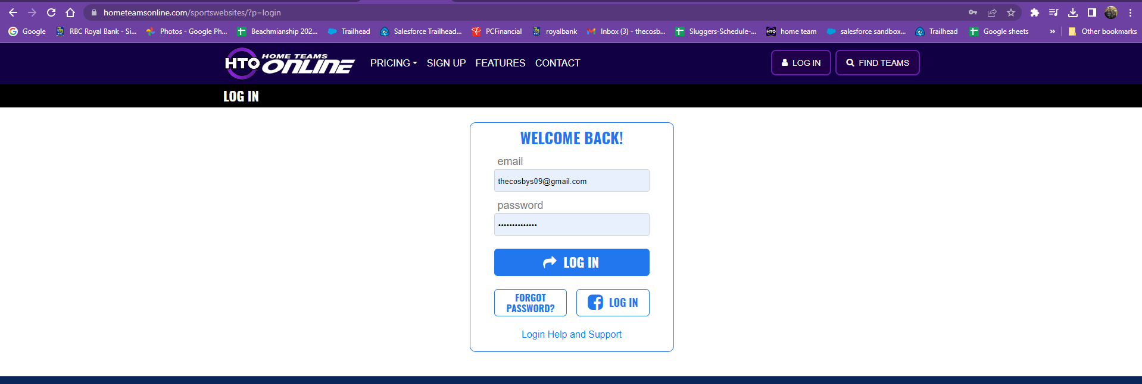

This is web-based platform and mobile friendly (there is no App)

Save the link on your phone to use from mobile

[**www.sluggerssoftballbradford30plusleague.com**](http://www.sluggerssoftballbradford30plusleague.com/)

Click on the HTO graphic to log-in

**OR direct access - Login URL:** <https://www.hometeamsonline.com/sportswebsites/?p=login>

*\*some of the pages on the league website are secured; Please use this password: Sluggers1234*

**Captains (Coaches & Staff) Notes:**

Setting up your team on Home Team Online

Quick notes as you get started:

* *If you have Exec access, your view will switch between your team and the league view using this icon on the top right corner*
* *Use the toggles at the top of the pages to change your views*
* *Use the Admin view for making changes*
* *The website view for access to your team or league info*

*Please contact Allana Cosby for support with your setup through HTO,* [*Thecosbys09@gmail.com*](mailto:Thecosbys09@gmail.com) *or 4165734345*

**Coaches (Captain) & Staff Access:** Once you login: you are brought to a dashboard

Click on the schedule button to see the full file – under [links](https://www.htosports.com/teams/default.asp?u=BRADFORDSLUGGERSSOFT&s=baseball&p=links) or [Administration](https://www.sluggerssoftballbradford30plusleague.com/teams/default.asp?u=BRADFORDSLUGGERSSOFT&s=baseball&p=custom&pagename=Administration) you will find a traditional excel copy of the schedule

Team communication with other staff members on your team or messaging to all players can be done in this section

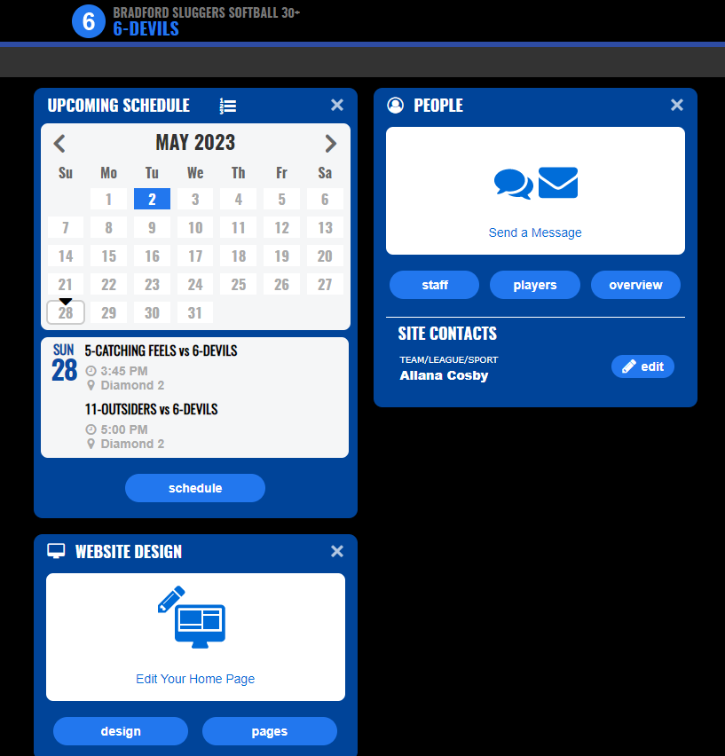

Your Team website gives you a view to your schedule, standings, and personalized messages for your team. To view your website, go to the right-hand corner at any time or click on websites on left hand side of the page in the admin view

-Your players will need to view full details from the website view as some players are getting an error message when they click schedule

You can customize your team website as you prefer



**Add your Players to your Roster for attendance tracking and granting access to the site**

1. 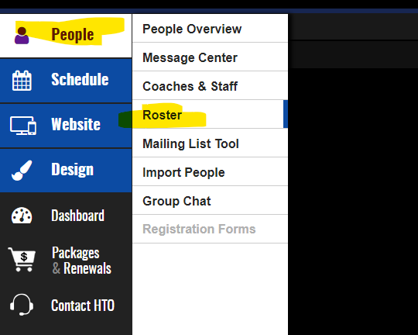Go to People> the Roster
2. Find the Add player button the left
3. Complete the name, email and mobile hit save on the next screen press edit player
4. Under status click send invite
5. Your player will not follow the activation steps from the email received
6. *If you have a spreadsheet with Players names and emails you can use the import people function*
7. *If you want to add another Staff member to your team, go to Coaches & Staff and find “add Staff” – If you cannot add a Coach or Staff contact Allana Cosby*

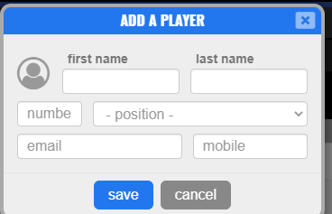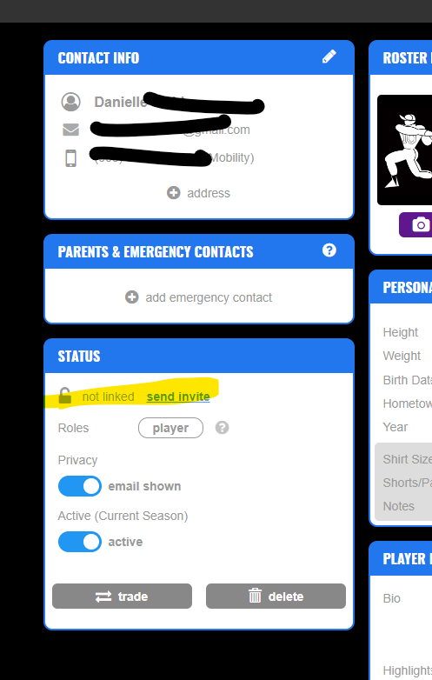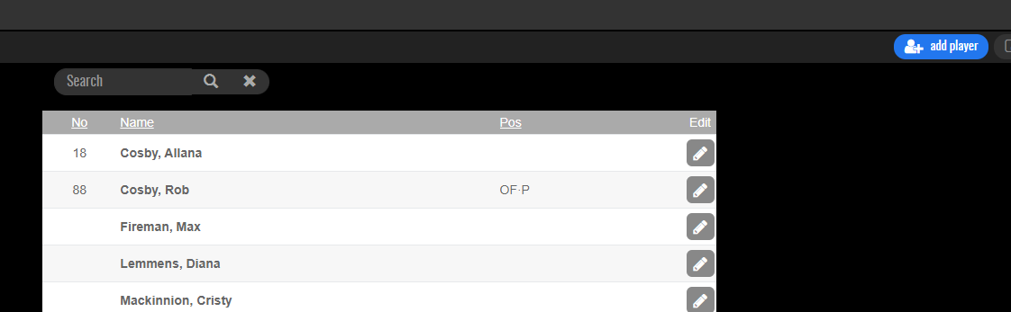**Add Scores**

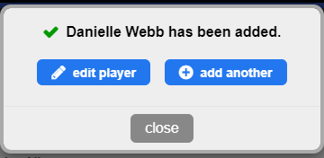

* As Captains with access you will be responsible for adding your scores within 24 hours to keep standings up to date
* First captain to enter the score will update the site for both teams.
  + The second captain can report a conflict or contact the scheduler for any issues.
  + Any issues that cannot be resolved will go to the Executive to review.
* 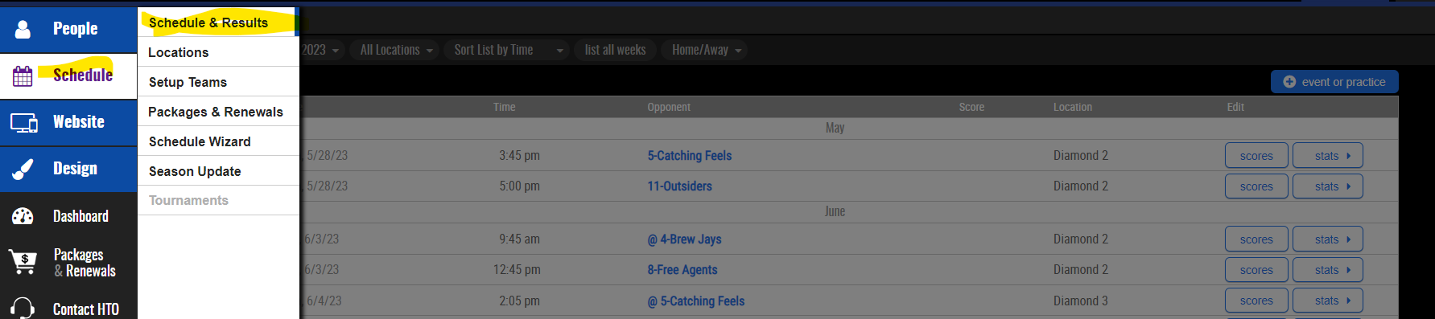Scores are entered under your admin view

Click on Schedule > Schedule & Results

The use the Scores button to report a score – A reminder will be sent after the May 28th game

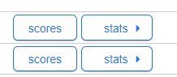

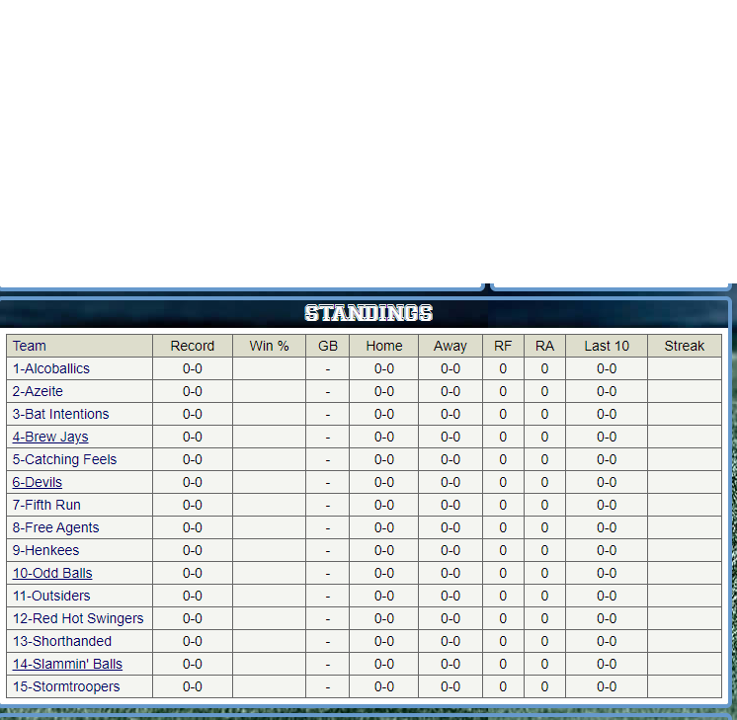**Standings will be maintained on the website automatically and will be up to the captains (Coaches & Staff) to keep their scores up to date**

League Website

[**www.sluggerssoftballbradford30plusleague.com**](http://www.sluggerssoftballbradford30plusleague.com/)

Click on the HTO graphic to log-in

**OR direct access - Login URL:** <https://www.hometeamsonline.com/sportswebsites/?p=login>

*\*some of the pages on the league website are secured; Please use this password: Sluggers1234*

*-You also have access to your own team website*

What you will find on the league page:

* League updates
* Schedule
* Link to this document
* Standings
* Scores
* News
* Event updates



**Subs****cribe to the Calendar**

Subscribe to Schedule is on the on the bottom right hand corner of the Visitor Schedule Page: <https://www.htosports.com/teams/default.asp?u=BRADFORDSLUGGERSSOFT&s=baseball&p=schedule> ==🡺 Filter to your own team first

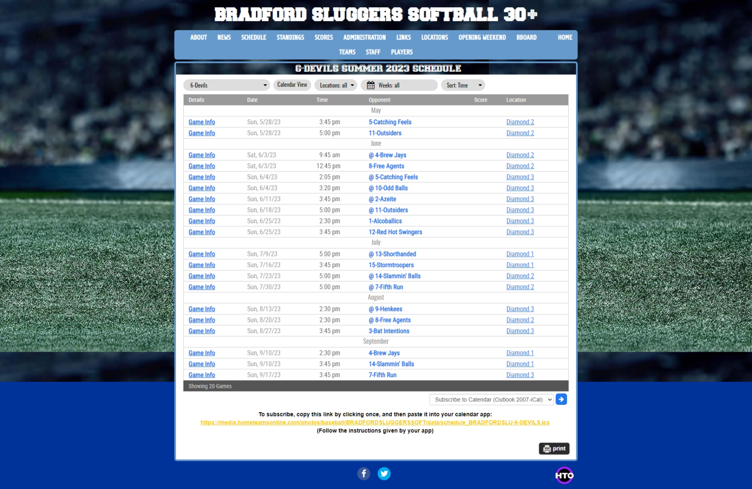

Please let us know if you have any questions or need further assistance. We are always willing to help. Use the help feature in the app as required