**Home Team Online (HTO)**

**Home Team Online User Guide – Bradford Sluggers Softball 30+ League**

Log-in

Quick Notes

Standings

Player information

League Website

Subscribe to your Calendar

[**www.sluggerssoftballbradford30plusleague.com**](http://www.sluggerssoftballbradford30plusleague.com/)

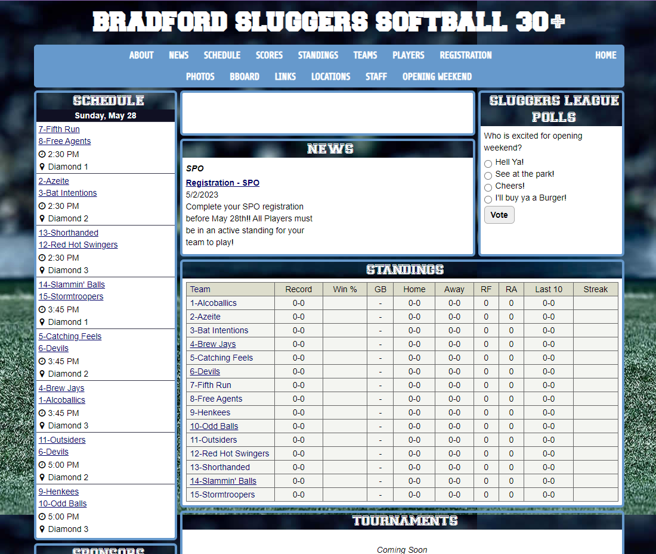

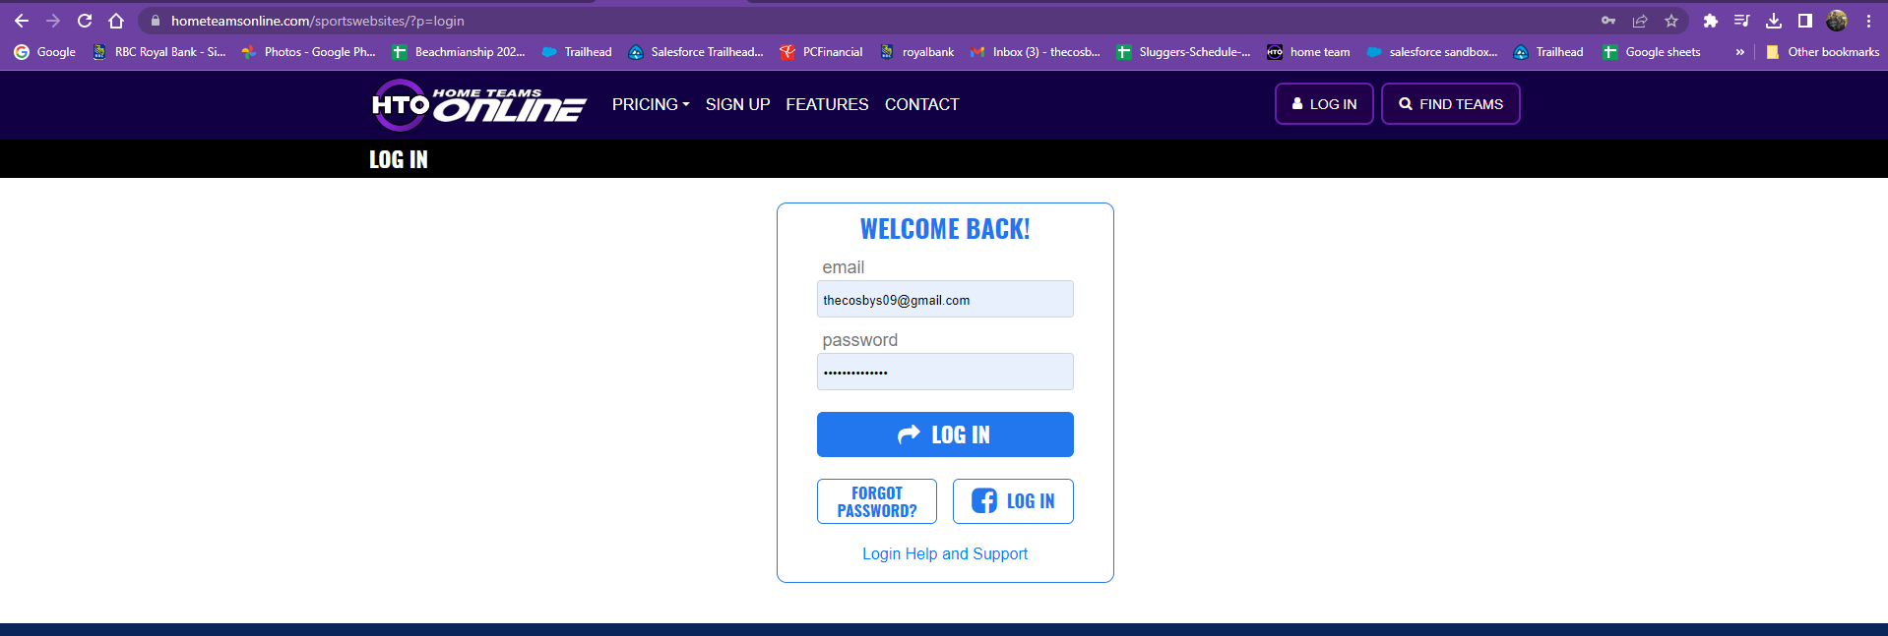

**Log-in info**

This is web-based platform and mobile friendly (there is no App)

Save the link on your phone to use from mobile

[**www.sluggerssoftballbradford30plusleague.com**](http://www.sluggerssoftballbradford30plusleague.com/)

Click on the HTO graphic to log-in

**OR direct access - Login URL:** <https://www.hometeamsonline.com/sportswebsites/?p=login>

*\*some of the pages on the website are secured use this password: Sluggers1234*

**Notes:**

**Accessing your team on Home Team Online

Quick notes as you get started:

* *Use the toggles at the top of the pages to change your views*
* *WEBSITE VIEW WILL GIVE YOU MORE ACCESS to information*

**

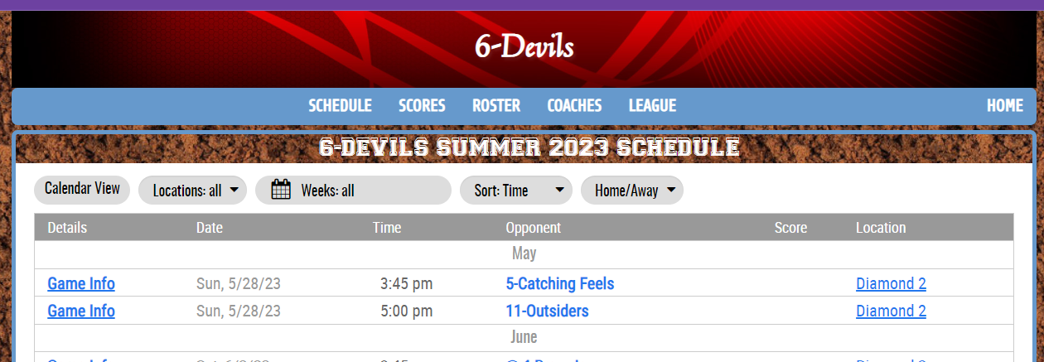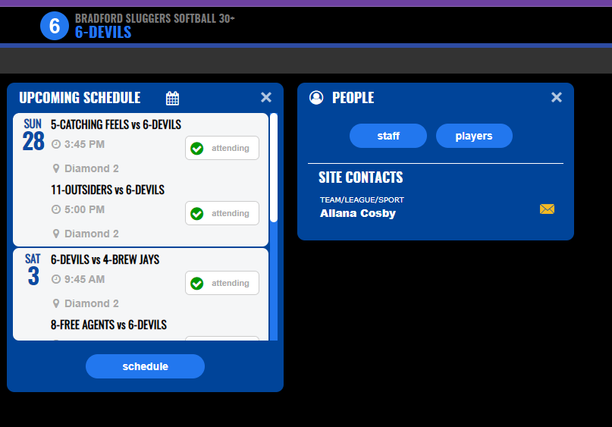Once you log-in: you are brought to a dashboard

Some players do not have access to the full Schedule when clicking the above button on their dashboard at this time. The error has been reported. PLEASE – **Go-to** the Website view and click on the schedule button.

– Under [links](https://www.htosports.com/teams/default.asp?u=BRADFORDSLUGGERSSOFT&s=baseball&p=links) or [administration](https://www.sluggerssoftballbradford30plusleague.com/teams/default.asp?u=BRADFORDSLUGGERSSOFT&s=baseball&p=custom&pagename=Administration) you will find a traditional excel copy of the schedule

Team communication with other staff members on your team or messaging to all players can be done in this section

Your Team website gives you a view to your schedule, standings, and personalized messages for your team. To view your website, go to the right-hand corner at any time or click on websites on left hand side of the page in the admin view

**- More information can be found from the website view than Admin HTO**

**Use the Gear icon to change any settings as required for your preferences.**

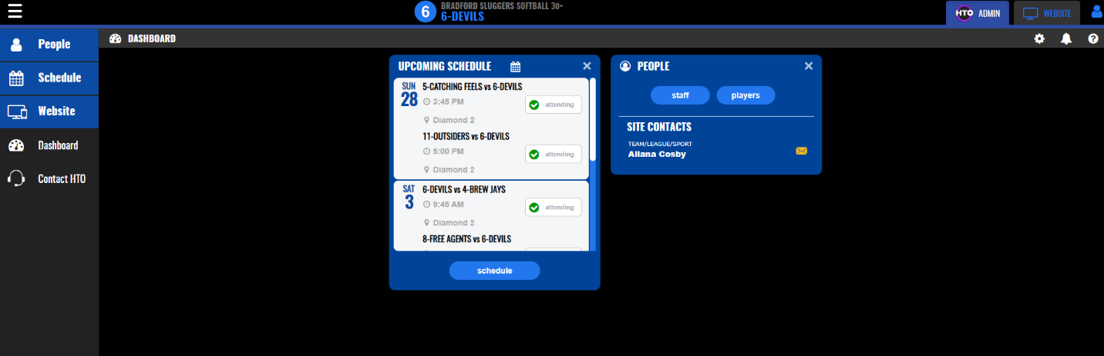

**Attendance**

1. From the Dashboard players can update their attendance for limited games
2. **Full Schedule and standing are found on the website view and continued ability for attendance tracking**

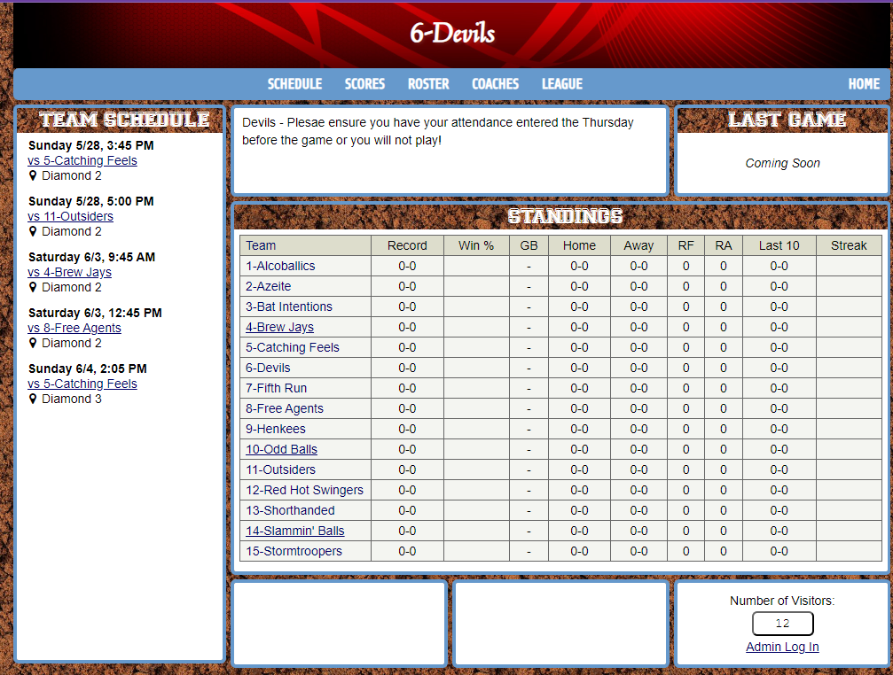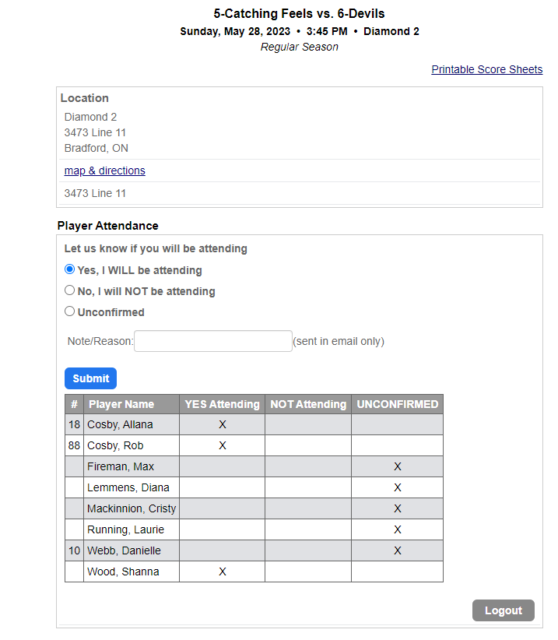3. Clicking on website on the side panel or at the top right will bring the player to your teams’ website. Players can also update their attendance by clicking game hyperlink. As we begin entering scores the standing will update for everyone.

Clicking on the League button will bring players to a league view of the standing and team information.



League Website

[**www.sluggerssoftballbradford30plusleague.com**](http://www.sluggerssoftballbradford30plusleague.com)

Click on the HTO graphic to log-in

**OR direct access - Login URL:** <https://www.hometeamsonline.com/sportswebsites/?p=login>

*\*some of the pages on the league website are secured; Please use this password: Sluggers1234*

*-You also have access to your own team website*

What you will find on the league page:

* League updates
* Schedule
* Link to this document
* Standings
* Scores
* News
* Event updates



**Subs****cribe to the Calendar**

Subscribe to Schedule is on the on the bottom right hand corner of the Visitor Schedule Page: <https://www.htosports.com/teams/default.asp?u=BRADFORDSLUGGERSSOFT&s=baseball&p=schedule> ==🡺 Filter to your own team first

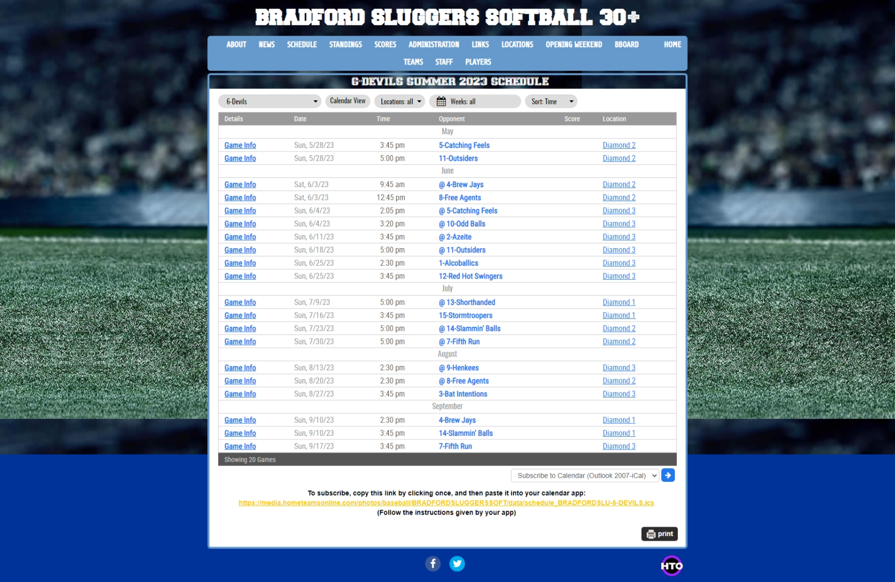

Please let us know if you have any questions or need further assistance. We are always willing to help. Use the help feature in the app as required