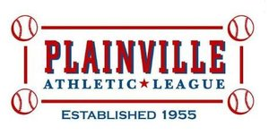 | 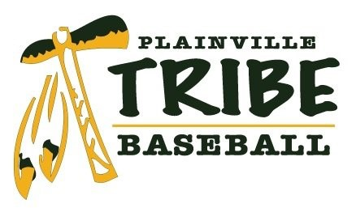

2016 KING PHILIP BASEBALL TOURNAMENT INSURANCE WAIVER

AS A REPRESENTATIVE FOR THE BELOW MENTIONED LEAGUE, I DO HEREBY WAIVE ANY CLAIM(S) AGAINST THE PLAINVILLE ATHLETIC LEAGUE OR ITS DIRECTORS, REPRENTATIVES AND ASSIGNS FOR ANY INJURIES OR LOSS THAT MAY RESULT DURING THE COURSE OF THE ABOVE-REFERENCED TOURNAMENT. I UNDERSTAND THAT EACH PARTICIPATING TEAM WILL BE RESPONSIBLE FOR PROVIDING THEIR OWN ACCIDENT AND LIABILITY INSURANCE, AND BY SIGNING BELOW, I CERTIFY THAT THE BELOW MENTIONED LEAGUE HAS ACCIDENT AND LIABILITY INSURANCE.

_________________________________________
SIGNATURE OF LEAGUE OFFICIAL

_________________________________________
TITLE

_________________________________________
DATE

_________________________________________
LEAGUE NAME

