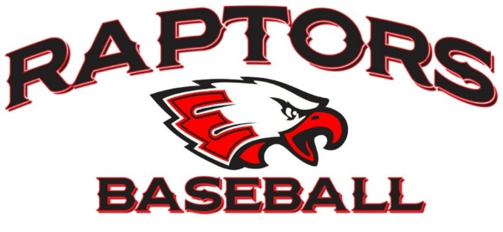

EAGLECREST HIGH SCHOOL
BASEBALL BOOSTER CLUB

NOMINATION FOR ADVISORY BOARD MEMBER
Please return the form to Tom McClanahan at t_mac19@yahoo.com by January 5, 2022

Name:

Connection to Program:

Contact Information
Phone Number:
Email Address:

What is your interest in serving on the Eaglecrest Baseball Advisory Board?

