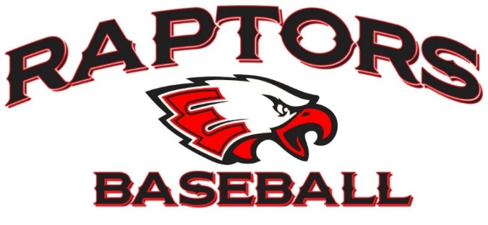

EAGLECREST HIGH SCHOOL
BASEBALL BOOSTER CLUB BYLAWS

ARTICLE I - NAME
The name of the organization shall be the Eaglecrest Baseball Booster Club and it is located at Eaglecrest High School, 5100 S. Picadilly, Aurora, CO 80015. The club shall be hereinafter referred to as The Booster Club.

ARTICLE II - DESCRIPTION OF ORGANIZATION
The organization is a voluntary, non-profit organization formed to support the Eaglecrest High School Baseball Team and all of its activities in a manner consistent with school policies. In addition, baseball players constitute an Auxiliary to the Booster Club which includes players from the past season until the new teams are formed. At that point, the players selected for the new season’s teams form the Auxiliary. An Auxiliary is defined as an association or organization which is subsidiary to another organization; is subordinate to the organization to which it is subsidiary; has as its primary purpose the support and assistance, particularly by donations and volunteer services, of the organization to which it is subsidiary; formally recognized as an adjunct by the organization to which it is subsidiary. Members of the Auxiliary have no voting rights, but are invited to attend Booster Club meetings at any time and may be required to attend, from time to time.

ARTICLE III - MISSION STATEMENT
The Booster Club is founded with the intent to provide a membership program for all people interested in supporting and developing a progressive baseball program for all levels of organized baseball at Eaglecrest High School. The Funds raised by the Booster Club, and/or its Auxiliary, shall be used to further the Eaglecrest Baseball Program. Specifically, money will be used for field improvements and maintenance, uniform purchases, as needed, and tournament expenses, as well as other miscellaneous expenses related to further the Eaglecrest Baseball Program. Funds from the Booster Club will also be used to foster and support youth baseball programs, as agreed upon by the membership.

ARTICLE IV - MEMBERSHIP
Membership in the Booster Club shall run from September 1 – 31 August of the following year. All families and friends of EHS baseball players as well as EHS baseball alumni may be members of the organization. Members must be present to cast a vote. Members in good standing, 19 years of age and older, shall have the privilege of the floor at meetings, the privilege of voting, the privilege of serving on the Advisory Board, and serving as a committee chair or volunteering in any capacity as determined by the Head Coach and or the Advisory Board.

ARTICLE V - MEETINGS/VOTING
The Booster Club values the active participation and the time commitment of each of its members. Members shall meet semi-annually (September and March) or in the case of a specific issue which necessitates the approval of the membership. The decision-making authority shall remain with the membership at large with all decisions made by a show of hands, unless a secret ballot is requested and agreed upon. The members in attendance at each publicized meeting shall constitute a quorum for the purpose of conducting Booster Club business. All members shall be notified by email, text, or other approved electronic method of regular meetings no later than seven days prior to each meeting, except in cases of emergency or short-notice meetings. In these cases, members shall be notified as soon as possible. All meetings are declared to be public meetings and are open to the general public at all times.

The Head Baseball Coach will appoint the President of the Booster Club on an annual basis. The term begins September 1 and ends on August 31st of the following year. An annual meeting will be held each year in September, at which time the appointment of no more than three (3) Advisory Board Members will be held conducted. Nominations for the Advisory Board need to be made prior to the meeting. The nominations will be reviewed by the Head Coach and the President of the Booster Club prior to the appointment to the Advisory Board in September or upon a vacancy in the position.

The agenda for each meeting will be prepared by the President and the Head Coach. Any individual wishing to submit an item for consideration on the agenda should contact the President.

ARTICLE VI – Advisory Board Responsibilities and Duties
The Booster Club Board shall consist of the President, Head Coach, and appointed Board Members.

- The Booster Club Advisory Board members shall determine policies and activities of the Booster Club and have general management duties pertaining to the club. All policies and activities of the club shall fall within the guidelines established by Eaglecrest High School for booster clubs. All actions taken by the Booster Club Advisory Board members will only concern the role, function and activities of the Booster Club.

2. The Officers of The Booster Club shall have the following duties:
- The President shall be the Executive Officer of the club and shall preside over all meetings of the club. The President shall perform such other duties as usually pertain to the office of the President or as directed by the Advisory Board, such as setting agendas, and coordinating with school administration.
- The Advisory Board Members shall act as the liaisons between the Committee Chairpersons and the Booster Club Membership.
- The Advisory Board will coordinate with the Head Coach for any activities requiring the participation of the coaching staff and or players.
- The Advisory Board members shall maintain a record of proceedings of all meetings, keep records of membership and attendance, papers, records, documents, and maintain official correspondence.

ARTICLE VII – Standing Committees

- Each Committee will have a Chairperson appointed by the Head Coach and the President of the Booster Club. The appointment will last for one year and may be renewed without term limits. The Chairperson is responsible for coordinating the actions of their committee with the President of the Booster Club and the Advisory Board.
- Rockies Ticket Sales Committee
- Banquet Coordinator
- Spring Concessions and Scoreboard Committee

ARTICLE VIII – By-Law Revision

The Booster Club Bylaws shall be reviewed bi-annually at the September meeting. These bylaws may be amended by a vote of two-thirds of the voting members who are present. All voting members have one vote (see Article IV above for more information).

ARTICLE IX - DISBURSAL OF FUNDS
Request for the disbursal of funds to purchase merchandise, pay for services and supplies, or for other valid club purposes shall be submitted to the Bookkeeper for consideration. The Head Coach may, as he feels necessary, submit a budget for specific purposes (i.e., field maintenance, uniform purchases) to be approved by the membership. Coaches may submit for reimbursement for any items that have prior authorization and are accompanied by receipts.
Summer baseball expenses should be completely covered by summer player fees. These expenses include but are not limited to umpires, uniforms, field materials, league & tournament fees, baseballs, & coaches’ stipends.

ARTICLE X - DISSOLUTION
The Booster Club shall have an indefinite existence until dissolved as hereinafter provided. In the event of dissolution, the remaining balances of funds shall be allocated to the EHS Baseball Activity Fund at Eaglecrest High School. In no case shall funds be disposed of in a manner inuring to the benefit of any member.

Revision History
For the Bylaws of
EAGLECREST HIGH SCHOOL BASEBALL BOOSTER CLUB.

The current version of the Eaglecrest High School Baseball Booster Club Bylaws was approved by the membership on June 8, 2018. The table below articulates details about those revisions.

Revision Approval Date | Article Revised | Description of Revision | Approved By
June 8, 2018 |  | Not documented | Board
November 30, 2021

