**2025 JUNIOR LEAGUE SOFTBALL EAST REGION TOURNAMENT**

**July 16th-July 22nd**

**Hosted by Pennsylvania District 16/31 Little League**

**HOST SITE: WILKES UNIVERSITY RALSTON COMPLEX SOFTBALL STADIUM**

**District 16/31 Administrator & Tournament Director**

**Robert Bertoni**

**Assistant Tournament Director**

**Phil Schoener**

**Tournament Umpire-In-Chief**

**Chris Thomas**

**District & Tournament Website**

[**www.padistrict16-31.com**](http://www.padistrict16-31.com)

**Contacts**

**District 16-31 DA & Tournament Director**

**Robert Bertoni**

[**Rab4um@aol.com**](mailto:Rab4um@aol.com)

**Phone- 570-574-5075**

**Assistant Tournament Director**

**Phil Schoener**

[**pschoener@hotmail.com**](mailto:pschoener@hotmail.com)

**Phone- 570-905-6902**

**Umpire-In-Chief**

**Chris Thomas**

**Butterpsu95@aol.com**

Dear Managers,

On behalf of Pennsylvania District 16/31, we extend our warmest congratulations to you, your players, and your coaches on your remarkable achievement in winning the State, Section, and District Championships. We are thrilled to welcome you to the East Region Junior Softball Championship tournament hosted at Wilkes University.

As you prepare for this exciting event, we have compiled an information packet that contains everything you need to make your experience as smooth as possible. You can access the packet and all related information on our District website: [www.padistrict16-31.com](http://www.padistrict16-31.com).

**Here’s a quick overview of what you’ll find:**

**- Information Packet**

**- Team Registration and Coaches Meeting Information**

**- Directions to Wilkes University Softball Field\**

**- Special Events Schedule**

Please remember to check the website frequently, as we will be updating it daily with additional information regarding the tournament.

It is important to note that no team will be allowed to compete without first submitting all necessary documentation. This includes a properly completed affidavit, boundary map, residency documents, and any required waivers. If you have any questions or concerns about the required documentation, please reach out to your District Administrator as soon as possible.

At Pennsylvania District 16/31 and Wilkes University, we believe that sportsmanship is key to a positive tournament experience. We adhere strictly to the Little League Official Regulations and Playing Rules, especially regarding rule XIV (a) - Field Decorum. All participants—including players, managers, coaches, umpires, and league officials—are expected to exhibit exemplary conduct. Any incidents of unsportsmanlike behavior will be addressed promptly, and we ask that coaches help manage the conduct of their fans.

We are looking forward to a thrilling tournament filled with competitive spirit, teamwork, and camaraderie. Thank you for your commitment, and most importantly, have fun and play hard!

**Tournament Rules and Procedure Highlight**

* **The East Regional will be a double elimination tournament.**
* **Playing rules will be per Little League Junior Softball Tournament Rules. All rules will be strictly enforced by the Tournament Staff and Umpires.**
* **All teams will submit their eligibility affidavits to the Tournament Director prior to the start of the tournament. These affidavits must be verified (and signed) immediately following each game and will be returned to each team at the end of the tournament.**
* **The tournament director and staff reserve the right to change game dates and starting times due to inclement weather.**
* **The home team for each game will be determined by the toss of a coin at the Coaches Meeting at the start of the tournament.**
* **The home team for each game will have 15 minutes of fielding practice 60 minutes before the start time of the game. The visiting team for each game will have 15 minutes of fielding, 45 minutes before the start time of the games. These times may be shortened to stay with the scheduled game times.**
* **The team manager is responsible for uniforms and equipment and all players must be in uniform with the Little League-approved patch.**
* **Players, managers, and coaches who become involved in any misconduct, on or off the field, or at their lodging, may be dismissed from the tournament. The activity and person will be reported to Little League Headquarters Tournament Committee, the parent league, DA, and the League President.**
* **Only Managers, Coaches, and Players listed on the official tournament eligibility affidavit are permitted in the dugout or playing field. Under no circumstances will coaching (or assistance to coaches) be permitted by anyone outside of the dugout area during games.**
* **Game balls will be supplied by the Host District.**
* **Both teams will line up as directed by the tournament director when introduced and remain there for the National Anthem and Little League Pledge.**
* **Both teams will meet at the home plate area immediately after the game and shake hands.**
* **After the tournament, the East Region Champ will be awarded the East Regional Tournament Championship Flag and move on to the Junior League Softball World Series in Washington.**

**Immediately Following the State Tournament Win**

**Once your team has won the State Tournament, please contact Robert Bertoni (**[**rab4um@aol.com**](mailto:rab4um@aol.com)**) (Phone- 570-574-5075 with the following information:**

* **Team Photo with your state Championship Banner**
* **Complete Team Registration Form**
* **Completed Background Checks for Managers and Coaches**
* **Team Roster with Names and Jersey Numbers**

**Please complete the following forms and submit them to Robert Bertoni as soon as possible:**

* **Banquet Registration Form**

**GAMES LIVE-STREAMED ON WEBSITE:** [**www.padistrict16-31.com**](http://www.padistrict16-31.com)

**CHAMPIONSHIP BANQUET REGISTRATION FORM**

PA DISTRICT 16-31 LITTLE LEAGUE WILL BE HOSTING A CHAMPIONSHIP BANQUET ON WEDNESDAY, JULY 16th, 5PM AT THE WOODLANDS INN AND RESORT. A DANCE WILL BE HELD IN THE NIGHTCLUB FOR ALL PLAYERS AND FAMILIES BEGINNING AT 7PM. THIS IS MANDATORY FOR ALL PLAYERS, MANAGERS, AND COACHES.

PLAYERS AND MANAGER, PLUS 2 COACHES, ARE FREE. FAMILY MEMBERS WISHING TO ATTEND THE FEE IS $45.00.

**CHAMPIONSHIP BANQUET:**

**TEAM NAME: ________________________________**

**ATTENDEES ADMITTED FREE OF CHARGE:**

**NUMBER OF PLAYERS: _______**

**MANAGER/2 COACHES: _______**

**TOTAL:                               _______**

**ADDITIONAL ATTENDEES: _______**

**TOTAL NUMBER OF ADDITIONAL TICKETS = ________**

**@45.OO PER TICKET**

**TOTAL AMOUNT DUE FOR BANQUET         = ________**

* **MAKE CHECKS OUT TO PA DISTRICT 16-31 LITTLE LEAGUE**
* **\*\*EMAIL FORM TO ROBERT BERTONI** [**Rab4um@aol.com**](mailto:Rab4um@aol.com)

**TEAM REGISTRATION FORM**

STATE- _____________________   SECTION- ________      DISTRICT-___________

LEAGUE NAME-_________________________________________________________

**(PLEASE TYPE OR PRINT)**

                             PLAYER’S NUMBER                                                      PLAYER’S NAME

1.

2.

3.

4.

5.

6.

7.

8.

9.

10.

11.

12.

13.

**MANGER- ______________________________________________ CELL PHONE- _______________**

**COACH- ______________________________________________ CELL PHONE- _______________**

**COACH-    ______________________________________________  CELL PHONE- _______________**

**LEAGUE PRESIDENT- _____________________________________CELL PHONE- _______________**

**DISTRICT ADMINSTRATOR- _______________________________  CELL PHONE- ______________**

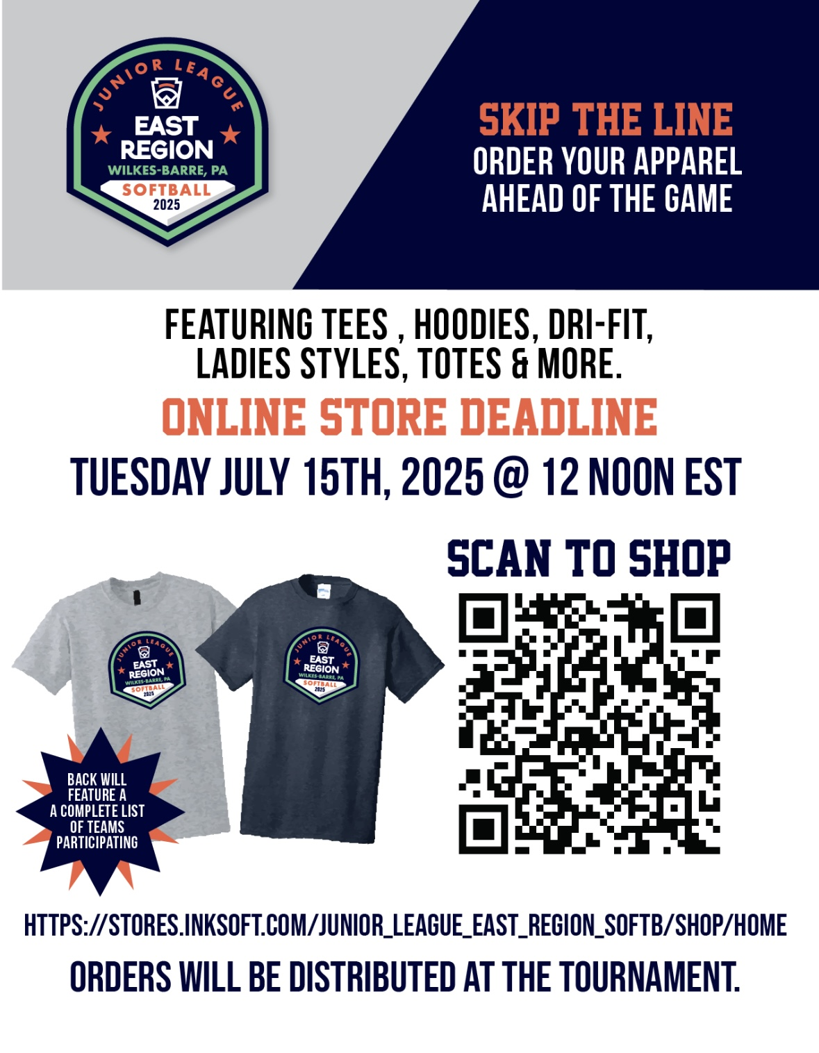

**HOST SITE: WILKES UNIVERSITY RALSTON COMPLEX SOFTBALL STADIUM**

**Opened in 2006, the softball stadium at the Ralston Athletic Complex offers lights, an outdoor batting cage, two bullpens, large dugouts, excellent seating views, and an elevated press box located directly behind home plate.**

**Ralston Athletic Complex - Wilkes University, 302 Northampton St, Edwardsville, PA**

**Wilkes Softball Website: https://gowilkesu.com/sports/softball**

**HOTEL ACCOMODATIONS**

**Holiday Inn Wilkes-Barre**

**600 Wildflower Dr.**

**Wilkes-Barre, Pa. 18702**

**570-822-1011**

**70 rooms available**

**Group code for phone reservations is: SRT**

**Booking link for online reservations is:** [**https://tinyurl.com/JuniorLeagueSoftball**](https://tinyurl.com/JuniorLeagueSoftball)

**Rate is $139.00 per night**

**Courtyard Wilkes-Barre Arena**

**879 Schechter Drive**

**Wilkes-Barre, Pa. 18702**

**1-888-557-8740**

**30 rooms available**

**Group Code SMERF**

**Rate is $139.00 per night**

**Once these hotels are full reach out to Bob Bertoni for other options.**

**AREA ATTRACTIONS AND RESTAURANTS**

* **Wyoming Valley Mall**
* **Mohegan Sun Casino and Racetrack**
* **SWB RailRiders Baseball Team**
* **Buffalo Wild Wings**
* **Longhorns**
* **Outback**
* **Olive Garden**
* **Five Guys**
* **Dairy Queen**
* **TGIF**
* **Chuckie Cheese**
* **Red Robin**
* **Logans**
* **Montage Water Park**

**Please Check Out:** www.tournepa.com **for more Info on NEPA**

**Things to See and Do in Northeastern Pennsylvania**

**Plan to visit Luzerne County in scenic Northeast Pennsylvania when looking to take a short getaway or just get out and do something. Whether you plan to visit Wilkes-Barre, Hazleton or points- in-between, there is always something going on. Outdoor recreation is bountiful and offers various scenery and activities for different skill levels. History is all around Luzerne County, from the various monuments to the many living reenactments. Area hotels offer various packages when you want to visit and stay overnight in Luzerne County. Packages typically include overnight accommodations, attractions, activities, or events while visiting Wilkes-Barre, Hazleton, and various smaller communities. Festivals around the region are occurring year-round with an emphasis from spring to fall.**

|  |
| --- |
|  |
|  |  |

**Visiting Wilkes-Barre, PA, Luzerne’s county seat, continues to revitalize the downtown with restaurants, pubs and a new urban park. The River Common offers 12 miles of trails for bikers, joggers, walkers, and roller bladers along the Susquehanna River. It is not uncommon to see kayakers paddling by the city. The River Common is host to many local events including Riverfest in June when 100’s of kayakers adorns the banks of Nesbitt Park.**

**Visiting Wilkes-Barre and Hazleton in Luzerne County is easy; conveniently located within easy driving distance to many cities in the Northeast and Mid-Atlantic. Reach Luzerne County via Interstates 81, 80, 84, 476 (Pennsylvania Turnpike) and Routes 309 and 115.**

**Medical Facilities**

**Geisinger Wyoming Valley Medical Center**

**1000 E. Mountain Blvd Wilkes-Barre, PA**

**( 570)808-7300**

**Wilkes-Barre General Hospital**

**575 North River Street**

**Wilkes-Barre, PA 18764**

**Phone: (570) 829-8111**