**Girl’s Major Softball**

**2025 Pennsylvania State Tournament**

Wednesday, July 9th - Tuesday, July 15th

Hosted by Pennsylvania District 16/31 Little League

Nanticoke Area Little League

Nanticoke, Pennsylvania



District 16/31 Administrator and Tournament Director

Robert Bertoni

Nanticoke Area Little League Player Agent

Jennifer Peluszak

Assistant Tournament Director District 16/31 Umpire-in-Chief

Heather Spudis Dave Baker

Dave Buchinski

District & Tournament Website:

[www.padistrict16-31.com](http://www.padistrict16-31.com)

Dear Manager,

If you are receiving this letter you made it to States! Congratulations to you, your players and coaches on your success to date and best of luck throughout the remainder of the tournament. Pennsylvania District 16/31 and Nanticoke Area Little League are looking forward to being your host and providing a memorable experience.

You’ll find everything you need on our District website: [www.padistrict16-31.com](http://www.padistrict16-31.com), including:

* Team Registration/Coaches Meeting Information
* Directions from area hotels to Nanticoke Area Little League
* Special Events Schedule
* Game Updates and Live Streaming Information

**\*\*The website will be updated regularly before and during tournament play so please check for updates\*\***

Should you have any questions with anything pertaining to the tournament, please do not hesitate to contact the Tournament Director, Assistant Tournament Director, or the Player Agent of Nanticoke Area Little League (contact information contained in this packet).

Teams will not be permitted to compete until their documentation has been submitted, verified, and approved (tournament affidavit, boundary map, residency documentation, coaching clearances, and necessary waivers). Please see your District Administrator immediately if you are unclear on any matters related to required documentation.

Pennsylvania District 16/31 and Nanticoke Area Little League strongly believe that all games are to be decided on the field by the players in accordance with the Little League Official Regulations and Playing Rules. In particular, rule XIV (a) – Field Decorum will be strictly enforced:

***The actions of players, managers, coaches, umpires, and league officials must be above reproach. Any player, manager, coach, umpire, or league official who is involved in a verbal or physical altercation, or an incident of unsportsmanlike conduct at the game site or any other Little League activity is subject to disciplinary actions by the local league board of directors.***

Unsportsmanlike conduct by players, managers, coaches, or fans from the opposing team to disrupt the play of any player, especially the pitcher, will not be tolerated and will be dealt with immediately. Managers are expected to control the behavior of their team and fans.

Thank You – HAVE FUN, PLAY HARD!

District 16/31

**General Information**

Contacts

District 16/31 Administrator and Tournament Director - **Robert Bertoni**

Cell Phone: 570-574-5075 Email: [Rab4um@aol.com](mailto:Rab4um@aol.com)

Assistant Tournament Director – **Heather Spudis**

Cell Phone: 570-574-2860 Email: [hjg2446@gmail.com](mailto:hjg2446@gmail.com)

District 16/31 Umpire-in-Chief – **Dave Baker**

Cell Phone: 570-574-6730 Email: [Davidabaker90@gmail.com](mailto:Davidabaker90@gmail.com)

District 16/31 Umpire-in-Chief – **Dave Buchinski**

Cell Phone: 570-262-5970 Email: [eagles1buzz@gmail.com](mailto:eagles1buzz@gmail.com)

Nanticoke Area Little League Player Agent – **Jenn Peluszak**

Cell Phone: 570-814-6249 Email: mzjenn78@gmail.com

Tournament Liaisons

Each team is assigned a Nanticoke Area Little League representative who will help guide them throughout the week to help with anything they may need. Liaisons will reach out prior to your arrival to introduce themselves and answer any questions you may have.

**Section 1**: Jill Stankoski 570-592-4063 **Section 2:** Shannon Bonham 570-417-4165

**Section 3**: Jennifer Peluszak 570-814-6249 **Section 4:** Shanan Mitchell 570-814-9756

**Section 5:** Dee Werner 570-855-2589 **Section 6:** Kristen Spencer 570-417-9658

**Section 7**: Erika Jacobs 570-905-5630 **Section 8:** Jayme Kirshner 570-902-5075

Tournament Site

**Nanticoke Area Little League**

750 East Union Street Nanticoke, Pennsylvania 18634

Emergency/Medical Information

**Commonwealth Health Wilkes-Barre General Hospital**575 N River St, Wilkes-Barre, PA 18765 570-829-8111

**Geisinger Wyoming Valley Medical Center**1000 E Mountain Blvd, Wilkes-Barre, PA 18711 570-808-7300

**Geisinger South Wilkes-Barre Urgent Care**  
25 Church Street, Wilkes Barre, PA 18765 570-808-3100

**Med Express Urgent Care**  
276 Narrows Shopping Center, Edwardsville, PA 18704 570-283-0791

**General Information**

**(continued)**

Conduct

Gross misconduct will not be tolerated and will result in a strong recommendation to the Williamsport Tournament Committee for removal of the individual or team from the tournament.

Schedule

The tournament will be played on an eight (8) team double elimination basis.

Transportation

All teams will be responsible for their transportation to the tournament sites and return to their own league.

Accommodation

All teams will be responsible for obtaining their own sleeping arrangements. A list of accommodations in the area provided in this packet on page 10.

Uniforms and Equipment

Uniforms and equipment will be the responsibility of the participating teams. All equipment must be Little League specifications. Equipment will be inspected by the tournament umpires prior to each game. The host league will cooperate and assist with any problem concerning equipment.

Medical Release Affidavits

Each team will be required to have in their possession a Medical Release certificate for each player on their affidavit. The form shall have been signed by the player’s parent or legal guardian.

Live Streaming

All games will be live streamed – information on accessing games will be posted on the district website – [www.padistric16-31.com](http://www.padistric16-31.com).

Concessions

Nanticoke Area Little League will have a fully operational concession stand with a large assortment of food and beverages. Credit cards are accepted along with cash and VENMO. Additionally, food will be available for players after each game in an area near the concession stand.

Tournament T-Shirts

An online store will be posted on the district website to pre-order tournament t-shirts. A limited amount will also be available for purchase.

Registration/Affidavit Verification

Registration for the tournament will be held on Tuesday July 8th – 4:00pm at the Nanticoke Area Little League Complex

Each team will be required to present their official tournament affidavit, complete residency verifications, boundary map, copies of birth certificates, medical release forms, required waivers, and clearances for the manager and coaches. Documentation will be reviewed by District 16/31 staff.

Manager/Coaches Meeting

A mandatory meeting for all managers and coaches will be held on Tuesday July 8th – 4:00pm at the Nanticoke Area Little League Complex.

Each team will be provided with additional information regarding the tournament logistics, rules, etc.Teams will also have the opportunity to schedule practice times for the week.

Opening Ceremony

The opening ceremony and player celebration will be held on Tuesday July 8th – 6:00pm at the St. Faustina Parish Grove, which is less than 10 minutes away from the tournament site. Your tournament liaison will provide you with additional details on purchasing tickets.

Tournament Rules

2025 Little League Tournament rules will apply as published by Little League Inc., along with regular season rules. Tournament rules supersede regular season rules.

All teams will submit their eligibility affidavits to the Tournament Director prior to the start of the tournament. The affidavit must be verified and signed immediately after each game.

The Tournament Director and staff reserve the right to adjust game dates and starting time due to inclement weather or unforeseen issues.

The team manager is responsible for uniforms and equipment (equipment will be checked by the Umpire-in-Chief prior to each game). Players must be uniform with the Little League approved patch. Managers and coaches shall dress neatly.

Only the manager, two (2) coaches, and players listed on the official tournament eligibility affidavit are permitted in the dugout or on the playing field.

The following is prohibited on the Nanticoke Area Little Complex

*All smoking and use of tobacco products, including the use of e-cigarettes and vaporizer   
*Alcohol   
*Pets with the exception of certified service animals  
*Noisemakers (thunder sticks, air horns, etc…)  
*Tarps, Tents, or Canopies  
*Beach umbrellas (small umbrellas 42” or less will be permitted)  
*Weapons of any kind/self-defense to include Pocket Knives or Guns and utility knives with blades

All game balls will be supplied by Nanticoke Area Little League.

Batting cages will be available for both teams two (2) hours prior to each game time. Practice fields will also be available in between games for teams.

The home team for each game will be determined by the toss of a coin at the Coaches Meeting prior to the start of the tournament.

The home team for each game will have 15 minutes of fielding practice 60 minutes prior to the start time of the game. The visiting team will have 15 minutes of fielding practice 45 minutes prior to the start time of the game. These times may be adjusted, and warmups may or may not be on the game field.

Teams listed at the top of the bracket will be in the first base dugout/teams listed at the bottom of the bracket will be in the third base dugout.

Players, managers, and coaches that become involved in any misconduct, on or off the field, may be dismissed from the tournament.

Both teams will line up as directed by the Tournament Director when introduced and remain there for the National Anthem and Little League Pledge.

Both teams will meet at the home plate area immediately at the end of the game and shake hands.

Each player, manager, and coach will be given an official State Tournament Pin courtesy of the host league. At the conclusion of the tournament, the winning team will be awarded a State Championship Flag.

Team Registration Form

**Important:** Please email this completed form to [Rab4um@aol.com](mailto:Rab4um@aol.com) by Tuesday, July 1st

|  |  |
| --- | --- |
| League Name: |  |
| Pennsylvania District: |  |
| Pennsylvania Section: |  |
| League President: |  |
| District Administrator: |  |
| Manager’s Name: |  |
| Manager’s Cell Phone: |  |
| Assistant Coach’s Name: |  |
| Assistant Coach’s Name: |  |

|  |  |
| --- | --- |
| Player Number | Player Name |
|  |  |
|  |  |
|  |  |
|  |  |
|  |  |
|  |  |
|  |  |
|  |  |
|  |  |
|  |  |
|  |  |
|  |  |

Tournament Activity Schedule

|  |  |  |  |
| --- | --- | --- | --- |
| **Monday** | **July 7th th** | Section Champions - Team Information Due | Email to [Rab4um@aol.com](mailto:Rab4um@aol.com) |
|  | | | |
| **Tuesday** | **July 8th** | Team Registration | 4:00 PM |
|  |  | Coaches Meeting | 4:00 PM |
|  |  | Opening Ceremony/Banquet | 6:00 PM |
|  | | | |
| **Wednesday** | **July 9th** | Game | 10:00 AM |
|  |  |  | 1:00 PM |
|  |  |  | 4:00 PM |
|  |  |  | 7:00 PM |
|  | | | |
| **Thursday** | **July 10th** | Game | 10:00 AM |
|  |  |  | 1:00 PM |
|  |  |  | 4:00 PM |
|  |  |  | 7:00 PM |
|  | | | |
| **Friday** | **July 11th** | Game | 4:00 PM |
|  |  |  | 7:00 PM |
|  | | | |
| **Saturday** | **July 12th** | Game | 1:00 PM |
|  |  |  | 4:00 PM |
|  | | | |
| **Sunday** | **July 13th** | Game | 1:00 PM |
| **Monday** | **July 14th** | Game | 1:00 PM |

2025 Pennsylvania State Softball Little League Tournament Bracket

**Winner’s Bracket**

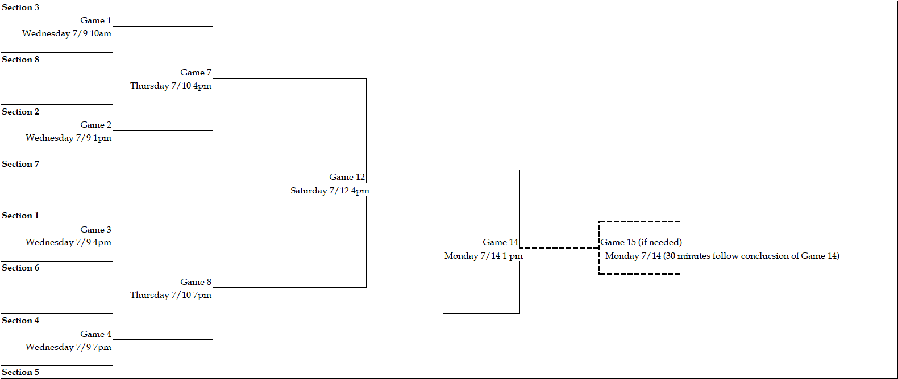

**Elimination Bracket**

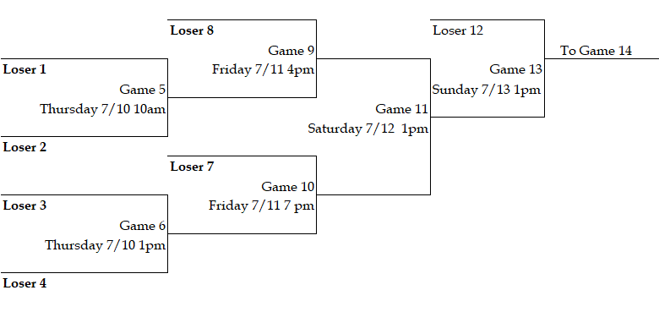

Accommodations

*Designates hotels with blocked rooms and special rates with anticipation of more to come.

Check out [www.padistrict16-31.com](http://www.padistrict16-31.com) for updates

**\*Home 2 Suites by Hilton** \***Courtyard by Marriott**

872 Schechter Dr. 879 Schechter Dr.

Wilkes-Barre Township, PA 18702 Wilkes-Barre Township, PA 18702

570-821-0777 570-235-6700

**\*Holiday Inn Express / IHG Hotel** **\*Hampton Inn and Suites**

1063 PA 315 876 Schechter Drive

Wilkes-Barre PA 18702 Wilkes-Barre Township, PA 18702

570-825-3838 570-824-1005

**(Hotel Block) US CODE SST for   
Tournament Rate**

Area Attractions and Things to Do

**Informational Websites**

<https://discovernepa.com/regions/valley-communities/nanticoke/>

<https://www.visitluzernecounty.com/>

**Sports**

Scranton Wilkes-Barre Railriders (<https://www.milb.com/scranton-wb>)

**Outdoor Activities**

Garden Drive-In- 20 US-11, Hunlock Creek, PA 18621

Pisano Winery- 2112 PA-29, Hunlock Creek, PA 18621

Lands at Hillside Farms - 65 Hillside Rd, Shavertown, PA 18708

Moon Lake State Forest and Recreation Area- 196 Moon Lake Road, Hunlock, PA 18621

Pike’s Creek Raceway and Mini Golf - 2542 PA-118, Hunlock Creek, PA 18621

**Indoor Activities**

Alden Axe Company 26 E. Kirmar Ave, Nanticoke, PA 18634

Chacko’s Family Bowling - 195 North Wilkes-Barre Blvd, Wilkes-Barre, PA 18702

Nova Trampoline Park - 1080 Wyoming Ave, Wyoming, PA 18644

Movies 14- 24 East Northampton Street, Wilkes-Barre PA 18701

Long Live Playtime 75 South Wyoming Ave. Suite 5, Edwardsville, PA 18704 ( ages 7 and under)

**Places to Eat Near Nanticoke Area Little League**

Marty’s Blue Room- 100 Old Newport St. Nanticoke, PA 18634 (Reservations Recommended)

R Bar and Grill-119 East Kirmar Ave, Nanticoke, PA 18634

Mil & Jim’s Parkway Inn- 24 West Kirmar Ave, Nanticoke, PA 18634

Stookey’s Famous Bar-B- Que- 122 East Poplar Street, Nanticoke, PA 18634

Morris Family Restaurant- 72 East Poplar Street, Nanticoke, PA 18634

Ruby’s Inn- 109 Epsy Street, Nanticoke, PA 18634

Antonio’s Pizza- 204 East Main Street, Nanticoke, PA 18634

Nardozzo’s Pizzeria- 145 East Main Street, Nanticoke, PA 18634

Passetti Hometown Deli- 400 Middle Road, Nanticoke, PA 18634

Picosita Taco’s- 185 South Market, Nanticoke, PA 18634

Grateful Roast Café and Coffee Roaster- 75 North Market Street, Nanticoke, PA 18634

Dragon’s Brew Drive thru Coffee- 443 West Main Street, Nanticoke, PA 18634

Murt’s Bake Shoppe- 153 South Market Street, Nanticoke, PA 18634

Sanitary Bakery- 126 East Ridge Street, Nanticoke, PA 18634

Nepa’rogi- 164 South Market Street, Nanticoke, PA 18634

Tarnowski Kielbasa- 579 East Main Street, Nanticoke, PA 18634

Dream Whip Ice Cream- 2 Alden Road, Nanticoke, PA 18634

**Flowers and Gifts Near Nanticoke Area Little League**

Barbara’s Custom Floral Creations- 1 Old Newport Street, Nanticoke, PA 18634

Sawdust Sixty Six – sawdustsixtysix.com and check out their Facebook page for locally customized made items. (Order a head of time to have something special ready for your team or player)