Hegewisch 30's Baseball
2026 Player Application
Application Deadline: APRIL 11, 2026 (subject to change)

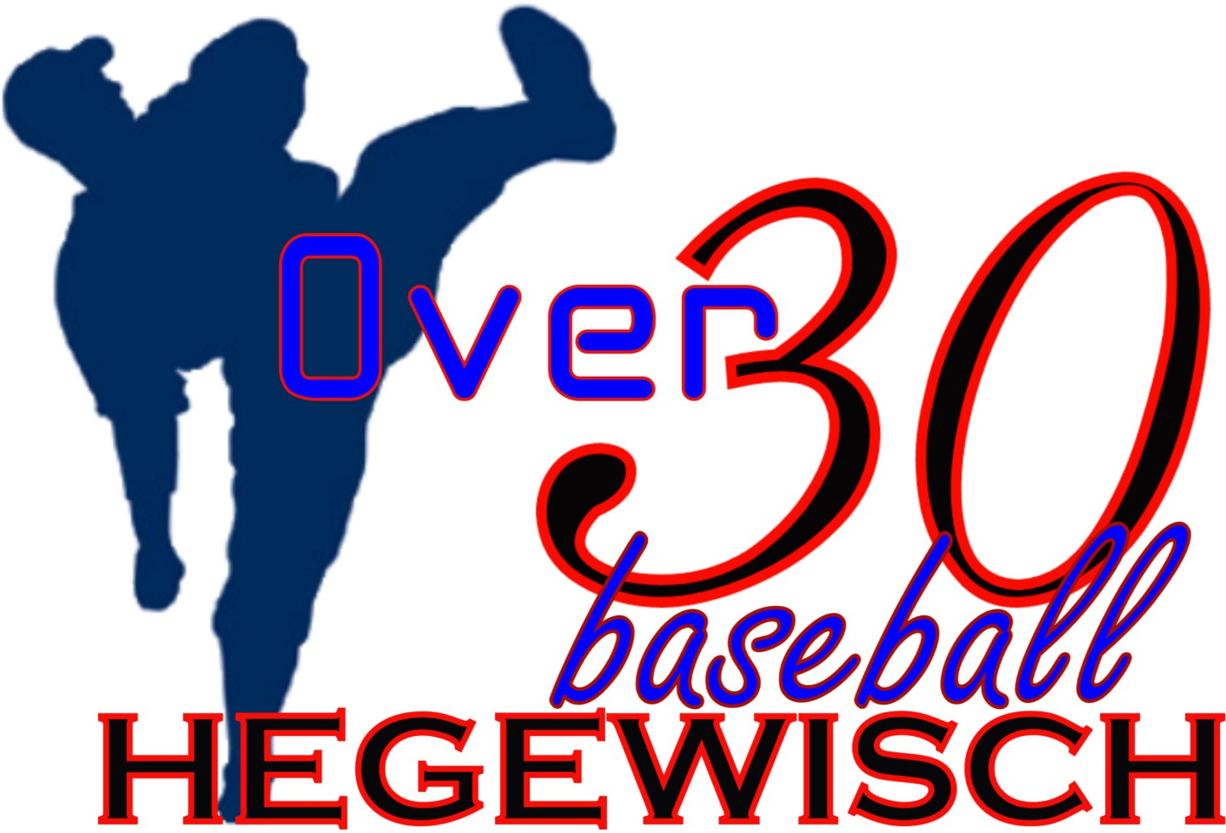
Please fill in ALL blanks LEGIBLY. All Information is for league purposes only and not disseminated to other parties.
FIRST NAME: |  |  | LAST NAME:
ADDRESS:
CITY: |  |  | STATE: |  |  | ZIP:
PHONE 1: |  | DOB:
EMAIL ADDRESS:
Please ensure the email address is written clearly and correctly. |  |  |  | ARE YOU A NEW PLAYER?  YES NO
IMPORTANT INFORMATION
- This is a draft league! There is no guarantee you will be on a certain team.
- Once the draft is over, everyone is locked in and there are no refunds.
- Once the draft is completed, anyone not drafted will be refunded in full.
- The league rules are available on our website. All players are required to read and follow these rules.
- Players will receive a uniform of a shirt and hat.
- A regular season will be played with playoffs.
- This is a wooden bat league.
- Prorated refunds may be available due to extenuating circumstances.
- It is your responsibility to make certain the league has received your payment.
- League board members have the right to check legal age.
2026
Registration Fee
$275.00
This fee includes a $20 raffle ticket for you to keep or sell.
Make check payable to: Hegewisch 30's Baseball League Mail to: Armando Gonzalez
c/o Hegewisch 30's Baseball League 13138 S. Brandon Ave
Chicago, IL 60633

We accept Zelle payments but must be coordinated first with Armando Gonzalez using cell 630-461-1172

DO NOT SEND MONEY FIRST WITHOUT NOTIFICATION

PERSONAL STATEMENT & DISCLAIMER
Baseball is a strenuous activity and I should engage in a conditioning program and see my doctor before participating. By submitting this application, I agree not to sue any Ball Fields played on, Hegewisch 30's Baseball League, its Board or Players in the event of accident, injury or death while engaged in this activity. I assume all risks associated with this activity.
SIGNATURE: DATE:

This form must be signed, completed and returned with a check or money order in the full amount.
This form may be photocopied and passed along to others.
Office Use Only:
Date Received: Amount: Payment Type: Other:
Print Form

