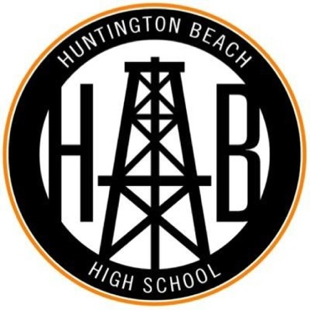

**Athletic Clearance**

***All athletes must complete each step of Athletic Clearance to participate in athletics.***

1. ***Athletic Physical:***

* See any M.D. or D.O that performs sports physicals. Physical must be dated after June 1, 2021.
* Physical form can be found at hboilers.com>Athletics>Athletics Physical Form
* Upload physical into Online Clearance (Step 3). *\*Skip this step if athlete completed physical at the HBHS physical event on campus.\**

1. ***ImPACT Concussion baseline test:***

* Complete solo
* [www.impacttestonline.com/testing](http://www.impacttestonline.com/testing)
* Code: xy2ty25u8q
* Be sure to have 20-30 minutes, uninterrupted time, on a computer with a mouse and keyboard.
* Results are sent to us automatically, no print/email required.

1. ***Online clearance:***

* Complete with parent/guardian
* www.athleticclearance.com
* Login to existing account and update OR

Click CA – then Register to make a new account.

* Info is also sent to us automatically, no print/email required.
* Parent receives an email when athlete is completely clear.

**Questions regarding Athletic Physical and/or ImPACT test please email Head Athletic Trainer Courtney Eargle at [ceargle@hbuhsd.edu](mailto:ceargle@hbuhsd.edu)

**Questions regarding online clearance please email Athletic Director Melissa VandenBosch at [mvandenbosch@hbuhsd.edu](mailto:mvandenbosch@hbuhsd.edu)