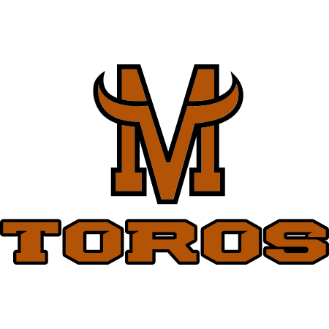
2025 Mountain View Baseball Scramble
Supporting Mountain View Baseball

Saturday October 11th at Boise Ranch Golf Club
6501 S. Cloverdale Rd. Boise, ID 83709

Cost: $125.00 per person/$500 per team. Cost includes greens fees, team golf carts, lunch provided and fabulous prizes for tournament winners, and closest to the pin. There will also be a few holes with fun games you can pay to participate in. Hole sponsorships are also available for $100. There will also be 5-hole activities that will be cash/Venmo only.

Sponsorships: Gold: $500 – Logo at a teebox and all Golf Carts
Silver: $250 – Logo at a teebox and Registration Table
Hole: $100 – Logo at a teebox

Teams: The scramble will consist of four-member teams but
individuals and groups of four or less may also enter.

Time: Golf Registration: Opens at 7:30 A.M.
Golf begins: 9:00 a.m. shotgun start.
Raffle and Lunch (Pulled Pork, beans, potato salad)
after tournament at Clubhouse

TOURNAMENT LIMITED TO FIRST 30 PAID TEAMS. GET YOUR ENTRIES IN EARLY TO RESERVE YOUR SPOT.

GOLFERS’ NAMES

1.____________________________________2.__________________________________

3.____________________________________4.__________________________________

Please make checks payable to Mountain View Baseball and return by Sept 27th

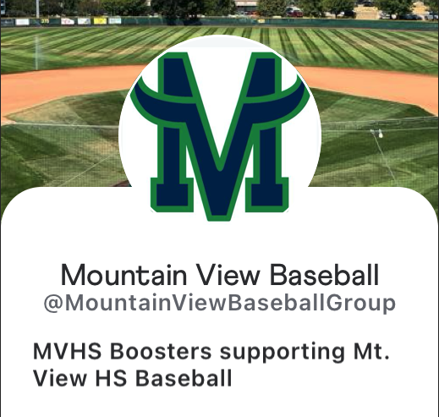
to ensure your spot in the tournament. We will allow registration at the tournament, but your spot cannot be guaranteed.

Send checks & entries to:
Mountain View Baseball
Attn: Justin Schneidt
P.O Box 332
Meridian, ID 83680

If you are going to pay at the event please contact Justin Schneidt in advance at schneidt.justin@westada.org or the Mountainviewbaseballgroup@gmail.com to reserve your space. Check or Venmo @MoutainViewBaseballGroup
Mountain View Baseball Inc. is a 501(C)3 non-profit organization. Tax ID # 51-0488104

