MOUNTAIN VIEW TOROS

PLAYER & PARENT/GUARDIAN AGREEMENT

Player Agreement
I agree to:
- Treat all coaches, teammates, opponents, umpires, and spectators with courtesy and respect.
- I understand that my role on this team is to play the game, to listen, and to learn. I also understand that the coach’s role on this team is to make decisions and teach the game of baseball: to help us become the best we can be. I will never get the two roles mixed up. I am here to be a part of a baseball team.
- I will think “TEAM FIRST”
- I will assume my role on the team, and give my best effort in that role.
- I will make an effort to encourage my teammates.
- I will assist in maintaining our facility.
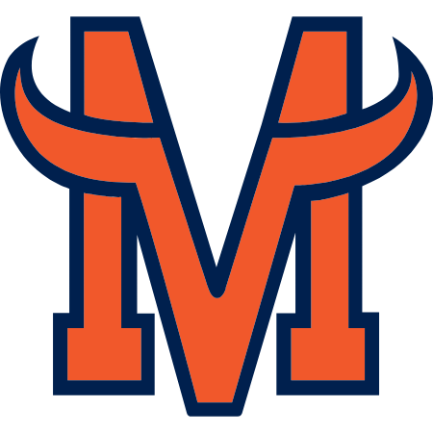
- Play to win but always fairly and while exhibiting good sportsmanship.
- Accept the decisions of the umpires with out gesture or argument.
- Control my temper and not use inappropriate, derogatory, or vulgar language.
- Never criticize the play of others or blame others for my mistakes.
- Follow instructions of my coach without argument, including all instances regarding playing time and position.
- Work hard, concentrate, cooperate, and not be disruptive in practices and games.
- Do my part by arriving on time to practices and games.
- Obey any and all team rules that the coach puts into place.
- Any issues that arise may lead to you being removed from a team.

PLAYER NAME: ___________________________________________

SIGNATURE: ___________________________________ DATE: ___________

Parent/Guardian Agreement
I agree to:
- Not coach or give instruction to players, including my own child, during games or practices.
- Never openly criticize players of either team or umpires during a game.
- Never confront a coach during or immediately following a practice or game.
- Never use inappropriate, derogatory, or vulgar language during a practice or a game.
- Take all measures to ensure my child has the means to arrive and be picked up on time for practices and games.
- Never openly criticize, talk bad, or state negatives about any member of the Mountain View Toros Baseball program. This shall include coaches, players, and other spectators.
- Encourage my child to be the best TEAM player possible.
- If there is an issue I will follow the proper chain of command. Talk/discuss with player, contact coach, set up a meeting with player, parent, and coach.
- Any issues that arise may lead to your son/player being removed from the team.

PARENT/GUARDIAN
NAME: _________________________ Signature: __________________________

PARENT/GUARDIAN
NAME: _________________________ Signature: __________________________

DATE: _______________

