


Date: Monday – Tuesday, June 21-22, 2021
Time: 9:00 – 12:00 p.m.
Cost: $35.00 ($30.00 each for two or more in the same family)
Campers: Boys and Girls, 6 – 12 years old
Registration Deadline to ensure T-Shirt: June 17, 2021 Refunds: None after Day 1
Only the first 40 applicants will be accepted. Hurry and Register.
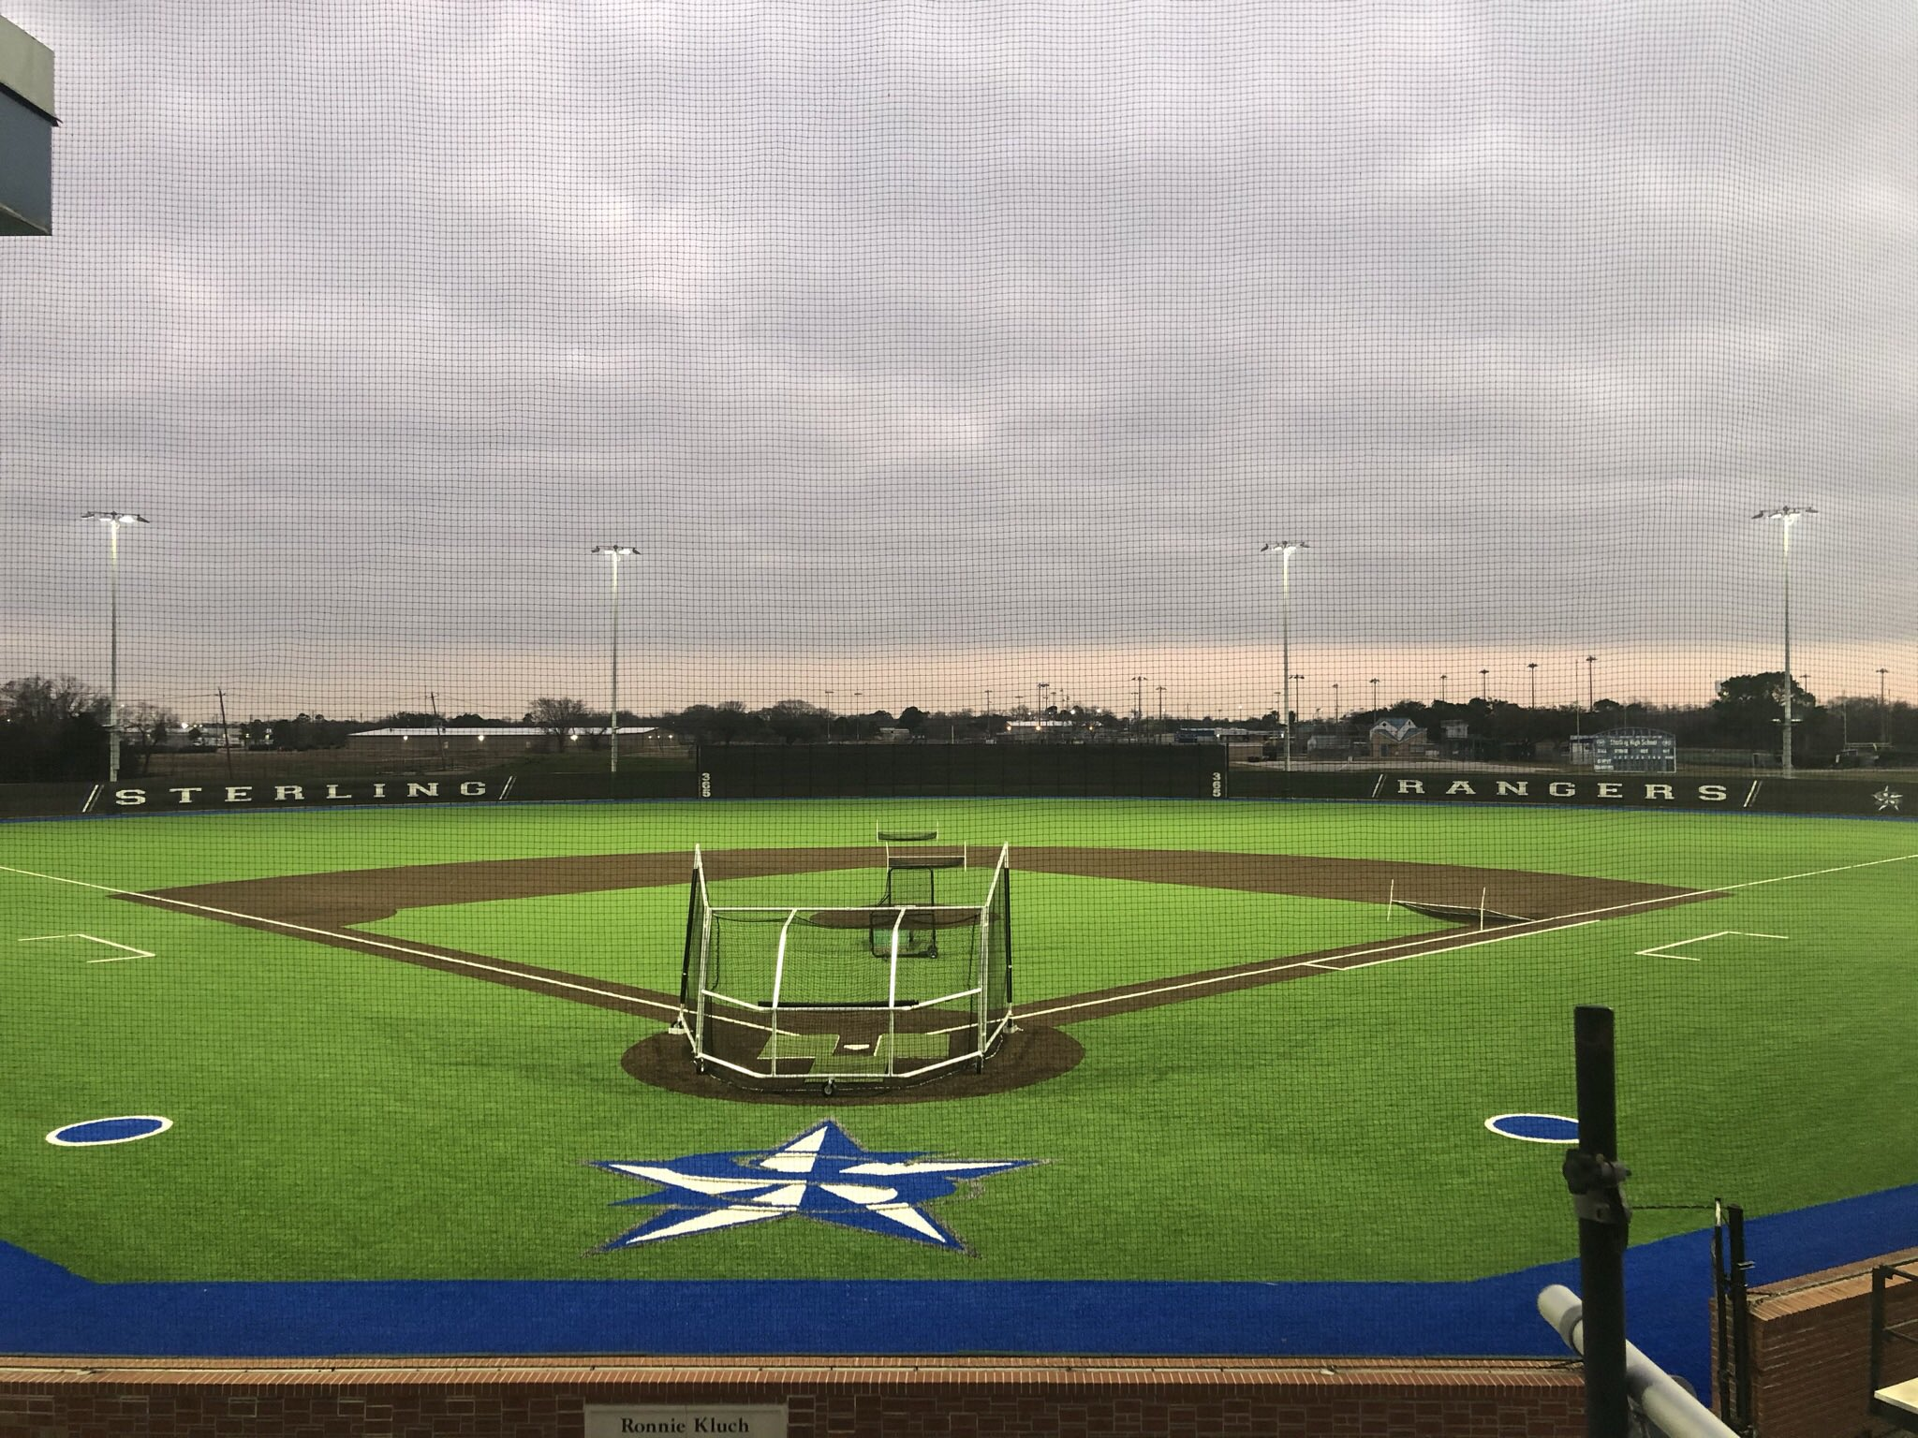
Cost Includes:
- T-shirt
- One Break time snack and drink per day
- Pizza on the final day
- Instruction

What to bring:
- Sunscreen
- Bat, Glove, and Cleats
- Water jug filled with water and ice
- Towel, Swim trunks, & a Change of clothes for slip’n slide/sliding practice at the end of day 2.
Typical Day at Ranger Baseball Camp:
9:00 – 9:15 Warm-up
9:15 – 10:00 Drills and skills
10:00 – 10:15 Games and competitions
10:15 – 10:45 More drills and skills
10:45-11:00 Snack Break
11:00 – 12:00 Instruction, skills, and play
Please return the attached form with information and payment.
Summer Baseball!!

Name _____________________________________________
Age ____________ (as of June 1, 2021)
Address ______________________________________________________________
______________________________________________________________
Cell # ___________________ Email ____________________________________
Emergency Phone number ____________________ Name _____________________
Please circle your choice(s): T-shirt guaranteed for pre-registered campers only
T-shirt size: Youth: S M L XL Adult: S M L XL
Food Allergy: Yes _____ No ____ If Yes, describe ________________________
Special Information: ____________________________________________________
Please pay upon arrival. Cash and Checks accepted. No debit or credit cards.
I hereby release the Ranger Baseball Clinic staff, Sterling High School, Goose Creek C.I.S.D. and Sterling Coaches from any responsibility due to injury while my child is participating in the Ranger Baseball Clinic.
My son/daughter is covered by the following Medical Insurance Policy:
Insurance Company ____________________________ Policy # ____________
Insurance Company phone # ______________________
Parent's Signature: ____________________________________
Please mail to: Coach Adam Shibley
Ross. Sterling High School
300 W. Baker Rd.
Baytown, TX 77521
Or Email: adam.shibley@gccisd.net
Please return this page to ensure T-Shirt order. Payment upon arrival.
Walk-ups welcome but t-shirt will not be guaranteed.

