[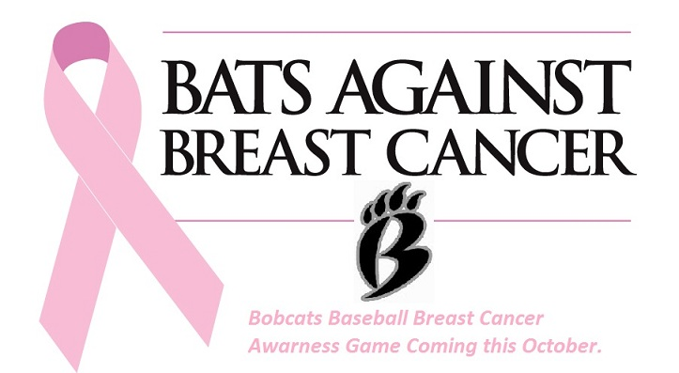](http://wbbobcatsbaseball.com/teams/default.asp?u=WBBOBCATSBASEBALL&s=baseball&p=slideshow&albumID=15671#248220) 

**Come and join us**

**Saturday, October 27th, 2018**

***7th Annual “Sergio Ambros' Bats Against Breast Cancer”***

***At West Broward High School***

***500 NW 209th Ave., Pembroke Pines, FL 33029***

**All Activities Start at 9am.**

Admission will be $5

Breast Cancer Pins, T-shirts and pink bracelets will be available to purchase

Silent Auction, Door Prizes and Food Concessions will be available

Proceeds from this event will be donated to

**The Memorial Foundation- Breast Cancer Fund**

Any survivors present will be recognized by the:

**WEST BROWARD BOBCATS - SAGEMONT LIONS**

**PINECREST SCHOOL – MATER LAKES ACADEMY – ELITE SQUAD ACADEMY**

*Refer to [www.wbbobcatsbaseball.com](http://www.wbbobcatsbaseball.com) for game/weather updates



Care

Bobcats

**Sponsored by** 