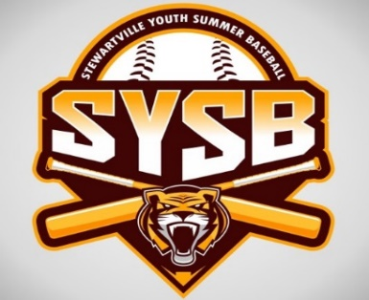

**1st Annual Stewie Spring Slugfest 2025**

**9-12U Tournament May 17th and 18th**

**Bear Cave Park, Stewartville MN**

9 & 10U May 17th

11 & 12U May 18th

3 games guaranteed with 6 team round robin

Pitch counts enforced

Medals for 1st and 2nd place

Fields dragged and chalked after each game

Full Concessions

**$200 entry fee**

3 game balls required

Please register by April 28th

Register at Stewartville Youth Sports web site: https://stewartvilleyouthsports.sportngin.com/ under tournaments or

Make checks payable to the Stewartville Diamond Club

Please send checks to PO Box 2 Stewartville MN 55976

Questions, please reach out to:

Eddie Fricker

507-884-0140

Eddie.fricker@yahoo.com