YOUR HYDRATION AND FUEL KIT FOR BASKETBALL
Leslie Bonci, MPH,RDN,CSSD,LDN,FAND
412-559-5974
boncilj1@gmail.com
IG @boncilj
Twitter @lesliebonci
Facebook @lesliebonci

TIMING:

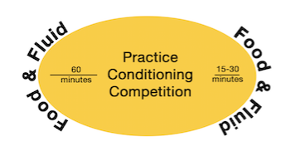
Your body is always in a state of prepare or repair. TO optimize performance and recovery you should fuel and hydrate BEFORE and AFTER every practice and workout. #FuelsofEngagement

Start your workouts well hydrated. Urine should be light in colors and higher in volume BEFORE you start to exercise. Choose fluid as well as liquid containing foods (fruits, vegetables, soups, smoothies) before you hit the field or the weight room. Being well hydrated will improve strength, speed and stamina.

SEEYOURPEE

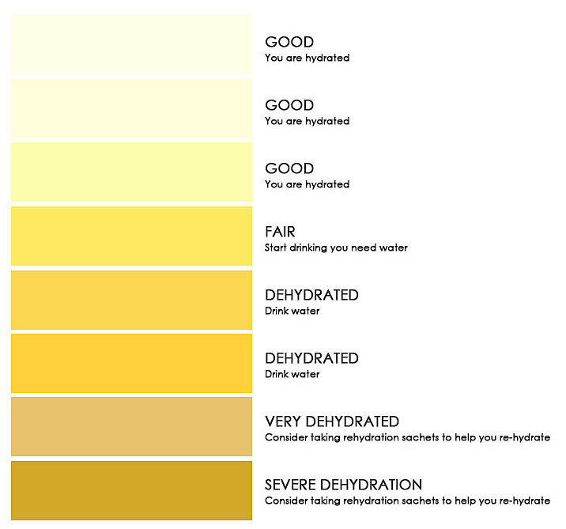

Adding electrolytes may be the right decision along with optimal hydration to prevent cramping. Sports drinks, electrolyte packets, adding salt to food or eating salty foods such as pickles, Soy sauce, and broth can be helpful.

REPLACE WHAT YOU LOSE. For every pound of fluid you lose during practice/workouts- replace with a bottle of water or sport drink. If you lose 5 pounds during practice, you will need to drink around 5 bottles. Aim for 1-2 bottles per hour after practice. Fluid replacement POST-exercise is in ADDITION TO your daily fluid needs

THINK YOUR DRINK!
Sports drinks may be of benefit during practice/games
Too much caffeine will leave you wired and eventually tired
Hydrate smarter, not harder, by drinking a max of 4-8 good sized gulps of water or sports drink every 20 minutes.

Food is only great if you eat what is on your plate! Choose foods you like as a part of your performance plate. Be selective but not neglectful when it comes to food choices. Do make an effort to include protein, produce and some carbs at every meal you eat.

IF YOU SKIP YOUR PERFORMANCE MAY SLIP. Skipping meals can hinder your performance and progress in changing your body composition. Aim to be consistent with the number of meals and snacks you choose daily. Food is fuel for performance; don’t let yourself run on empty.

START OFF STRONG. Breakfast is a chance to refuel, replenish and rehydrate so your body does not have to play catch up. Do make sure to put protein, produce and carbs on your plate. If you are too tired to chew, a smoothie may be a great choice for you.

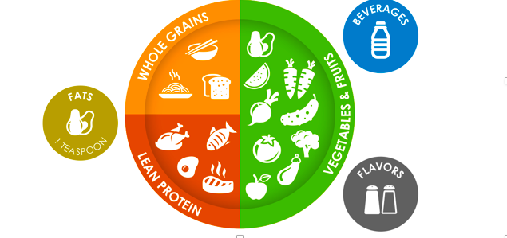

Create a #winningplate with half of your plate as produce ( fruits and vegetables), ¼ as protein ( meat, poultry, fish/shellfish dairy, eggs, plant based protein) and ¼ as carbs( rice, pasta, quinoa, potato, bread, cereal A performance plate delivers on quality, quantity and consistency to help you maximize strength, speed, stamina and recovery.

CARBS ARE NOT THE ENEMY! Carbs from fruits, pasta, rice, potatoes, bread, corn provide the fuel your body needs for practice and workouts. If you eliminate the carbs from your plate, you may find yourself slower, weaker and more fatigued. Plus, too few carbs force your body to use lean mass as a fuel source during exercise. So just say no to low when it comes to carbohydrates.

On hard practice days and game days here is what your plate should be:
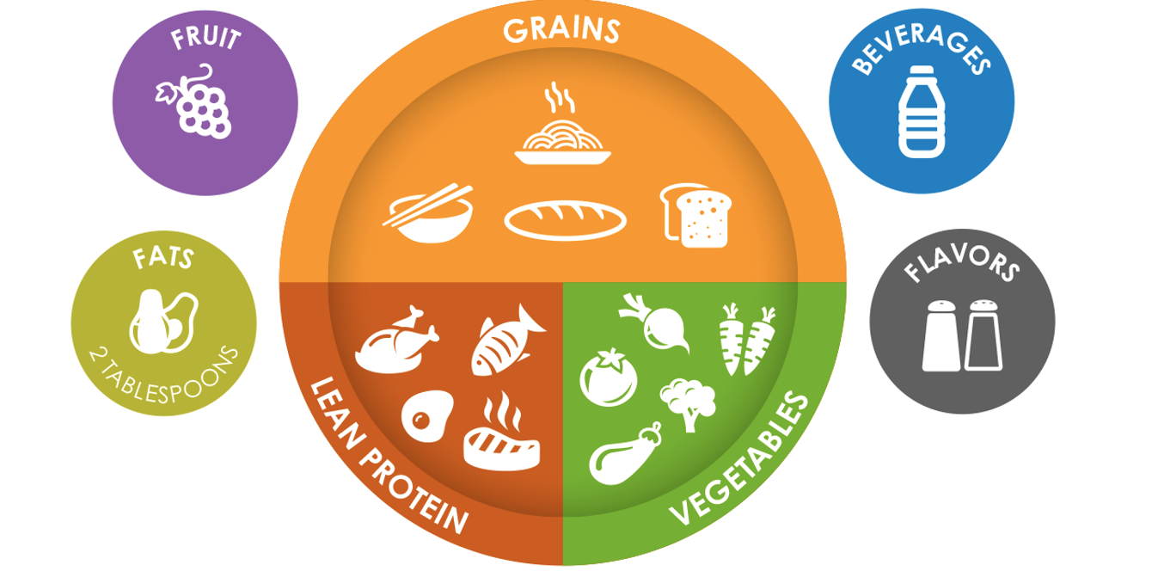
More carbs on the plate can help make your performance great- more energy, more speed and greater strength.

When it comes to protein, more is not always better. Your body has no way of storing amino acids from protein. If you take in more protein than the body can utilize at one time, part will be will be used for energy or stored as fat and the rest will be peed out or money down the drain. A better approach is to maintain adequate and consistent protein intake throughout the day.
Protein needs to be on the plate at every meal and part of snacks too.

Milk Yogurt Cheese Eggs Jerky Turkey chicken
Fish Beef Tofu Veggie burgers Peanut butter

SUPPLEMENT SAVVY: When it comes to supplements, just because you can buy it does not mean you have to try it. Supplements are a complement to NOT a replacement for food
Supplements that could be helpful- protein isolates. Carbohydrate Gus/chews/bloks
Supplements that are useless- BCAAs, Caffeine supplements

RECIPES

Bonci’s Bites
2 cups mixed cranberries and dried cherries
1.5 cups dry oats
2 cups Crispy rice cereal
¼ cup peanut butter powder
1 cup peanut butter ( creamy or crunchy) I use ½ chunky and 1/2 dark chocolate peanut butter
¼ cup unsweetened cocoa powder
½-2/3 cup honey- depending upon desired level of sweetness

In a large bowl stir together peanut butter and honey until well mixed. Add in peanut powder, cocoa, dried fruit and the cereal and mix well, use your hands to mix well. Wearing gloves makes this a lot easier! Roll into quarter size balls. Put into mini muffin cups or on a tray. Refrigerate or freeze briefly to set.

Yield: 64 bites: Serving = 2 bites

POTATOES A GO-GO
24 ounces ( 40 mini potatoes)
1/3 cup olive oil
¾ cup bread crumbs
1 package dry ranch dressing mix or Buffalo dip mix
¼ tsp paprika
Salt and pepper to taste

Put potatoes in a bowl and toss with the olive oil. Mix to coat well. In a separate bowl, combine bread crumbs , Ranch dressing mix, paprika, salt , pepper and mix well. In small batches, put the potatoes in the bread crumb mixture and roll around to coat well. Transfer to a cookie sheet. Bake at 450 degrees for 20 minutes.
Preparation time: 10 minutes
Cook time: 20 minutes
Total time: 30 minutes

Can make ahead and freeze. Take out of freezer the night before use , keep in the refrigerator and remove when ready to use.

Time saving tips: buy mini potatoes. Make a few bags, cook off and then freeze in small portioned bags to use for sport.
Customization: white potatoes, small red potatoes, purple potatoes

