OVER-THE-HILL BASKETBALL
2025-26 SEASON SCHEDULE

- All scheduled games are played on Wednesdays at the McConnell Center
- Games 2 and 3 start times are estimates. Players should arrive early to ensure making each event.
- If inclement weather forces game cancelations, a league-wide text will be sent to all, captains will be notified, and the website updated. This will push games back one week. Additional cancelation(s) may affect the schedule differently and resulting changes will be announced to all players via multiple ways.

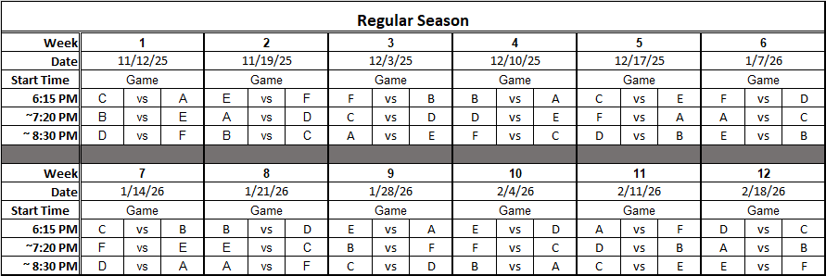
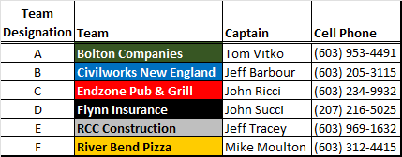

PLAYOFFS: 1st Round: Single Elimination. Double Elimination thereafter.

Visit the league website www.overthehillbasketball.com for more information including teams, schedules, and updated stats.

11/13/25

