

|  |  |
| --- | --- |
| BRANDON COWBOYS | |
| YOUTH FOOTBALL and CHEERLEADING **REGISTRATION PACKET** | |
| Member of the TCYFCC  Tri-County Youth Football and Cheerleading Conference | |
|  | |
| **Included in packet:**  GENERAL INFORMATION  ORGANIZATION GUIDELINES  REGISTRATION FORMS (F)(C)  PHYISCAL FORM  HILLSBOROUGH COUNTY PARKS and CONSERVATION  HILLSBOROUGH COUNTY PARKS and RECREATION  ORGANIZATIONAL POLICIES and RULES  PLAYER RULES  CHEERLEADER RULES OF CONDUCT  PLAYER/PARTICIPANT RULES OF CONDUCT  PARENT/GUARDIAN PARTICIPATION AGREEMENT  PHOTOGRAPHY RELEASE  FUNDRAISING AGREEMENT |



BRANDON COWBOYS YOUTH FOOTBALL & CHEERLEADING

|  |  |  |
| --- | --- | --- |
| **FOOTBALL** REGISTRATION: | | |
|  | | |  |
| **Pre-Registration** | **$100.00** *deposit* NON-REFUNDABLE/NON-TRANSFERABLE DEPOSIT | |
| **General Registration** | **$235.00** | |
|  |  | |
| **CHEERLEADING** REGISTRATION: | | |
|  | | |  |
| **Pre-Registration** | **$100.00** *deposit* NON-REFUNDABLE/NON-TRANSFERABLE DEPOSIT | |
| **General Registration** | **$235.00** | |
|  |  | |
| **ALL REGISTRATION FEES AND REQUIRED PAPERWORK MUST BE SUBMITTED BY** **JUNE 30, 2016.** OR THE PLAYER WILL NOT BE ISSUED EQUIPMENT/UNIFORM UNTIL ALL PAPERWORK AND REGISTRATION FEES ARE CURRENT. | |  |

|  |  |
| --- | --- |
| **REQUIREMENTS TO PARTICIPATE** | |
| **MEDICAL PHYSICALS** | **Physicals must be dated after May 1, 2016 or they will not be accepted!** A physical form signed by a doctor must be turned in by June 30, 2016, or he/she will be ineligible to participate. The proper physical form is the Florida High School Athletic Association form which can be found in this packet or on our website at [WWW.BRANDONCOWBOYS.ORG](http://WWW.BRANDONCOWBOYS.ORG)  **This is the only acceptable physical form.**   Absolutely **NO** practicing will take place until a high school physical form has been **certified by a doctor and given to the secretary**. |
| **BIRTH CIRTIFICATES** | An original birth certificate (certified copy) must be given to the secretary at time of registration. |
| **PARENTS** | **One parent is REQUIRED to be present during each practice and game for emergency purposes and/or inclement weather.** If any child is left at the practice or game field without a parent/guardian, the Hillsborough County Sheriff's Department will be notified.  Each parent/player will be required to sign a parent participation agreement, parent rules of conduct and players rules of conduct. All players will be required to participate in league fundraising activities |
| **PRACTICES & GAMES** | |
| **PRACTICES** | **Summer/ Pre-Season:** Practices are conducted from **6:30 p.m. – 8:30p.m.** Monday – Thursday until beginning the first full week of school. Wednesdays are at the discretion of individual teams/coaches.  **Regular Season:** Practices are conducted from **6:30 p.m. – 8:30p.m.** Monday, Tuesday & Thursday.  **Location:** Practices are held at the Brandon Cowboys Field.  **Inclement Weather:** In the event a practice day is rained out, Wednesdays and Fridays are reserved for “make-up” practice days. This is to the discretion of individual teams/coaches. You are still required to come to the field, unless the board has canceled practice.  ALL PLAYERS AND CHEERLEADER NEED TO BRING A 32OZ WATER BOTTLE OR LARGER.  Practice attire should be navy blue, silver or white.  Cheerleaders need to bring towels and bug spray with deet. |
| **HOME GAMES** | There will be (5) five home games and (5) five away games. There may also be playoffs and a super bowl. The season ends December 31, 2016.  **Location:** Home games are held at the Brandon Cowboys Field.  **Physical Address:** 2929 S Kingsway Road  Seffner, FL 33583 |
| Practice and game schedules are subject to change due to weather conditions and holidays.  All practices and games are mandatory. The only excused absences will be for attending church, school functions, illnesses or death in the family, unless the Coach grants prior approval. Absences may result in suspension, limited game time, no game time, no cheer competition. Please keep in mind, this is a team sport which requires 100% attendance from all players and cheerleaders. When someone is missing, the coach has to make changes which affect the whole team. Do not forget, the children see you watching them, show them some support.  Please Remember:   1. These ARE kids 2. This is THEIR game 3. Coaches and Officials ARE human 4. This IS FOR FUN. 5. Positive cheering IS encouraged by all. | |

**IT IS MANDATORY THAT PARENTS STAY WITH THEIR CHILD DURING ALL LEAGUE FUNCTIONS!** There must always be a parent/guardian (or someone 18 years and older) at all practices, games, competitions and any other league function in case of an emergency or inclement weather. **If you drop your child off without any prior arrangements with the Head Coach your child will be considered abandoned and the Hillsborough County Sheriff's Department will be notified.**

**This also applies to the parents that sit in their vehicles. We do not have the time to run out to everyone's vehicle when there is an issue with your child.

FOOTBALL & CHEERLEADING GUIDELINES

|  |  |
| --- | --- |
| **FOOTBALL GUIDELINES** | |
| * Each football player must participate in 8 hours of fitness training/conditioning prior to any physical contact, regardless of when he/she signs up. This is conducted under the supervision of the coach. * Football players will be required to purchase cleats, soft cups, practice pant, practice jersey, and mouthpieces. Mouthpieces **CANNOT** be white of clear. * Strict age guidelines are mandatory per the TCYFCC playing rules. These are guidelines for the safety of all the children and there will be **NO EXCEPTIONS** made. * Each child will be evaluated and placed in the best position by the coach’s standards, not only for the best interest of the team, but for the success of the child. * Football equipment will be issued on July 2nd, 2016. | |  |  |  | | --- | --- | --- | | **DIVISIONS** | **AGES** | **MAXIMUM WEIGHTS** | | MIGHTY MITES | 5 - 6 | UNLIMITED | | PEE WEE | 7 - 8 | UNLIMITED | | MIDGETS | 9 - 10 | UNLIMITED | | JUNIOR VARSITY | 11 - 12 | UNLIMITED | | VARSITY | 13 - 14 | UNLIMITED | |
|  | |
| **CHEERLEADING GUIDELINES** | |
| * Cheerleaders will be required to size shoes, bloomers and practice uniforms thru the league. Uniform fittings and orders will be done at the April 23rd and May 14th fittings. The cost of the uniforms is included in your registration fee. * Cheerleaders will be required to purchase practice shoes, practice shorts, and practice shirts. * Items included in registration costs are: Shorts, Shirt, Bloomers, 1 pair of socks, competition shoes, game day hair bow, competition fees and the use of game day uniforms.      * Each child will be evaluated and placed in the best position by the coach’s standards, not only for the best interest of the team, but for the success of the child. | |  |  | | --- | --- | | **DIVISIONS** | **AGES** | | MIGHTY MITES | 4* - 6 | | PEE WEE | 7 - 8 | | MIDGETS | 9 - 10 | | JUNIOR VARSITY | 11 - 12 | | VARSITY | 13 - 15 |   *Number of 4 year olds is limited. |

BRANDON COWBOYS YOUTH FOOTBALL & CHEERLEADING

**REGISTRATION FORM**

Please select the sport which applies: Please select the appropriate age group: **May 1, 2016**

|  |  |  |  |  |  |  |  |  |  |  |
| --- | --- | --- | --- | --- | --- | --- | --- | --- | --- | --- |
|  | FOOTBALL | | | MIGHTY MITES | |  | | | | |
| PEE WEES | |  | | | | |
|  | CHEERLEADING | | | MIDGETS | |  | | | | |
| JUNIOR VARSITY | |  | | | | |
|  |  | | | VARISTY | |  | | | | |
| Are you currently or previously ever registered with another football and/or cheerleading organization? | | | | | | | **If yes, where:** | | | | |
| **Last Name** | | | **First Name** | | | | **Date of Birth** (mm/dd/yyyy) | | | | |
|  | | |  | | | |  | | | | |
| **Football Age** (as of July 31, 2016) | | | **Cheer Age** (as of Aug 31, 2016) | | | | **School as of August 2016:** | | | | |
| **Choose Jersey #** OPT 1) | | | | | | |  | | | | |  |
| **SIBLINGS: *(BROTHERS AND/OR SISTERS REGISTERED WITH OUR ORGANIZATION)*** | | | | | | | | | | | |
| Child Name #1 | |  | | | | | Team |  | | | |
| Child Name #2 | |  | | | | | Team |  | | | |
| Child Name #3 | |  | | | | | Team |  | | | |
| **Mailing Address:** | | Street: | | | | | Apt No: | | | | |
|  | | City: | | | | | ST: | | | Zip Code: | |
| **PARENTAL INFORMATION** | | | | | | | | | | | |
|  | | **Mother’s Info** | | | **Father’s Info** | | Emergency Contact (other than parents) | | | | |
| **Name:** | |  | | |  | |  | | | | |
| **Cell:** | |  | | |  | |  | | | | |
| **Email:** | |  | | |  | |  | | | | |
| **Allergies/Medications:** | |  | | | | | | | | | |
| **REGISTRATION: PAYMENT INFORMATION** | | | | | | | | | | | |
|  | | **Comments:**       **☐ $235.00** Football **☐ $235.00** Cheerleading | | | | | | | | | |
| **League use only:** | | **Payment #1** | | | **Payment #2** | | **Payment #3** | | **Payment #4** | | |
| **Date:** | |  | | |  | |  | |  | | |
| **Amount Due:** | |  | | |  | |  | |  | | |
| **Amount Paid** | |  | | |  | |  | |  | | |
| **Method (check #)** | |  | | |  | |  | |  | | |
| **Initials** | |  | | |  | |  | |  | | |

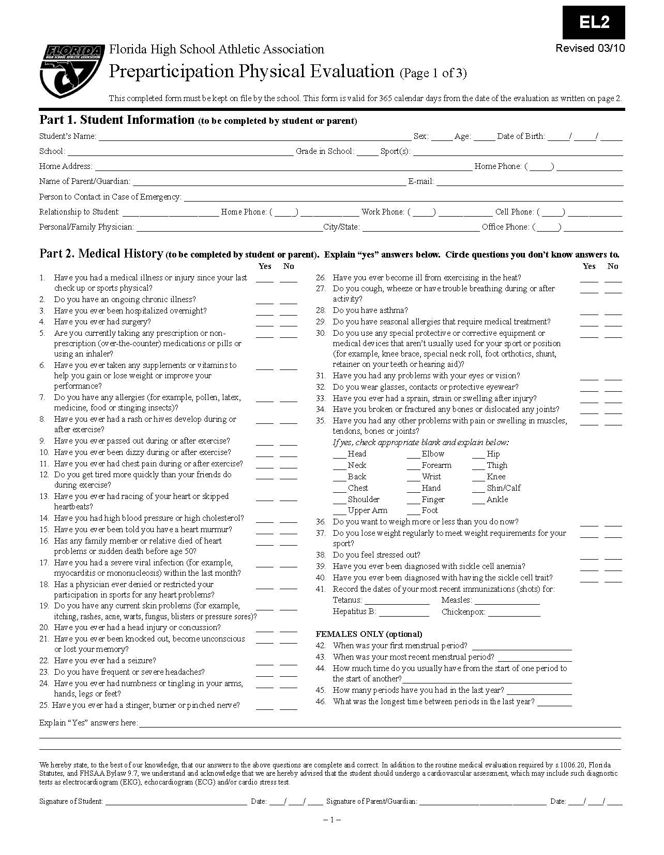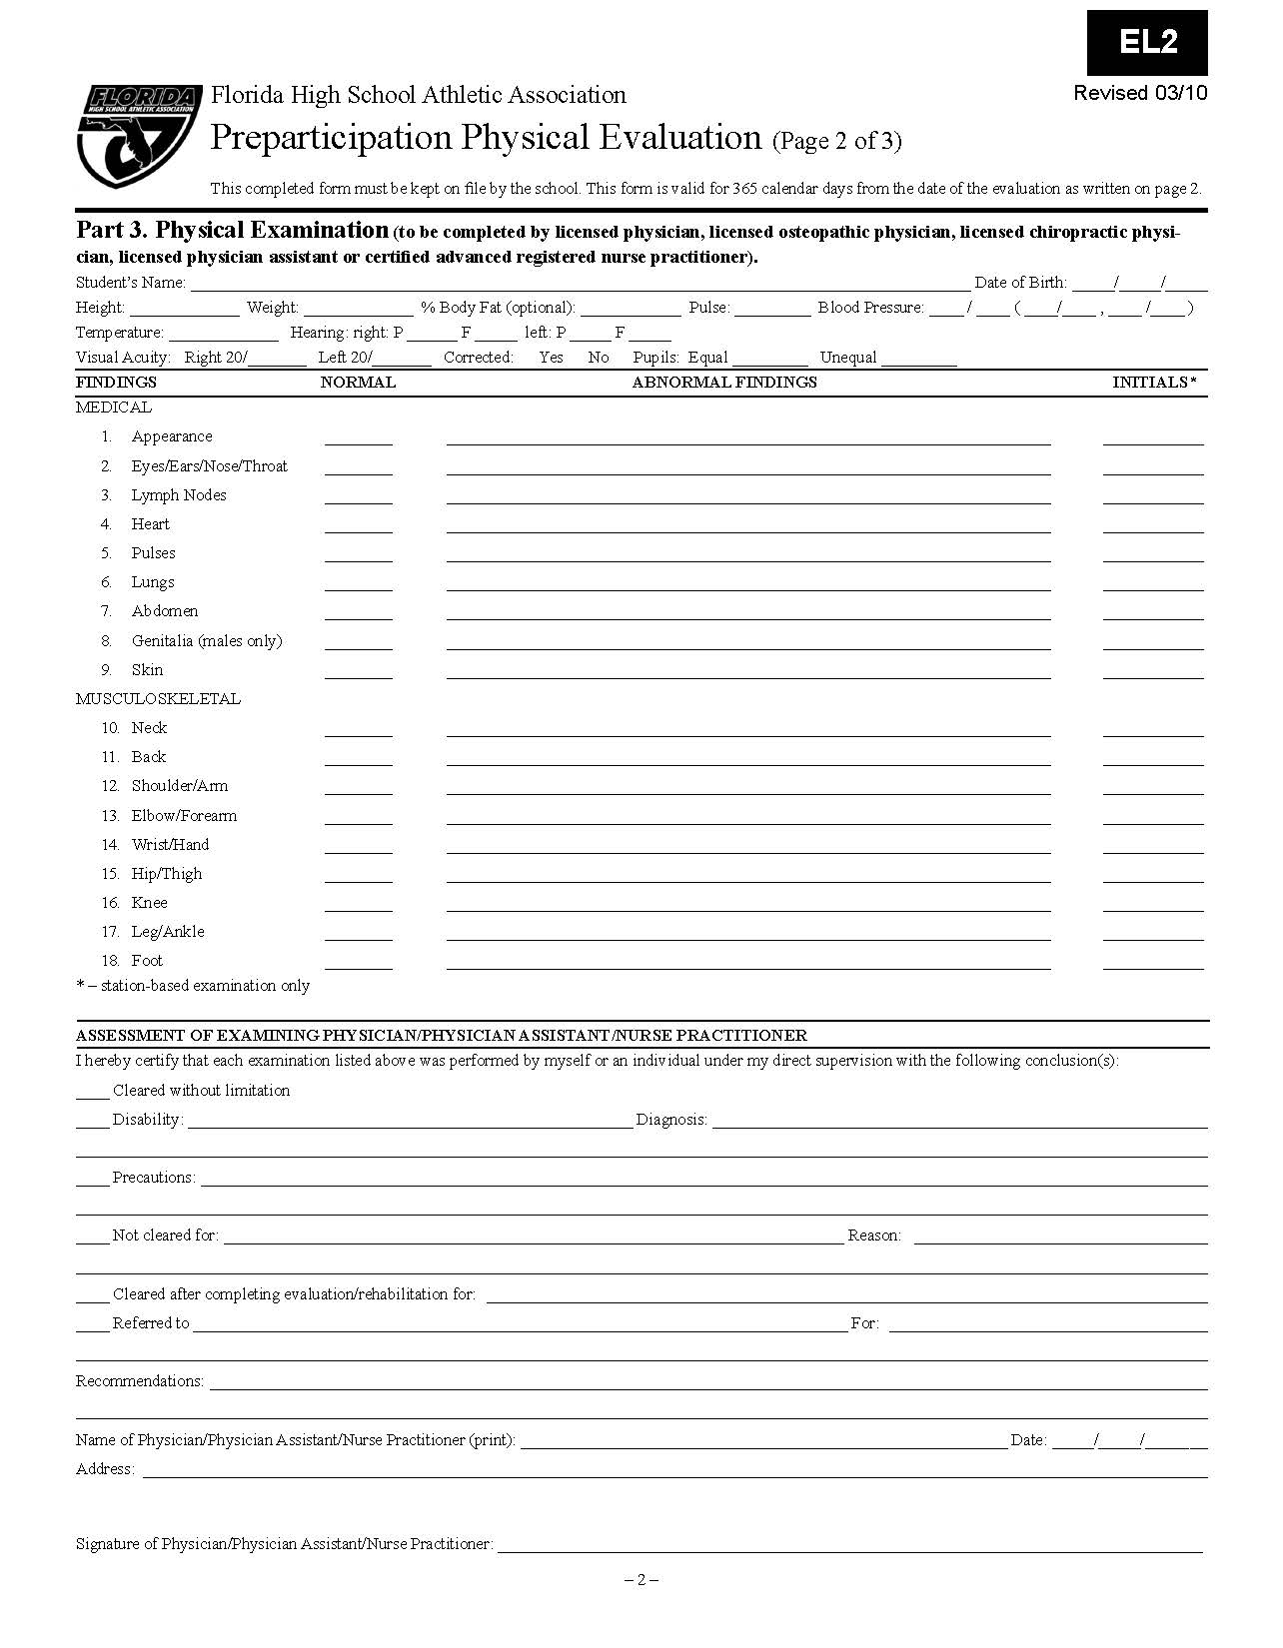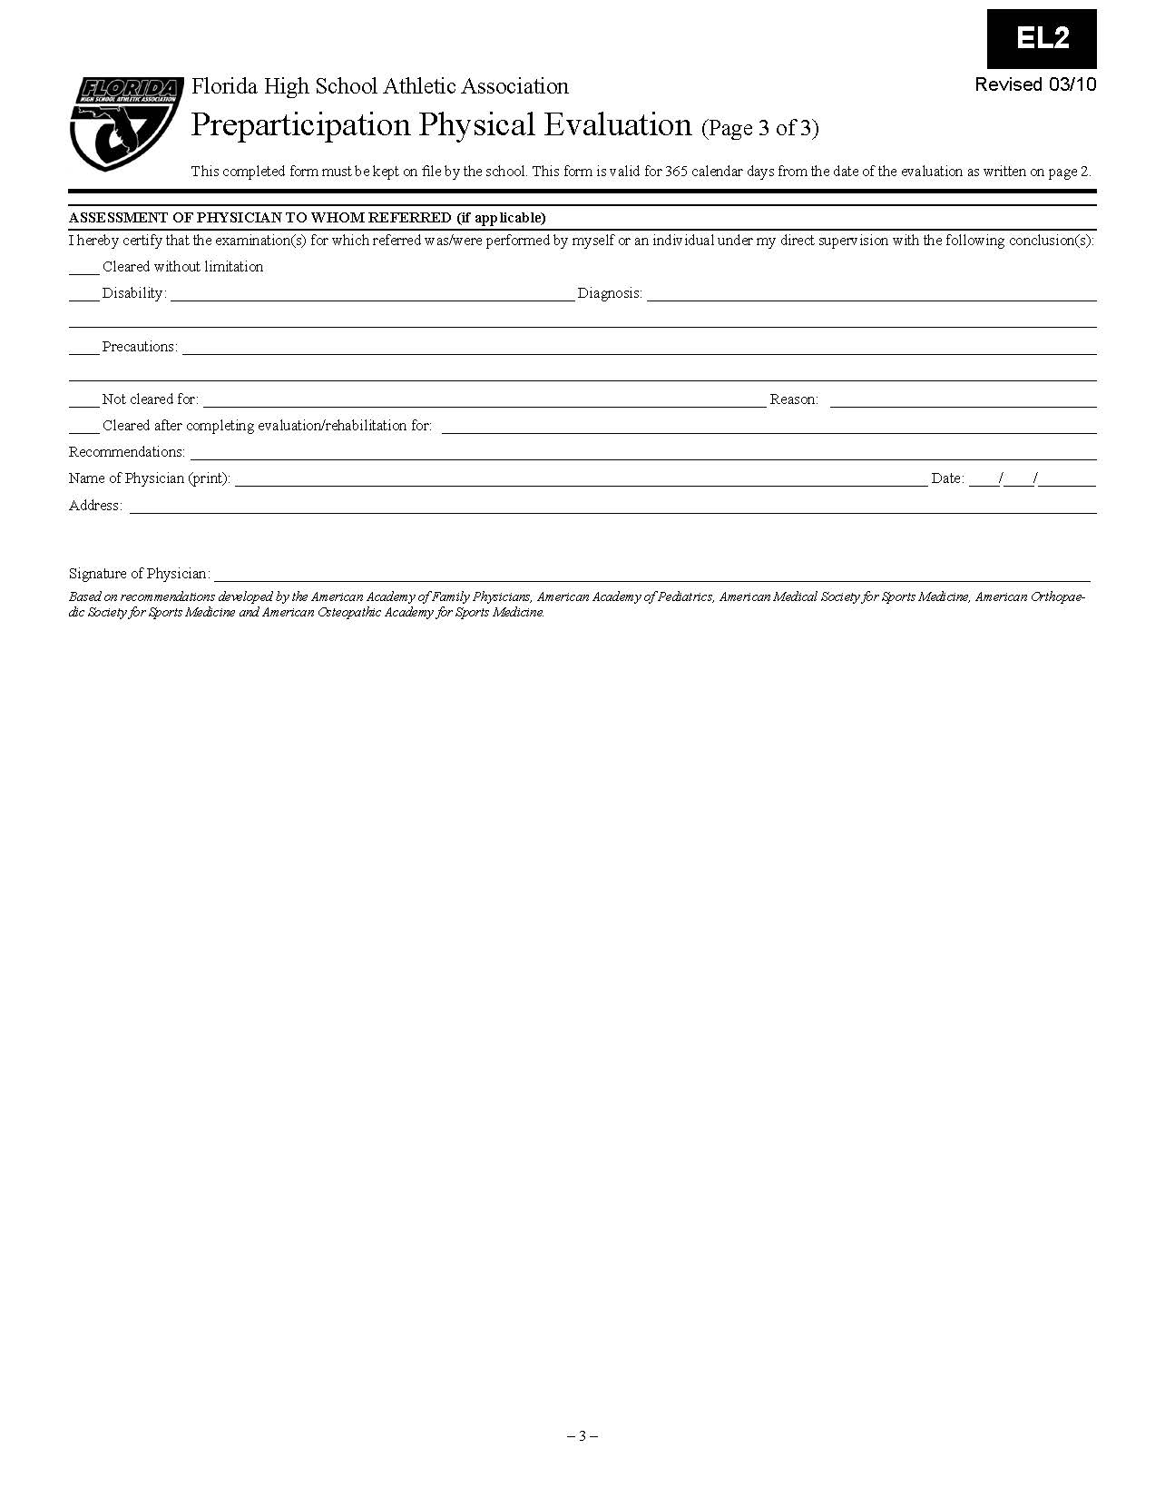

Department of Parks, Recreation and Conservation

Hillsborough County, Florida   
INFORMED CONSENT/GENERAL RELEASE — YOUTH SPORTS PARTICIPANTS   
***This is a release of liability. Please read carefully before signing***

**Since participation in youth sports activities can be dangerous, Hillsborough County requires all participants (and their adult parent(s) or guardian(s) to assume all risks associated with youth sports by signing this general release.**

For and in consideration of my child being permitted to participate in HILLSBOROUGH COUNTY youth sports activities, I hereby voluntarily release, discharge, waive and relinquish any and all claims or actions for damages for person injury, permanent disability, death, or property damage which I or my child may have, or which may hereafter accrue to me or my child, as a result of my participation in youth sports activities during play and while I am at the facility while others play or for any other reason. This release is intended to discharge, in advance, HILLSBOROUGH COUNTY, its officers, employees and agents, the **BRANDON COWBOYS YOUTH FOOTBALL** & **CHEERLEADLNG,** its officers and agents, and the owners and maintainers of any facility used for the activities, from any and all liability arising out of or connected in any way with my child's participation in sports camp/clinic activities, even though that liability may arise out of negligence or carelessness on the part of HILLSBOROUGH COUNTY, its officers, agents or employees and the **BRANDON COWBOYS YOUTH FOOTBALL** & **CHEERLEADING,** its officers and agents.

I further understand that serious accidents occasionally occur during youth sports activities, and that participants occasionally sustain serious personal injuries, death or property damages as a consequence thereof. Knowing the risks, I have voluntarily applied for my child to participate in the activity and thereby agree to assume those risks to release and hold harmless HILLSBOROUGH COUNTY, its officers, employees or agents and the **BRANDON COWBOYS YOUTH FOOTBALL** & **CHEERLEADLNG,** its officers and agents used for the activity, who (through negligence or carelessness) might otherwise be liable to me or to my child (or my heirs or assigns) for damages.

I further understand and agree that this release, discharge, waiver, and assumption of risk are to be binding on my and my child's heirs, executors, administrators and assigns.

I further agree to indemnify and to hold harmless HILLSBOROUGH COUNTY, its officers, employees and agents and the **BRANDON COWBOYS YOUTH FOOTBALL & CHEERLEADING,** its officers and agents for any loss, liability, damage, cost or expense which they may incur as a result of any injury or property damage I or my child may sustain while participating in the activity.

I agree to comply with the program's stated and customary terms and conditions for participation according to **BRANDON COWBOYS YOUTH FOOTBALL & CHEERLEADING.** If I observe any significant changes with regard to my child's readiness for participation in the program, I will remove my child from the program immediately.

**I have read this Informed Consent/General Release, fully understand its terms, that I give up substantial rights by signing it, and sign it voluntarily.**

|  |  |
| --- | --- |
| Print Name: | Date: **May 1, 2016** |
| Address: | City:       Zip: |
| Signature of Parent: __________________________________ | |

**This document is a Release of Liability, which affects the rights of you and your child.   
Please read the document carefully before signing**

I **have read this Informed Consent/General Release and** I **understand** the seriousness of the risks involved in participating in this program, my personal responsibilities for adhering to rules and regulations, and accept them as a participant. (To be signed by all players who are league age 12 and older.

|  |  |
| --- | --- |
| Name of Participant: | Date of Birth (00/00/0000): |
| Participant Signature: ____________________________ | Date Signed: ________________________________ |

BRANDON COWBOYS YOUTH FOOTBALL & CHEERLEADING

**MEDICAL TREATMENT AUTHORIZATION FORM**

|  |  |  |  |  |
| --- | --- | --- | --- | --- |
| Name of Participant: | | Date of Birth (00/00/0000): | | |
| In the event of an emergency occurring while my son/daughter is at practice, game, or competition, I grant my permission to the Brandon Cowboys volunteers to administer first aid or arrange for transportation to a medical facility if the agent or official deems there to be an emergency. At that time, medical treatment may be given to my child including but not limited to anesthesia and emergency surgical treatments as deemed necessary by a qualified physician at the medical facility. | | | | |
| Parent Name: | | | Date: **May 1, 2016** | |
| Address: | | | City:       Zip: | |
| Cell: | | |  | |
| Signature of Parent: __________________________________ | | | | |
| |  |  | | --- | --- | | STATE OF FLORIDA | The foregoing instrument was acknowledged before  me on this, the _______day of__________________ , 20 ____ , by  ( ) who is personally known to me or ( ) who has produced as identification and who (did) or (did not) take an oath. | | COUNTY OF HILLSBOROUGH | | | | | |
| { Notary Seal }    X ______________________________________________________ | | | | |
| **Person to be notified (other than parent/guardian) in case of emergency**: | | | | |
| Name: | Phone: | | | Relationship: |
| Name: | Phone: | | | Relationship: |
| Insurance Company: | | | | |
| Group #: | Policy #: | | | Phone: |
| **Medical Information**: | | | | |

|  |  |  |  |  |  |  |  |  |
| --- | --- | --- | --- | --- | --- | --- | --- | --- |
| **Heart Disease** | Yes | No | **Asthma** | Yes | No | **Diabetes** | Yes | No |
| **Allergic to**  **Medication** | Yes | No | **Convulsions** | Yes | No | **Sickle Cell Anemia** | Yes | No |
| **Environmental/Insect**  **Allergies** | Yes | No | **Food Allergies** | Yes | No | **Current Medications** | Yes | No |

If yes to any above or other, please describe treatment to be provided:

|  |
| --- |
|  |

**TRI-COUNTY YOUTH FOOTBALL AND CHEERLEADING CONFERENCE (TCYFCC)**

**WAIVER AND RELEASE OF LIABILITY**

**In consideration of being permitted to utilize the facilities, services and programs of the TCYFCC (or for my children to so participate) for any purpose, including, but not limited to observation or use of facilities or equipment, or participation in any off-site program affiliated with the TCYFCC, the undersigned, for himself or herself and such participating children and any personal representatives, heirs, and next of kin, hereby acknowledges, agrees and represents that he or she has, or immediately upon entering or participating will, inspect and carefully consider such premises and facilities or the affiliated program. It is further warranted that such entry into the TCYFCC for observation or use of any facilities or equipment or participation in such affiliated program constitutes an acknowledgment that such premises and all facilities and equipment thereon and such affiliated program have been inspected and carefully considered and that the undersigned finds and accepts same as being safe and reasonably suited for the purpose of such observation, use or participation by the undersigned and such children.**

**In further consideration of being permitted to enter the TCYFCC for any purpose including, but not limited to observation or use of facilities or equipment, or participation in any off-site program affiliated with the TCYFCC, the undersigned hereby agrees to the following:**

**1. THE UNDERSIGNED ON HIS OR HER BEHALF AND BEHALF OF SUCH CHILDREN, HEREBY RELEASES, WAIVES, DISCHARGES AND CONVENTS NOT TO SUE TCYFCC and all branches thereof, its directors, officers, employees, and agents (hereinafter referred to as “releasees”) from all liability to the undersigned or such children and all his personal representatives, assigns, heirs, and next of kin for any loss or damage, and any claim or demands therefore on account of injury to the person or property or resulting in death of the undersigned or such children whether caused by the negligence of the releasees or otherwise while the undersigned or such children is in, upon, or about the premises or any facilities or equipment therein or participating in any program affiliated with TCYFCC.**

**2. THE UNDERSIGNED HEREBY AGREES TO INDEMNIFY AND SAVE AND HOLD HARMLESS the releasees and each of them from any, loss, liability, damage or cost they may incur due to the presence of the undersigned or such children in, upon, or about TCYFCC premises or in any way observing or using any facilities or equipment of TCYFCC or participating in any program affiliated with TCYFCC whether caused by the negligence of the releasees or otherwise.**

**3. THE UNDERSIGNED HEREBY ASSUMES FULL RESPONSIBILITY FOR AND RISK OF BODILY INJURY, DEATH, OR PROPERTY DAMAGE to the undersigned or such children due to the negligence of releasees or otherwise while in, about or upon the premises of TCYFCC and/or while using the premises or any facilities or equipment thereon or participating in any program affiliated with TCYFCC.**

**Dated: May 1, 2016**

Participant Name:

|  |  |
| --- | --- |
| Parent or Guardian Name *(please print)* | Parent or Guardian Signature: |
|  | X |
| STATE OF FLORIDA | The foregoing instrument was acknowledged before  me on this, the _______day of__________________ , 20 ____ , by  ( ) who is personally known to me or ( ) who has produced  as identification and who (did) or (did not) take an oath. |
| COUNTY OF HILLSBOROUGH |
| { Notary Seal }    X ______________________________________________________ |  |



**T.C.Y.F.C.C.**

**Informed Consent about Concussions and Head Injuries**

Effective July 1st, 2012 Florida Statute 943.0438 requires the parent or guardian and the youth who is participating in athletic competition or who is a candidate for an athletic team to sign and return an informed consent that explains the nature and risk of concussion and head injury, each year before participating in athletic competition or engaging in any practice, tryout, workout, or other physical activity associated with the youth’s candidacy for an athletic team.

**The Facts:**

* A concussion is a brain injury.
* All concussions are serious.
* Concussions can occur without the loss of consciousness.
* Concussions can occur in any sport.
* Recognition and proper management of concussions when they first occur can help prevent further injury or even death.

**What is a concussion?** A concussion is an injury that changes how the cells in the brain normally work. A concussion is caused by a blow to the head or body which causes the brain to move rapidly inside the skull. Even a “Ding”, “Getting your bell rung”, or what seems like a mild bump or blow to the head can be serious. Concussions can also result from a fall or players colliding with each other or obstacles, such as a goal post, even if they do not directly hit their head.

**To help recognize a concussion, you should watch for the following signs in your athletes:**

1. A forceful blow to the head or body that results in rapid movement of the head. -and-
2. Any change in the athlete’s behavior, thinking, or physical functioning.

**Signs and symptoms of concussion that may be reported by a coach or other observer:**

* Appears dazed or stunned.
* Is confused about assignment or position.
* Forgets sports plays.
* Is unsure of game, score, or opponent.
* Moves clumsily.
* Answers questions slowly.
* Loses consciousness(even briefly)
* Can’t recall events prior to hit or fall.

**Signs and symptoms that may be reported by the player:**

* Headache or pressure in the head.
* Nausea or vomiting.
* Balance problems or dizziness.
* Double or blurry vision.
* Sensitivity to light.
* Sensitivity to noise.
* Feeling sluggish, hazy, foggy, or groggy.
* Concentration or memory problems.
* Confusion.
* Does not feel right.

Both parents/guardians and players are advised to take the Center for Disease Control’s free online concussion training at <http://www.cdc.gov/concussion/HeadsUp/Training/HeadsUpConcussion.html>

Under Florida law the player who is suspected of having a concussion or head injury must be removed from play or practice. Before the player may return to practice or competition a written medical clearance to return stating the athlete no longer exhibits signs, symptoms, or behaviors consistent with a concussion or other head injury must be received from an appropriate health care professional trained in the diagnosis, evaluation, and management of concussions. In Florida, an appropriate health care professional (AHCP) is defined as either licensed physician(MD as per Chapter458, Florida Statutes) a licensed physicians assistant under the supervision of a MD/DO(as per Chapters 458.347 and 459.022, Florida statutes) or a health care professional trained in the management of concussions.

I have read and understand this consent form, and I volunteer to participate.

Player Name:

Signature:____________________________________________ Date: **May 1, 2016**

As parent or guardian, I have read and understand this consent form and give permission for my child named above to participate.

Parent/Legal Guardian Name:

Signature: ____________________________________________ Date: **May 1, 2016**

BRANDON COWBOYS YOUTH FOOTBALL & CHEERLEADING

**REGISTRATION POLICIES/RULES**

To prevent further confusion regarding some our Registration Policies/Rules, we are now requiring all parents and/or legal guardians to initial each line and sign this form. If you have any questions or do not understand any of the following please see the Player Director before signing.

Please initial:

|  |
| --- |
| 1. I understand that All **registration fees must be paid** by **June 30th, 2016.** BRANDON COWBOYS will **no longer accept payment plans after the payment dead line date (June 30th),** You have from the date you sign your child up to June 30th to make payments or arrangements. If your registration is not paid by the deadline date, your child will not be allowed to participate or issued equipment.       **(Initial by parent)** |
| 1. I understand that all registration deposits are ***NON-REFUNDABLE AND NONTRANSFERABLE****.* The required registration deposit is $100.00      **(Initial by parent)** |
| 1. I understand that **my child(ren) must have** a **sports physical dated after May 1, 2016. All physicals must be submitted on a Florida High School Athletic Association physical form** with the **physical date (after May 1, 2016), doctor's signature and address.** I further understand that my **child's physical must be turned *in* by June 30, 2016**; **this applies to football players and cheerleaders.**       **(Initial by parent)** |
| 1. I understand that July 31, 2016, is the **FINAL DATE TO SUBMIT A REQUEST FOR A REFUND**; We will not accept any refund requests after July 31st! I further understand that refunds are subject to board approval and will be reviewed at the August board meeting. Any refund checks will be mailed to the address you provided.       **(Initial by parent)** |
| 1. I understand that a written request must be submitted to the treasurer to receive a refund whether my child is on the roster or on the waiting list. The written request must include my name, my child's name, mailing address, and reason for the request.       **(Initial by parent)** |
| 1. I understand that all football/cheer equipment must be returned prior to any refund being issued.       **(Initial by parent)** |
| 1. I understand that my child(ren) are required to be all practices, games, Cowboys’ functions. I furthermore understand that my child(ren) may have disciplinary action due to absences as outline in the bylaws.       **(Initial by parent)** |
| **I have completely read the Registration Policies/Rules and understand that by signing this document I fully agree to and accept all the terms,** | |

|  |  |  |
| --- | --- | --- |
| **Child’s Name:** |  | |
| **Team Name:** | **BRANDON COWBOYS YOUTH FOOTBALL and CHEERLEADING** | |
| **Parent Name: (Print)** |  | **Signature: ______________________________________ Date:** |
|  |  |  |
| **Board Member Name:  (Print)** |  | **Signature: ______________________________________ Date:** |

BRANDON COWBOYS YOUTH FOOTBALL & CHEERLEADING

**PLAYER RULES**

The BRANDON COWBOYS Youth Football League has developed a set of disciplinary rules by which all football players and their coaches will abide. Those rules will be used as a guideline for the Board of Directors disciplinary committee in the event that it is deemed necessary. All players will be expected to conduct themselves in a manner that will have a positive reflection on our league, their parents, and themselves. It is the responsibility of each player and his/her parent/guardian to read and fully understand the consequences that will result if there are any infractions of these rules.

## SUSPENSIONS

1. Poor sportsmanship or disrespectful behavior directed toward anyone will result in the suspension for the first full half of the next game that the player is present.
2. For any player throwing his helmet or any other equipment, he will forfeit the equipment for the time remaining in that game. In addition, he will also be suspended for the full first half of the next game that the player is present.
3. Profanity, racial slurs, obscene gestures or rude behavior during any BRANDON COWBOYS or T.C.Y.F.C.C. functions directed toward coaches, players, officials, directors are strictly prohibited.
4. Fraternizing with cheerleaders (home or visitors) during practice, game or when in uniform, will result in the suspension of the first full half of the next game that the player is present
5. Disruption of games or practices will result in a suspension for the first half of the next game that the player is present.
6. Fighting before or after a game will result in a minimum one game day suspension. Further suspensions may be added as deemed necessary by the BRANDON COWBOYS Board of Directors and/or Disciplinary Committee.
7. "Leaving the bench area" to participate in a fight during a game, will result in a two full game suspension for the next two full games that a player is present. In addition, there will be disciplinary actions taken by Florida Youth Football and Cheerleading Association.
8. Gang or drug related paraphernalia will not be tolerated at any BRANDON COWBOYS activity.
9. Bullying of any kind WILL NOT be tolerated and will result in disciplinary action.
10. Any second violation of these will result in a review by the Disciplinary Committee.
11. If the Disciplinary Committee deems any violation too severe, a player could be dismissed from the BRANDON COWBOYS League with no refund.

If any parent or player disagrees or has any complaints, this should be discussed with the head coach first. In the event that the situation cannot be resolved, the coaching director and/or trustee will then make a determination on the matter. At no time will a public discussion of a problem be conducted. Concerns and problems are to be discussed in private with the coach and/or coaching director and not in the presence of uninvolved parties and NEVER in the presence of any child.

## ACKNOWLEDGEMENT OF PLAYER RULES:

**ALL PLAYERS AND PARENTS MUST SIGN AND RETURN WITH THE REGISTRATION PACKET.** As a participant in the BRANDON COWBOYS League, I have fully read and understand all the rules required and the consequences that will result if I do not abide by them.

|  |  |
| --- | --- |
| **Print Football Player Name:** |  |
| **Football Player Signature:** | X__________________________________________________ |
| **Date Signed:** | **May 1, 2016** |
| As the parent/guardian, I have fully read and understand the rules and the consequences that will occur if my child does not abide by these rules as stated. | |
| **Print Parent Name:** |  |
| **Parent Signature:** | X__________________________________________________ |
| **Date Signed:** | **May 1, 2016** |

BRANDON COWBOYS YOUTH FOOTBALL & CHEERLEADING

**CHEERLEADING RULES**

In order to establish a more orderly organization, the Board of Directors, and the coaching staff have established rules for all cheerleaders. Cheerleading is a team effort requiring hard work and dedication. Each cheerleader will be expected to conduct themselves in a manner that will have a positive reflection on our program, their parents, and themselves. Cheerleaders are to cheer in a manner to promote team spirit and support their fellow cheerleaders.

Remember……**Cheerleaders are athletes too!!!**

SAFETY

NO CHEERLEADER IS ALOUD TO PARTICIPATE IN STUNTS/PYRAMIDS WITHOUT THE SUPERVISION OF THEIR COACH OF HIS/HER STAFF.

## UNIFORMS

1. Uniforms are to be washed each week. **DO NOT** dry in the dryer. If your uniform is not clean on game day you will be asked to turn in your uniform.       **(Initial by parent)**
2. You are not allowed to eat in your uniform before or after the game. During break you must have a shirt over your uniform. NO CONCESSION FOOD WILL BE ALLOWED DURING BREAKS. Parents do not go to the concession and bring your cheerleader back food; she will not be able to eat it. If you break this rule you will be asked to turn in your uniform**.**       **(Initial by parent)**
3. Do not wear your uniform to the game if you have to come earlier than 1 hour before your designated time. When wearing your uniform on game days it must be the complete uniform. Not shell with shorts not skirt with tank. You will be given one(1) reminder and if it continues you will be asked to turn in your uniform**.**       **(Initial by parent)**
4. If you have to stay at the park after your game is over you must remove your uniform and change clothes. You will be given 1 reminder and if it continues you will be asked to turn in your uniform.       **(Initial by parent)**
5. You are not allowed to wear any part of your uniform to school (skirt or shell) and the uniform is NOT a Halloween costume. Do not wear your uniform to a restaurant to eat in, after the game **change your clothes**. If you break this rule you will be asked to turn in your uniform**.**       **(Initial by parent)**
6. Jewelry is not allowed. (post earrings that cannot be removed must be covered with tape) During competitions all jewelry must be removed. **NO EXCEPTIONS.**
7. Shoes and socks are to be kept clean.

## COMPETITIONS

1. Competitions are scheduled at the beginning of the season. But are subject to change, if one is cancelled another competition will be scheduled in its place and can be on a different date and location. Competition months are normally in October and November of the season. Please schedule your family events accordingly.
2. On the Saturday before a competition, the girls are required to wear their practice uniforms, **NOT** their game day uniforms.

**IF YOU HAVE BEEN ASKED TO TURN IN YOUR UNIFORM, YOU AND YOUR PARENTS WILL HAVE TO COME TO THE CHEER DIRECTOR / AND BOARD OF DIRECTORS TO GET IT BACK.**       **(Initial by parent)**

## HYGIENE

1. Hair must be kept clean and pulled back in designated hair bow.
2. Older girls will please use antiperspirant deodorant.
3. All fliers and tumblers must wear bloomers.
4. Nails must cut sport length and have no color nail polish.

## PRACTICE and GAME RULES

1. No gum or candy during practice or games unless on break.
2. No being late for practices or games, unless prior notification is given to the coach.
3. No leaving games or practices early without prior approval of the coach.
4. No being late meeting the coach for practice prior to games (coaches will give designated time out on Thursdays).
5. Failure to return from break on time during practice.
6. Absences from practice.
7. Absences from games. If you have 3 or more absences from games you will be **ineligible for competitions.**      (**initial by parent**)
8. Violating any uniform rule.
9. Practicing stunts without approved supervision and the knowledge of your coach.
10. Disruption of games or practice. (This includes talking back to the coach and/or directors and horsing around.
11. Poor cooperation or attitude. (Ignoring, not giving a full effort, rolling eyes, walking away from practice etc…)
12. Being disrespectful of coaches, team moms, trainers or fellow cheerleaders. (This includes name calling and making fun of others)
13. Profanity, abusive language or obscene gestures at any BRANDON COWBOYS activity.
14. Fraternizing with boys during practice or when in uniform.
15. Poor sportsmanship towards any other organization, before, during or after the game.
16. Inappropriate physical confrontations (fighting) **KEEP YOUR HANDS TO YOURSELF.**

**Violating any of these rules at practice or games is punishable at the Coaches discretion or Board of Directors if necessary.**

If any parent or cheerleader disagrees or has any complaints with a coach on any matter, this should be discussed with the coach first. If an agreement cannot be reached then the matter should be taken up with the cheerleading coordinator. The cheerleading coordinator will then make the final decision on the matter. At no time will a public discussion of a problem be conducted. Concerns and problems are to be discussed in private with the coach and/or cheerleading coordinator and not in the presence of uninvolved parties.

## ACKNOWLEDGEMENT OF CHEERLEADER RULES:

I have read and understood the cheerleader rules listed above and agree to abide by them to the best of my ability. I also understand that violation of these rules could result in suspension or removal from the team.

|  |  |
| --- | --- |
| **Print Cheerleader Name:** |  |
| **Cheerleader Signature:** | X__________________________________________________ |
| **Date Signed:** | **May 1, 2016** |
| As the parent/guardian, I have fully read and understand the rules and the consequences that will occur if my child does not abide by these rules as stated. | |
| **Print Parent Name:** |  |
| **Parent Signature:** | X__________________________________________________ |
| **Date Signed:** | **May 1, 2016** |

BRANDON COWBOYS YOUTH FOOTBALL & CHEERLEADING

**PARENT/GUARDIAN/FAMILY RULES OF CONDUCT**

## Dear BRANDON COWBOYS Parent/Guardian:

The BRANDON COWBOYS organization was organized to sponsor and promote youth sports activities for children in the surrounding community. Currently, our organization provides the opportunity for boys and girls to participate in a well-organized and highly structured football and cheerleading program. Our goal is to develop and encourage our youth the American principles of community and personal loyalty, teamwork and constructive effort, the spirit of competition, principles of fair play, and physical and mental discipline.

It is for the welfare of all the children involved with our organization that we have implemented the Family Rules of Conduct. We ask that you please inform everyone in your family concerning these Rules of Conduct because when you sign, you will be signing for everyone in your family, not just yourself.

1. As a part of the BRANDON COWBOYS organization, you will be required to actively participate in all league fund-raisers.
2. The use of any tobacco, alcoholic beverage, e-cigarettes or any evidence of while attending any TCYFCC and BRANDON COWBOYS function is strictly prohibited.
3. Inappropriate physical confrontations (i.e., fighting) will not be tolerated.
4. Inappropriate verbal comments, racial slurs, profanity; towards coaches, football players, cheerleaders, officials, directors, and/or other parents are STRICTLY PROHIBITED.
5. If there are any complaints not resolved by the coaching staff, then the complaint shall be in writing to the appropriate authority. Please keep in mind to follow the proper chain of command. Jumping the chain of command will delay your response from the board as everyone will need to be informed of the complaint to reach a decision.
6. You will not be able to start practicing with your team until ALL paperwork and registration money is turned in.
7. Please no video posting on social media such as Facebook. This is just a precaution, we would hate for other league to have an advantage by viewing our practices, plays in football, or cheerleading routines.

## ACKNOWLEDGEMENT OF PARENT/GUARDIAN/FAMILY RULES OF CONDUCT

As a participant in the BRANDON COWBOYS league, I have fully read and understand the Family Rules of Conduct. I also understand that I am signing for all family members. These parent and family rules apply to any family member whose child/relative is participating within the BRANDON COWBOYS organization. Violation of any rules can result in a verbal reprimand or suspension and/or dismissal of parent/relative AND CHILD from the BRANDON COWBOYS football league with no refund.

|  |  |
| --- | --- |
| **Parent/ Guardian Name:** |  |
| **Parent Signature:** | X__________________________________________________ |
| **Date Signed:** | **May 1, 2016** |

BRANDON COWBOYS YOUTH FOOTBALL & CHEERLEADING

**PHOTOGRAPHY RELEASE**

**FUNDRAISING PARTICIPATION AGREEMENTS**

**PARENT/GUARDIAN PARTICIPATION AGREEMENT**

**PHOTOGRAPHY RELEASE**

The BRANDON COWBOYS Youth Football & Cheerleading League will be taking photos of our football players and cheerleaders in a variety of plays. These pictures will be used for our yearbook, website, and Facebook.

There will be times when a member of the news media will take pictures of your child for the local newspaper. In such a case, pictures are released only in accordance with Hillsborough County. I agree to allow the Brandon Cowboys to use pictures on my child as described.

**☐ No**, *my child may NOT be photographed or filmed.*

**FUNDRAISING PARTICIPATION AGREEMENTS**

All families and players are required to participate in fundraising. All money collected shall be turned into the team mom/dad.

**PARENT/GUARDIAN PARTICIPATION AGREEMENT**

I hereby commit myself or immediate family member to complete the following required hours in the Brandon Cowboys Football and Cheerleading Organization:

(3) 2-Hour Concession Night Practices (6:30-8:30pm)

(1) 2-Hour Concession Game Day Shift

(1) 2-Hour Corral Duty (Cowboy Merchandise Building)

(4) Additional Hours (see Team Parent for duties available)

I understand that if Volunteer Hours are not met my children will lose their returning player status OR I will be obligated to compensate the Brandon Cowboys Football and Cheerleading Organization at $8.00 per hour not worked.

|  |  |
| --- | --- |
| **PLAYER NAME**: |  |
| **TEAM NAME:** |  |
| **PARENT NAME:** |  |

X __________________________________________________ **May 1, 2016**

Signature of Parent Date of Signature