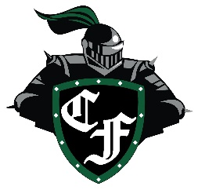

CFHS Football Booster Club Membership Form

|  |  |
| --- | --- |
| Parents/guardians |  |
| Email |  |
| Phone # |  |
| Player Name | Grade: |

Booster Club Membership Levels:

|  |  |  |  |
| --- | --- | --- | --- |
|  | Knight | $500 | Includes: Player fee, name on web, full page ad program, football duffel, drawstring bag, yard sign, decal |
|  | Sword | $250 | Includes: player fee, name on web, half-page ad program, drawstring bag, yard sign, decal |
|  | Shield | $100 | Includes: Player fee, drawstring bag, decal |
|  | Shout-Out | $300 | For Non-football students  Includes: full page ad & program |

Mail form to POB 299, Kemah, TX 77568 or email to: [clearfallsfootballbooster@gmail.com](mailto:clearfallsfootballbooster@gmail.com) or join at Booster Club table at football program event.

Cash, Card, Check (payable to CFHSFBBC), or Venmo @ClearFallsFootball-BoosterClub

(For Booster use: SWAG given: _____________)