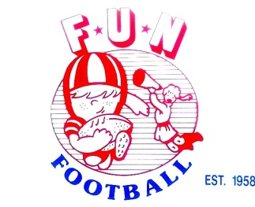
FUN FOOTBALL SOUTHWEST INC.
Dear League Organizers:
Football United National, Inc. (FUN) will sponsor its Annual Greater Houston FUN Football Super Bowl XXX and Tournament on December 12, 13, and 14, 2025. Over the years, this event has successfully hosted hundreds of teams who have enjoyed good competition in a football friendly environment. The event’s location is on the beautiful FUN Football Stadium 6400 Bissonnet Street, Houston, Texas 77074
.
Payment must be in Cash AP($funleaue), Zelle(funfootball@hotmail.com) or credit card(admin charge will be added), or money order. So, ACT NOW and don’t be one of those teams left out of the excitement this year! Fee $300 prior to November 22, 2025. After $350.
Event Details
1) Teams will be competitively matched based upon age and weight in brackets. Ideally, no more than 4 teams per bracket.
2) A roster showing your team name, each player’s age, weight, birth date and telephone number is due by December 1st
3) Original Birth Certificates or certified document must be provided for player certification, prior to your first tournament game.
4) Recommended team size is 25 players; only that number of trophies are provided.
5) Each team can have no more than 5 coaches with badges, plus a trainer, on the sidelines during games.
6) Coaches are not allowed on the field except during time out or injuries, and must wear their badge.
7) No “Select Teams” nor players from current year that played in FUN will be allowed with non-FUN teams.
7) The age and weight groups are as follows:
Freshman | Sophomore | Junior Varsity | Varsity | Flag(Min 3 teams required)
6 years or less  No weight limit | 8 and Under  No weight limit | 10 and Under  No weight limit | 12 and Under  No weight limit | 6 years or less  No Weight limit  Fee $150

**Ages are as of July 31 of current year.

8) Trophies will be awarded to the teams who advance to the championship game. Teams must participate in a awards game to receive awards. Note: Every team is scheduled 2 games(byes and forfeits count as game).

You may contact the Tournament Director, Marcus Brigance at mbrig1001@hotmail.com or text (832) 766-8758. Secondary contact is Funfootball@hotmail.com. Please pass on this information on to any other team/s you feel may be interested. Please act promptly as spots are limited and fill up quickly.

Sincerely,
Marcus Brigance, mbrig1001@hotmail.com
President FUN Football Inc.
-------------------------------------------------------------------------------------------------------------------------------
_____________________________________________ _________________________________________
Name of Organization Contact Person

_____________________________________________ _________________________________________
Address City, State, Zip

_____________________________________________ _________________________________________
Team Level (Freshman, etc.) Telephone Home/Work

. . . .
Email Address(Primary) Credit Card Number Exp.Date Security Code
Note: $5 processing fee for credit/debit card payments.

