- More
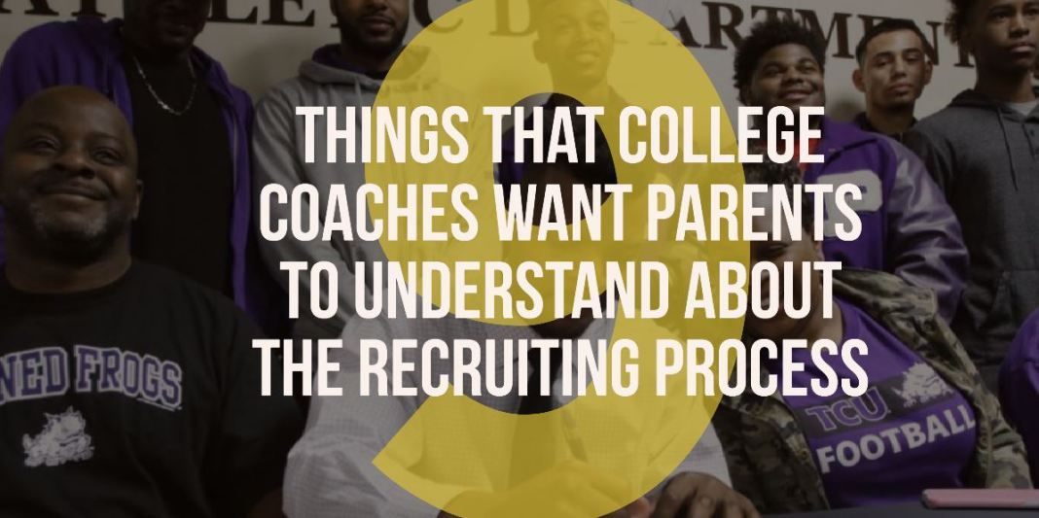

9 things that college coaches want parents to understand about the recruiting process
By Doug Samuels -
December 27, 2017

Share

Tweet

The amount of time that coaches put into recruiting prospects is impossible to pin down, and while different aspects of the recruiting process get a lot of attention, one area that does not get talked about enough is the parents role in recruiting.
The recruiting process can be intimidating, exciting, and a bit scary for parents to navigate, especially for those doing it for the first time.

–– ADVERTISEMENT ––
thanks for watching!
After talking with a number of college coaches over the past few days on the topic, coaches shared nine things that they want parents to understand about the recruiting process.
1 – Don’t be afraid to ask questions
The recruiting process can be daunting, unfamiliar territory for a lot of families, so don’t be afraid to ask coaches questions about different things as they come up. Coaches recruit a large number of kids every year and have likely handled a number of unique situations, so don’t be afraid to lean on them for some guidance every now and then.

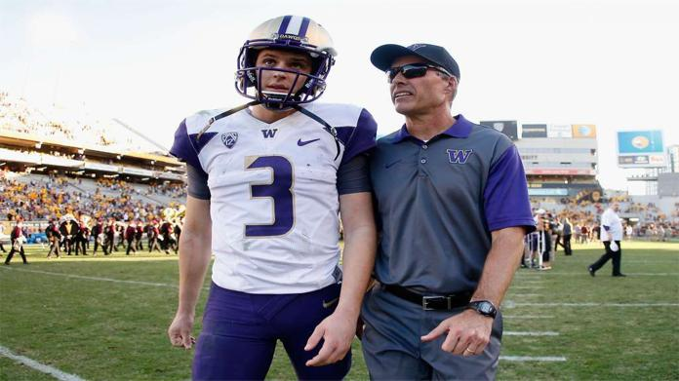

Sponsored By Connatix
2 – “Every offer matters”
One coach shared that you should treat every offer with care, adding “you could get dropped at any point, don’t ignore the smaller offers if you only have one or two Division I offers.” Also, if you’re looking at small colleges, it might surprise some parents that when weighing opportunities between NAIA programs that can offer athletic scholarships and Division III programs that can’t offer athletic money, you may end up being surprised at how close their financial aid packages are at the end of the day.
3 – Take all the visits you possibly can
I remember encouraging recruits and their families as a small college head coach to go out and visit as many campuses and coaching staffs as they possibly can because the only way to truly get a feel for if the place is a fit for you is being on their campus and around its people. I’ve had a number of coaches share that same sentiment. Taking the time to visit campus also shows the coaching staff you’re genuinely interested in their school and football program and not just flattered by the attention that recruiting brings.
4 – Make time for a game day visit
Getting on campus any time of year is important, but a number of coaches shared that it’s significantly more important to get to a game, especially during their sophomore or junior years in high school. One coach suggested going to visit a Division I, II, and III game during the prospect’s junior season because it will help to give both the prospect and the parents a feel for the size and skill of the players on the field, especially pregame and help to set realistic expectations of what level prospects should be looking to play at.
5 – Let coaches know up front how much you want to be involved in the recruiting process
Parents vary from situation to situation on how much they want to be involved in the recruiting process. Some want coaches to give them updates on the conversations they’re having with their son’s, while others prefer to hand over the reigns to their kid and let them lead the process. A number of coaches shared that setting clear expectations early on regarding how much they want to be involved is beneficial.
6 – Coaches that bash other programs should be a red flag
Negative recruiting is something that more than a handful of coaches encounter every year, so it’s understandable that this topic came up with a number of different coaches. Each one of them shared, more or less, the same sentiment – if they’re willing to bash other programs to help sell their own, why wouldn’t they do they same in other areas and where does that stop? Overall, coaches agree that it’s just not a good look.
7 – Stats don’t matter to 99% of coaches
There’s a reason that college coaches request game film and not stats when recruiting a potential student athlete. Just because a back runs for 1,500 yards and 18 touchdowns in the wing-t, or single wing, or just because a quarterback throws for 3,000 yards doesn’t mean he’s meant to play college football. Coaches want to see game film to see what kind of athlete a kid is, how he moves, how he reacts to adversity, how he competes, how he responds with his body language after a mistake, and all sorts of other things that stats can’t speak to.
8 – Encourage your kid to be honest and stress good communication
Few things are more frustrating to college coaches pursuing a number of prospects than A) getting the runaround from a recruit, and B) not being able to understand what a kid is looking for in an opportunity at the next level. Being able to articulate what your son (or daughter) wants in a school and athletic program is something that coaches shared is becoming increasingly rare for some reason. If a kid can communicate that, it can go a long way. The second part of that is being upfront and honest during the recruiting process. It can be very frustrating to not have a firm grasp on where a recruit stands, so stressing good communication can go a long way in relationships with college coaches.
9 – You, as parents, are often being evaluated as well
That’s right, coaches are also evaluating the parents of prospects as well. Just as coaches look for recruits that are a fit for their culture, they want parents who can fit in as well. No one wants headaches or media circus like being brought into the program like a certain famous dad out on the west coast has been known to bring with him wherever he goes.
Other things that coaches mentioned: “Don’t try to negotiate the cost of a school with small college coaches. Talk to people in admissions and financial aid,” “Learn about the academic programs of interest and talk to the professors in that department,” “We don’t care what your trainer says about your athletic ability.”
Earlier this year we shared a piece highlighting 12 recruiting red flags, according to college coaches across the country, so that may be of interest as well to those reading this.
Feel like there’s one we missed? Feel free to let me know at Doug@FootballScoop.com, or via Twitter @CoachSamz.

