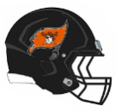 GET BETTER THIS SUMMER!  RYLE Football  2025  Youth Football Camp  ___________________________________  Monday (June 9), Tuesday (June 10) & Wednesday (June 11)    CAMP REQUIREMENTS:  What: Noncontact football camp emphasizing fundamental techniques and drills of every aspect of the game.  When: June 9, 10, & 11  Where: Larry A. Ryle High School  Who: MS=Grades 6-8 / Youth=Grades K-5  Time: 6:00pm – 8:00pm  Drop-off=5:45pm, Pick-up=8:10pm  Cost: $75 for all 3 Nights ($25 per Night) (If registered by June 1) –  All Camp Sign-Ups and Payment will be done through GoFan  GO FAN Events Payment Link  Waiver Form (Must be Completed)  See www.ryleraidersfootball.com for Links  What to bring daily:  - Jersey (tee shirt) and mouth guard  - Rubber Cleats and\or tennis shoes (be sure to bring tennis shoes (In case threatening weather forces the camp inside).  - 2 Tee shirts, shorts or sweat pants.  - Personal water jug (plenty of water will be on hand for those that don’t bring their own jug).  CAMP HIGHLIGHTS:  - Superior football instruction (Work with Ryle Coaches and Players)  - Players carefully grouped by age and ability  - Skill development drills with qualified staff  - Special Topics: nutrition, injury prevention, cross training,  and sportsmanship  - Daily training to develop speed, strength and agility  - Chalk talk and film sessions  - Timed and tested in variety of drills  - Campers work on conditioning, fundamentals and technique at individual positions, plus offensive and defensive team play.  - Each camper will receive a Ryle Camp t-shirt and a one-game pass for a varsity football game of the camper’s choice.  - There will be Concessions | 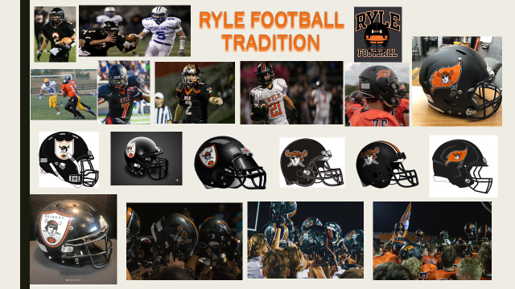  Registration  GO FAN Events Payment Link  Waiver Form (Must be Completed)  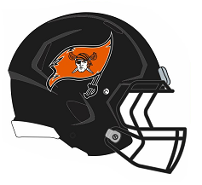  BURN THE SHIP!  Come See the Meaning!    