
Southern Plains Football League (SPFL)

Game Play Rules

TABLE OF CONTENTS

Section 1. | The Game
Section 2. | Scoring
Section 3. | Timing and Time Outs
Section 4. | Overtime Rules
Section 5. | Live Ball, Dead Ball, Possession, Out of Bounds
Section 6. | Distinctive SPFL Defensive Formation and Blitzing Rules
Section 7. | Distinctive SPFL Penalty Enforcements
Section 8. | Distinctive SPFL Special Teams Plays Rules
Section 9. | Inclement Weather Game Interruptions/Postponement Rule

Section 1. THE GAME
1.1 The Game
A. The game is patterned after American football
B. It is a contest between two (2) teams of nine (9) players.
C. The team scoring the most points at the end of regulation play is the winner. If tied at end of regulation, see Section 4 Subsection 4.2 to determine the winner.
1.2 The Field
A. The field dimensions can either be 40x80 yards plus 10-yard end zones, 55x80 yards plus 10-yard end zones, 40x100 yards plus 10-yard end zones, or 55x100 yards plus 10-yard end zones. Any dimensions not meeting these must be brought to the SPFL January League meeting for approval or denial.
B. The field will be properly mowed, with any holes filled and foreign objects removed or covered and protected.
C. At least one goal post of either NFHS Width (23’4”) or NCAA Width (18’6”).
D. Penalty for first reported violation for a non-regulation field is a warning; second violation will be a 15-yard unsportsmanlike conduct penalty against the violating team; third violation will be a 15-yard unsportsmanlike conduct penalty against the violating team and the violating team will be reported to the league staff and will become a traveling team for remainder of the season, including playoffs. The officiating crew will be notified by the league of the penalties to be administered. Field violations can be reported by the officials, the visiting team, a designated representative of any team, or any SPFL Board member.

1.3 The Ball
The SPFL Official Game ball will be a Wilson TDS or GST Leather or Composite. Kicker may bring his own ball in for kickoffs, extra points, and field goals – this ball must still be cleared by the officials prior to game time – who will mark the kicking ball with a “K.” Punts must use the ball that is in play at that point.
1.4 Rosters
A. Each team may dress a maximum of fifty (50) players.
B. Teams must abide by SPFL By-Laws as to the proper method of adding players to a roster.
C. The identity of all players may be subject to review by a roster check that can be conducted prior to or during a game at any point. Players found to be playing that are not on a team’s active roster will result in forfeiture of the game and all subsequent penalties as listed in the SPFL By-Laws.
1.5 Referee Clarifications
Head Coaches are the only individuals that may request an explanation from the Referee on interpretation or application of rules. A time out must be taken. If it is determined that there was a misapplication of a rule the team timeout shall be withdrawn. See NFHS Rule 3-5-11.
1.6 Player Positions
A. Offense
1. The offense must have five (5) players on their line of scrimmage with their shoulders substantially parallel to the line of scrimmage.
2. Of the five (5) players, three (3) players are designated as the center and guards (offensive lineman).
3. The center is the player who is over the ball in a position to snap the ball to a back.
4. The gap between downed guard-center-downed guard can be no more than 2 yards. If more than two yards, the offensive team can be penalized for illegal formation. Referees are allowed to use judgment on 2-yard width.
• Infraction: Illegal Formation (Live ball)
• Penalty: 5 yards
B. Defense.
A defensive player is on the line of scrimmage if he is within 1 yard of the neutral zone at the snap and inside the invisible box of 6 yards to the left and right of the ball.
1.7 Uniforms
A. Teams shall confirm and certify to the Referee that all players are properly equipped according to the uniform guidelines listed as follows.
B. All players must be numbered 0 through 99. Numbers must be prominently displayed in contrasting color on the front and back of the jersey. Player nameplates are optional.
C. If multiple players of the same team are to participate in the same game with identical numbers the team must notify the Referee and opposing team.
D. Numbers may be changed during a game only in the event of a damaged jersey. However, any changes shall be reported to the Referee and to the opposing team’s Head Coach.
E. Players of opposing teams shall wear jerseys of contrasting colors, and all players on a team shall wear jerseys of the same color and similar design. Such jerseys shall cover all pads worn under the jersey

F. All players shall wear the following mandatory equipment:
1. Football pants.
2. A legal helmet:
a. A helmet is legal if it has been NOCSAE approved and has a legal facemask and chinstrap. All helmets with face mask visors attached may be any color/tint but must have a speed release clip system. If the visor is not attached via speed release clip system, the visor will have to be removed before said player will be allowed to play or return to play.
b. All players on a team must have the same helmet shell color.
3. Football shoulder pads.
4. Football Jersey.
5. Mouth guard.
6. Football shoes suitable for football or turf activities.
G. Hip, thigh, tail, and knee pads are HIGHLY recommended, but not mandatory.
H. The Umpire is the sole judge of legal and illegal equipment and shall rule on such without appeal.
1.8 Referee Crew & Chain Crew
A. Each game shall be worked by a crew of a minimum of 4 officials, with all the officials being a state certified official in at least one of the following states: Minnesota, Iowa, South Dakota, Nebraska, or Wisconsin.
B. A crew of 5 officials shall be paid $750/game by the host team ($150 per official.). If a crew of 4 officials work said game, $187.50/official is paid.
C. The host team shall furnish chains/down markers and sideline markers, scoreboard and all staff to cover those responsibilities.
D. Back Judge Official needs to be the official counting down the play clock with hand up at 10 seconds, followed by a 5-second chop to signal to the Offensive team the nearing of the end of play clock.
Section 2. SCORING
2.1 Points for Scoring
A. The following points will be awarded:
1. Touchdown: Six (6) points
2. Safety: Two (2) points
3. Field Goal (3) points
4. PAT by scrimmage play: two (2) Points
5. PAT by placekick: One (1) point. The ball becomes dead at the moment the PAT place kick or dropkick is attempted. Neither team can advance the ball.
6. Returned PAT by defense to Team A’s end zone: Two (2) points. If defense gains possession of the ball by fumble recovery or pass interception during a point after touchdown attempt, they may score two (2) points by advancing it into the offensive team’s goal area.
Section 3. TIMING AND TIMEOUTS
3.1 Starting the Game
A. The game shall start promptly at the scheduled time.
B. See Section 9 for appropriate delay or postponement rules.
3.2 Playing Periods
A. The length of the game is forty-eight (48) minutes of actual playing time, divided into four (4) quarters, each twelve (12) minutes in length. The scoreboard clock is the official time for the game and shall be operated by a timekeeper under the direction of the Referee.
B. The intermission between the First (1st) and Second (2nd) Quarter and between the Third (3rd) and Forth (4th) Quarter may not be longer than three (3) minutes.
C. Halftime is Fifteen (15) minutes in length unless otherwise approved by the League Office or both teams and officials.
D. Overtime periods are authorized in the event neither team has scored more points than the other at the conclusion of the game.
3.3 Accelerated Timing Rule
A. Running time as per MSHSL rules which states: the clock will run nonstop if a team’s lead is 35 points in the fourth quarter but will operate normally if the margin subsequently shrinks to below 30 points.
B. The team that is behind by 35 or more points can elect to have a running clock once the game has reached the conclusion of the first half.
C. Once the running clock has started, it will continue for the rest of the game, except for TIP’s:
T – Officials’ and losing team time outs (leading team has no timeouts in the running clock time period but would be able to use any remaining timeouts should the running clock period end).
I – Injuries
P – Penalties.
D. Leading team failure to comply may be subject to forfeit.
Section 4. OVERTIME RULES
All overtime rules will follow NFHS guidelines
Section 5. LIVE BALL, DEAD BALL, POSSESSION, OUT OF BOUNDS
A. The ball is considered live and in play until the ball becomes dead. An official shall sound his whistle after the ball is dead. The whistle does not kill the play. The whistle is an aid to assist players in recognizing the fact the ball is dead.
B. A player has to be down by contact or give themselves up for the play to be over and the whistle sounded. In other words, a player that falls to the ground on their own volition can get up and continue the play.
C. A runner declares himself down by:
1. falling to the ground, or kneeling, and clearly making no immediate effort to advance, or
2. sliding feet-first on the ground. When a runner slides foot first, the ball is dead the instant he touches the ground with anything other than his hands or his feet
Section 6. DISTINCTIVE DEFENSIVE FORMATION
AND BLITZING RULES
6.1 Defensive Line of Scrimmage
The maximum number of defensive players that may be lined up on the defensive line of scrimmage when the offense initially becomes set is 4. The defensive line of scrimmage is defined as being within 1 yard of the neutral zone and no more than 6 yards to the left and right of the ball.
Infraction: Illegal Formation (Dead ball): 10-yard penalty

6.2 Blitz Eligibility Rule – Including special teams (i.e. Field Goal Kicks, PAT Kicks, 2pt PAT attempts, & Punts)
A. Only eligible defensive players may blitz past the line of scrimmage after the snap. To be eligible, the defensive player must be inside the “Blitzing Box” when the offense initially becomes set.
B. A non-blitz-eligible player who inadvertently crosses past the offensive line of scrimmage and upon realizing this, takes himself out of the play, will not be penalized.
C. The “Blitzing Box” is a rectangular box 6 yards on either side of the ball and 5 yards behind the defensive side of the ball (i.e. 12 yards wide x 5 yards deep).
D. The Blitz Eligibility Rule ends when:
1. Once the QB becomes a runner
2. QB exhibits the intent to run
3 QB hands the ball off to another player
4. QB goes beyond the width of the blitz box
5. Any loose ball from the time of the snap.
Infraction: Illegal Blitz
a. 1st offense for a player: 15-yard penalty and warning for the player
b. 2nd offense for a player: 15-yard penalty and disqualification
If the officials deem player safety to be at risk during an illegal blitz, the officials should sound their whistle and terminate the live ball play.

Section 7: DISTINCTIVE SPFL PENALTY ENFORCEMENTS
In general, the SPFL will follow the National Federation of State High School Associations (NFHS) rules for penalty enforcements, using the prior year’s rules (e.g. the 2026 season will follow the 2025 NFHS rules), with the following exceptions:
7.1 Targeting Rules
A. Penalties for Targeting: When in question, it is a foul!
Penalty: 15 yards from the succeeding spot. Automatic first down for fouls by Defense. Player is automatically disqualified from the game.

B. For fouls in the first half: Disqualification for the remainder of the game.
C. For fouls in the second half: Disqualification for the remainder of the game and the first half of the next game. If the foul occurs in the second half of the last game of the season, players with remaining eligibility shall serve the suspension during the first game of the following season.
7.2 Defensive Pass Interference
A. The SPFL enforces defensive pass interference calls with a spot of foul penalty, and automatic First down. If the penalty occurs in the end zone, the ball is placed at the one-yard line.
B. At the referee’s discretion, if the pass is considered uncatchable, pass interference may be reversed or not called at all.
7.3 Holding
Defensive holding is enforced as a 10-yard penalty from the previous spot and an automatic first down.

7.4 Blocking Below the Waist
A. The SPFL does not allow any blocking below the waist.
B. Penalty for an illegal block is 15 yards and a warning for the player involved
C. A second violation is a 15-yard penalty and game ejection disqualification of the player in violation. Player can also then face further discipline from the league to include, but not limited to, further suspension or expulsion from the SPFL and Ejection fines will apply.
7.5 Hurdling
Hurdling is not a foul in the SPFL.
7.6 Sportsmanship Warnings
When a game participant (coach, player, or any other team affiliated personnel) exhibits poor sportsmanship behavior that in the opinion of an official does not rise to the level of a 15-yard unsportsmanlike conduct foul, the official shall issue a sportsmanship warning to the offending team. The official shall indicate the foul by throwing their flag at the time the conduct occurs. The warning shall be issued during the dead ball period if the conduct occurs during a dead ball period or at the next dead ball period if the conduct occurs during a live ball period.
There is no yardage penalty assigned to the first warning issued to a team and the clock shall maintain the same status as it had at the time the warning is issued.
For a second warning, the penalty is a 5-yard penalty enforced from the succeeding spot.
The clock shall maintain the same status as it had at the time the warning is issued.
If a team continues to exhibit poor sportsmanship, all additional infractions shall be penalized under NFHS Rule 9.
The signal for a Sportsmanship Warning shall be an open hand over the mouth.
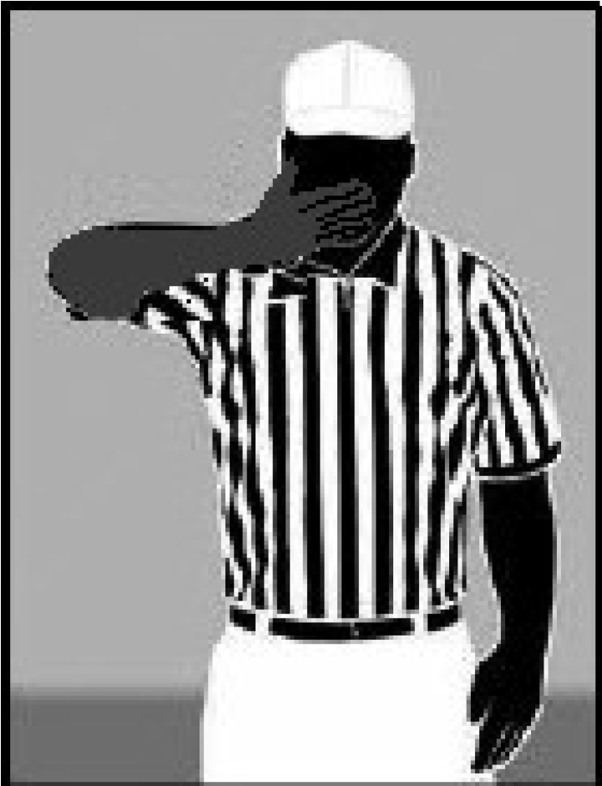
Section 8: Distinctive Special Teams Play Rules
A. The SPFL treats Special Teams Plays – (i.e. Field Goal Kicks, PAT Kicks, 2pt PAT attempts, & Punts) the same as a normal offensive plays and defensive rules apply including the limitation of the number of defensive players on the line of scrimmage and the blitzing rule.
B. Following an unsuccessful Field Goal Attempt during which the kick becomes dead beyond the neutral zone and was untouched beyond the neutral zone by the return team, the succeeding spot will be the previous spot. Otherwise, NFHS scrimmage kick enforcement rules apply.
C. Kicking Line Formation – Teams may line up no less than 3 players on each side of the kicking formation on kickoffs.
D. A Defense illegal formation penalty on a PAT allows the offensive team to enforce the 10-yard penalty on the subsequent kickoff or a half the distance penalty from the spot of try.

Section 9. Inclement Weather Game Interruptions/Postponement Rule
A. Game Not Started
If game has not started and needs to be postponed to another time and or date due to inclement weather, the hosting team must notify the visiting teams immediately andalso notify the league commissioner. If the hosting team has lights on the field and a minimal delay lasting no more than 1 hour can result in the game being played, both teams and officials are to remain to play out the game. If the hosting team does not have lights on the field, then an alternate date and time must be agreed to by both teams’ officials and the league commissioner to make up the game date.
B. Game in Progress Before Halftime (Regular Season & Playoff)
If a game has to be terminated and the progress of the game is in that it has not reached halftime, the entire game will be replayed on an alternate date and time that must be agreed to by both teams’ officials and the league commissioner to make up the game date.
C. Game in Progress After Halftime (Regular Season Game)
If a game has to be terminated and the progress of the game is in that it has surpassed halftime, the game will end with the winning team being the team ahead at the time of termination. If the game is scoreless or a tie, than the game will end in a tie.
D. Game in Progress After Halftime (Playoff Game)
If a game has to be terminated and the progress of the game is in that it has surpassed halftime, the game will end with the winning team being the team ahead at the time of termination. If the game is scoreless or a tie, the remainder of the game will be played out on an alternate date and time that must be agreed to by both teams’ officials and the league commissioner to make up the remainder of the game.
E. Championship Game in Progress
If the championship game has to be terminated at any point of the game after opening kickoff, the remaining portion of the game will be played out on the most immediate date that can be agreed to by both teams and approved by the league. If the game has to be continued both teams are only allowed to play the players that were present for roster check at the onset of the initial Championship kickoff.
F. Heat Related Delay
Prior to the scheduled kickoff if heads of both teams and the officials meet out of concern over the heat index which is measured in Temperature and Humidity, the game can be delayed up to no more than one hour from the scheduled start time to assist in allowing the heat index to lower, unless previously agreed on by the league. Referees are instructed to have an increase in official’s timeouts to allow for water breaks at a minimum of one per quarter or more at their discretion.

