**COME CELEBRATE WITH THE**

**$115**

Includes golf, cart & meal

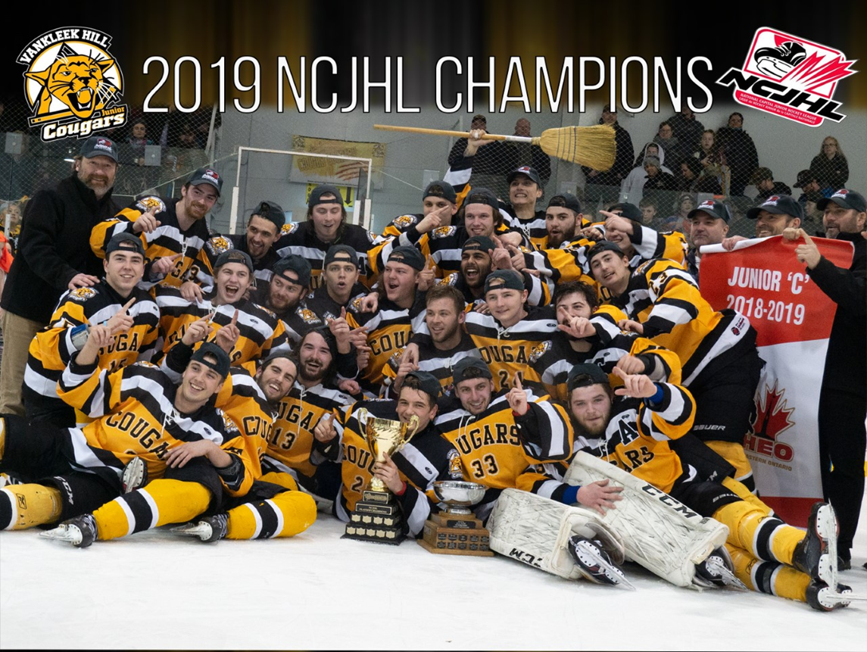

**VANKLEEK HILL COUGARS ANNUAL**

**GOLF TOURNAMENT FUNDRAISER**

**SATURDAY JUNE 15TH, 2019**

**AT THE HAWKESBURY GOLF & CURLING CLUB**

**SHOTGUN START AT 1PM**

**To register contact:**

**Marc Berniqué: 613-330-2271 /** [**marc.bernique@hotmail.com**](mailto:marc.bernique@hotmail.com)

**or**

**Franky Dopelhamer: 613-678-0574 /** [**fdopelhamer@ivacorm.com**](mailto:fdopelhamer@ivacorm.com)

**or**

**Greg McEachern: 613-677-3579 /** [**gregmceachern3@gmail.com**](mailto:gregmceachern3@gmail.com)

**or**

**on our website: vankleekhillcougars.net**