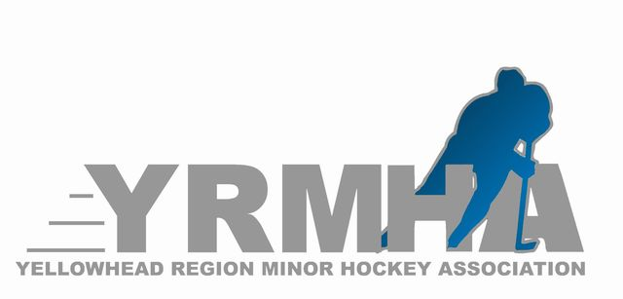

Yellowhead (Region Minor) Hockey – Annual Meeting
Minutes – Wednesday, September 1, 2021

The Annual Meeting of the Yellowhead Region Minor Hockey Association was held on Wednesday, September 1, 2021 via Zoom video conference. Director, Jeff Hume, presided over the meeting with members of all regional organizations present.

Attendees

Jeff Hume (Director)
Shelly Nichols (Vice-Director, Female)
Alison Swereda (Vice-Director, Development)
Andrea Smith (Secretary / Treasurer)
Alison Swereda (North Rep)
Wyatt Rapsky (ref in Chief)
Ken Morrice
Mark Stainer (South Rep, Birtle)
Amanda Lelond (Rivers)
Trevor Peters (Rivers)
Ben Howard (Miniota)
Brent Brennand (Elkhorn)
Brian Kay (Shoal Lake)
Ty Burton (Minnedosa)
Carla Gambler (Waywayseecapo)
Bradley Hall (Erickson)
Briane McDonald (Strath)
Ryan Smith (Neepawa)
Shawna Siemens (Elkhorn)
Sheldon Strachan (Hamiota)
Danton Hintz (Hamiota)
Greg Facey (Hamiota)
Troy Luhowy (Coach Coordinator, Tri-Valley)

- Call to Order
  - Director Jeff Hume called the meeting to order at 7:05pm. All attendees introduced themselves.

- Minutes
  - Minutes of the April 28, 2020, Annual Meeting, were confirmed to have been read by all in attendance by the Secretary.
  - MOTION: Ryan Smith, Ken Morrice
  - “That minutes of the April 28, 2020, Annual meeting be adopted as presented.”
  - MOTION CARRIED

- Reports
  - Directors Report – Scholarships were handed out this year to Cole Stainer & Liam Bachewich
Provided by Jeff Hume
  - Vice Director (Female Hockey) Report – Provided by Shelley Nichols
        - U18 - 41 registrants
        - League to Start October 2
        - U15 – 21 Players Registered
  - Vice Director (Development) Report – Provided by Alison Swereda
        - U15 43 registered as of September 2
        - U18 37 registered as of September 22, 2020

  - Treasurer – Provided by Andrea Smith
    - Andrea Smith presented the interim Income and Expense report for September 2020 as we are still working on getting into Sunrise Credit Union
    - MOTION: Alison Swereda, Ryan Smith
      - To be able to do online banking and etransers starting for the upcoming 2020 -2021 season”
      - MOTION CARRIED
    - MOTION: Brian, Bradley Hall
      - “That the treasurer can purchase a laptop and Quickbooks”
      - MOTION CARRIED
    - MOTION: Ryan Smith, Shelley Nichols
      - “That Yellowhead Region Minor Hockey add Andrea Smith on as Treasurer”
      - MOTION CARRIED
    - MOTION: Allison Swereda, Shelley Nichols
      - “That the YRMA remove Dan Johnson & Shirley Wowryk from all banking and banking accounts”
      - MOTION CARRIED
    - MOTION: Ryan Smith, Shelley Nichols
      - “That the Financial Statement from April 27, 2020 to Sepember 2, 2020 be adopted as presented.”
      - MOTION CARRIED
  - Coaching Coordinator Report – Provided by Troy Luhowy
        - Nov 2 Checking Clinic – Hamiota 9 am
        - Nov 3 Coach level 2 – Hamiota 9 am
        - Oct 10 Coach Level 1 – need host
        - Nov 7 Checking Clinic – Tri Valley
        - Nov 8 Coach level 2 – need hist Provided Troy Luhowy
  - Referee Coordinator Report –
        - 1 & 2 ref clinic will be face to face
        - Level 3 ref clinic will be done on zoom
        - 4 clinics – Neepawa, Hamiota, Rivers, Elkhorn
Provided by Wyatt Rapsky
- Other Business
  - Age groups have changed across Canada and Hockey Manitoba
  - Regional Name and logo may be in question for next year. Decided on a subcommittee to do research
  - Play In tournaments
        - U11 Birtle Jan 21-24
        - U13 Rivers Jan 2-31
        - U15 Minndosa Feb 5-6
        - U 18 –Will be played as a best of 3 to see who does to provincials

  - Development Weekend – January 23-24
  - Return to play – all documents need to be filled out and sent to Jeff Hume for Friday September 11 including a rink policy
- South Rep – to be tabled until a later date

- Next Meeting & Adjournment
  - NEXT MEETING – Semi Annual meeting will be held December 9th 7:00 pm in Hamiota
  - Adjourned by Ken Morrice at 8:45 PM

____________________________________ _______________________________
Jeff Hume, Director Andrea Smith, Secretary-Treasurer

