**Cross Country Yard Sign Anyone?**

How about a Cross Country yard sign? We are ordering coroplast signs with metal stakes. The signs and stakes are $25. The sign will look like the example below, but with **your** runner’s first name on it and will come with yard stakes.

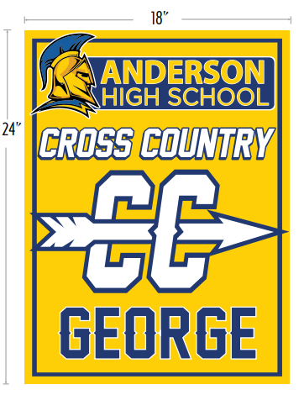

To order:

1. E-mail Lynne Stein at [lynnestein4108@gmail.com](mailto:lynnestein4108@gmail.com) with your runner’s name and your address (for delivery purposes only) by **Monday, August 16th**.
2. Send the $25 via Venmo: @Michele-Guzman-7

-OR-

Write a check for $25 payable to Anderson High School with “Cross Country yard sign” in the memo section and mail it to:

*Michele Guzman, 3207 Benbrook Drive Austin, Texas 78757*

Your sign will be personally delivered by the yard sign delivery team!