SCHOOL CASH ONLINE INSTRUCTIONS
https://austinisd.schoolcashonline.com

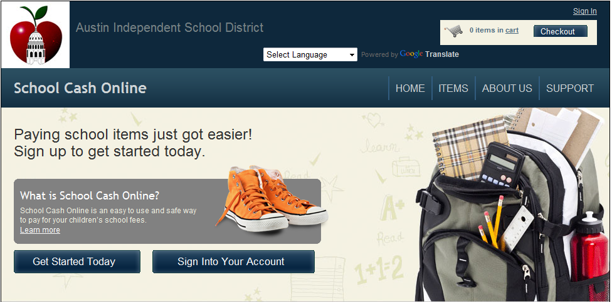

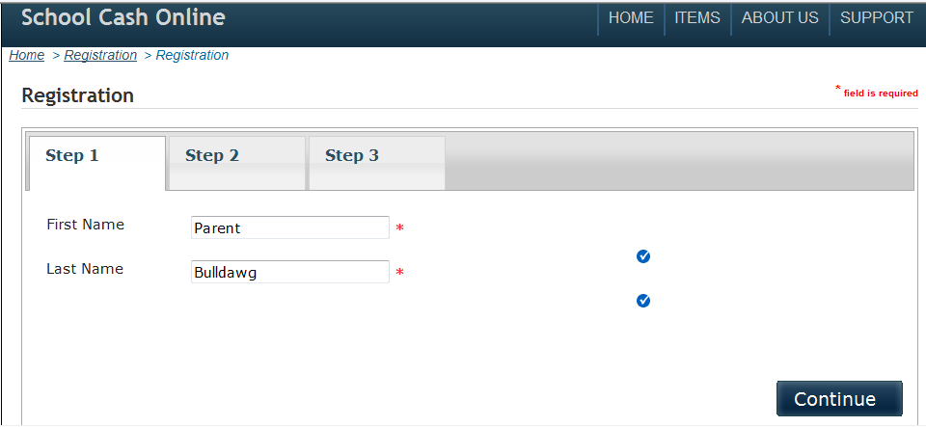

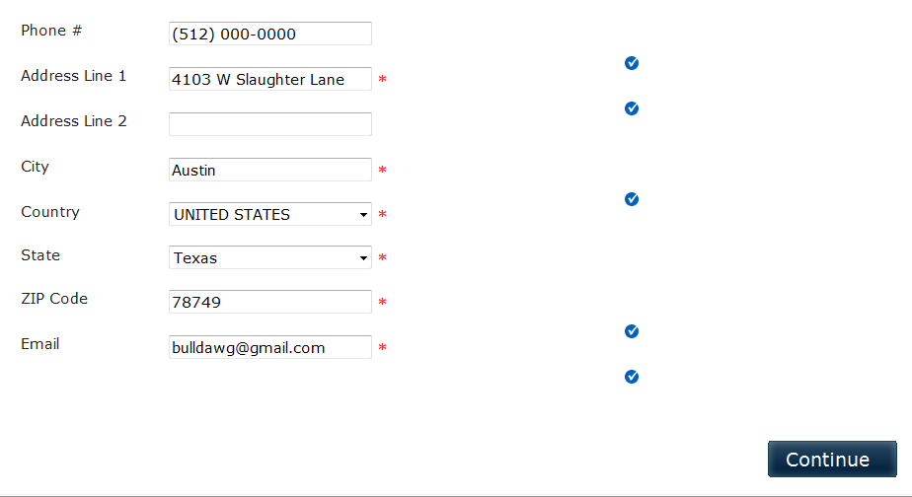

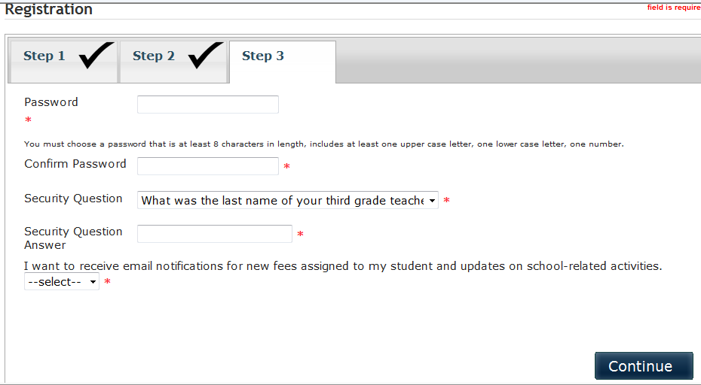

You will receive an email asking you to confirm your email address.

Going forward, you can then log in to your account, assign your student(s) to your account and view all items that are listed for your student(s) or available for the general public.
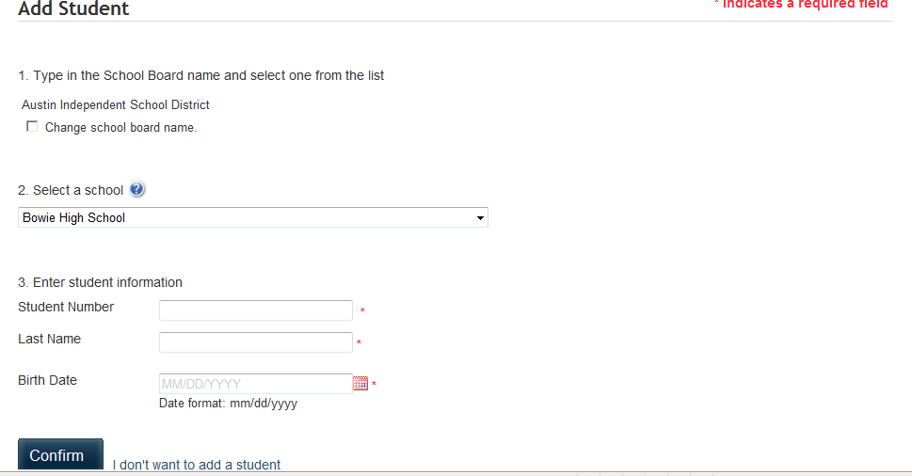

HINT:
When you are ready to pick your item, click on “Show All Items”, then when the next screen comes up, click on the arrows in the “School” box. This will put the schools in alpha order and make it easier to find your item.
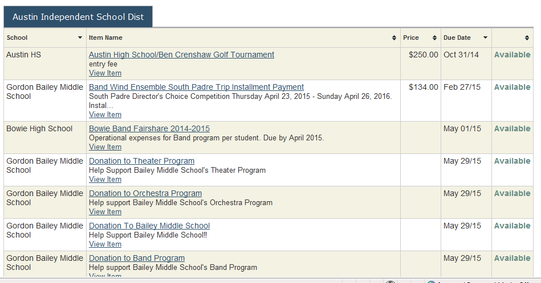
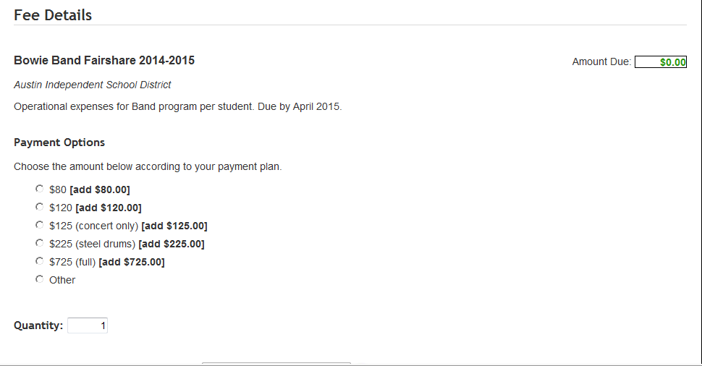
Select your payment amount and add it to your cart.
You can add as many payments as you want to your cart before you check out.
School Cash Online accepts major credit cards as well as echecks.
For FAQ & Email assistance:
https://austinisd.schoolcashonline.com
(scroll to bottom of home page)

