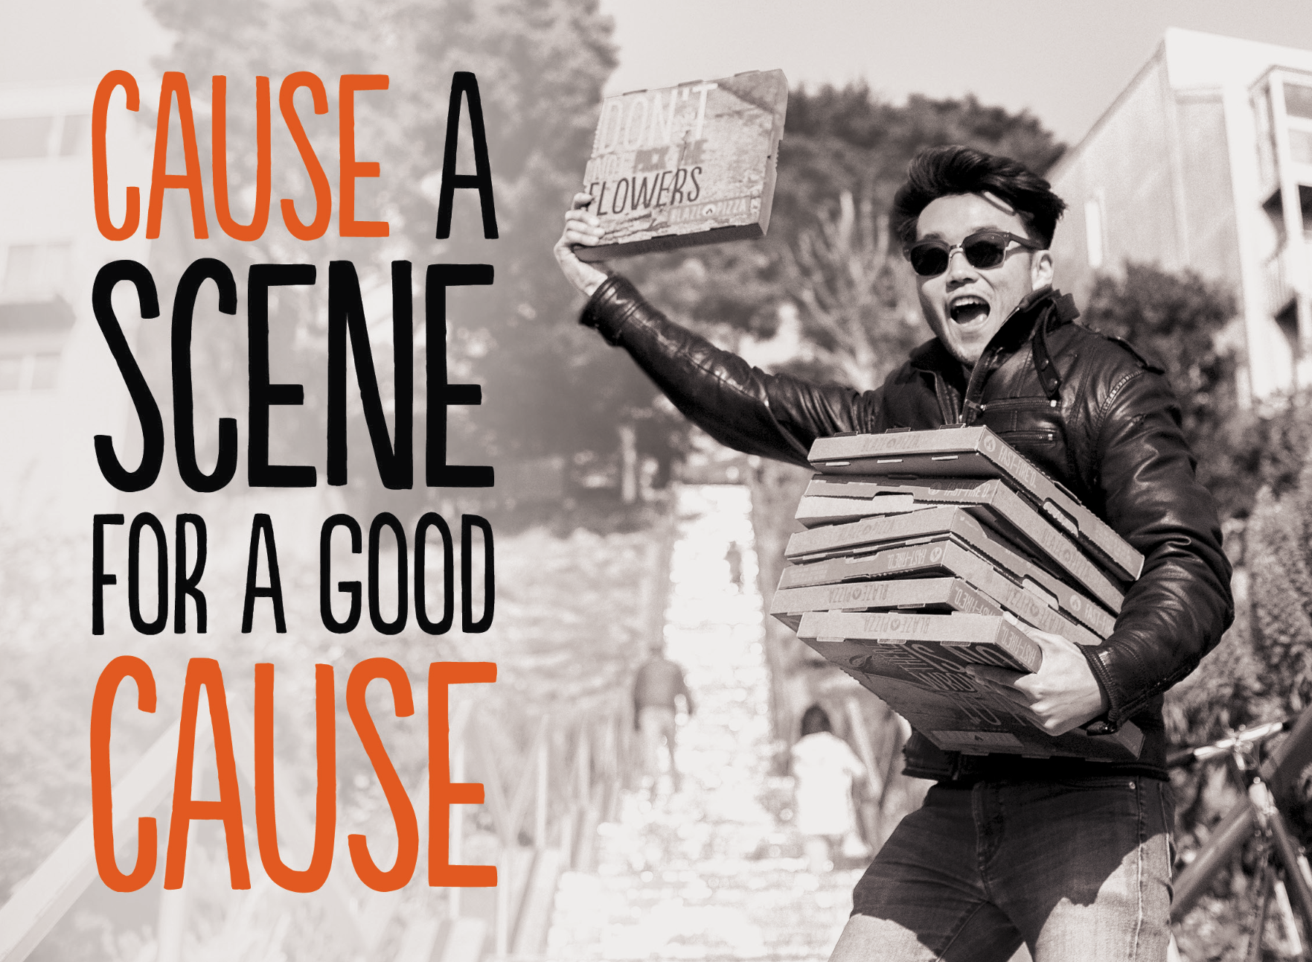

Enjoy yourself and support our cause at a special
fundraising event for:
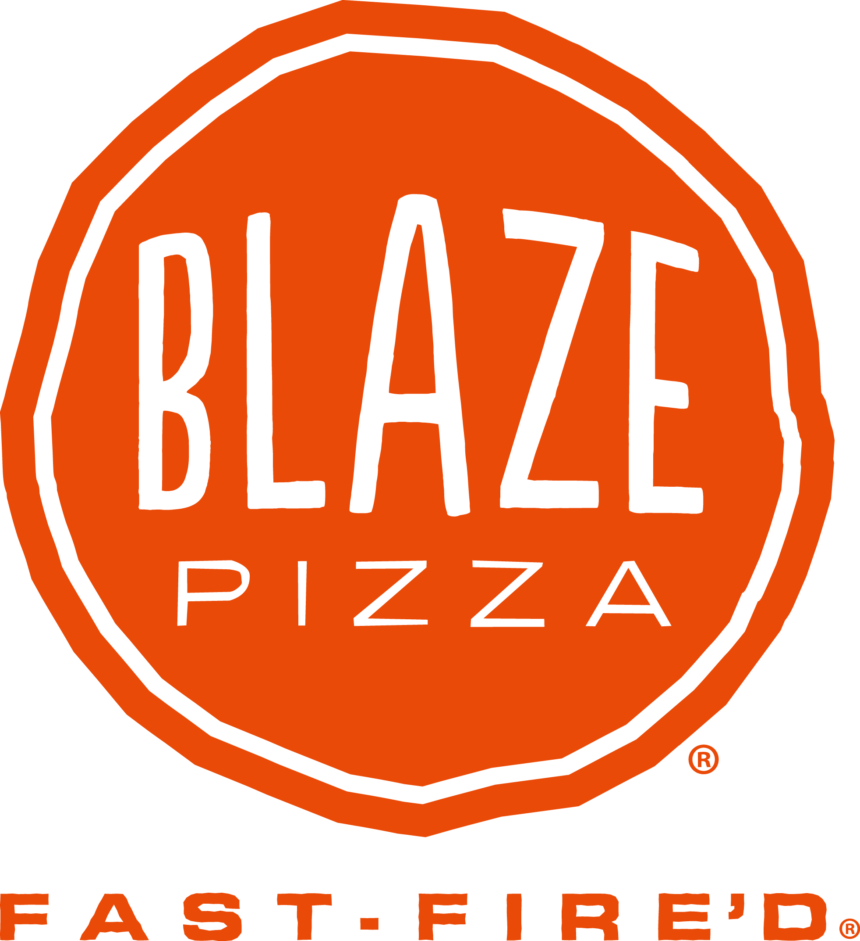
Organization Name: JBHS Aquatics
Date: March 26,2019
Time: 4pn to 10pm
Location: 1723 N. Victory Pl. Burbank

Bring in this flyer or show it on your phone before paying. Blaze Pizza will donate 50% of proceeds from your meal back to our organization.

