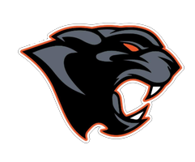Central York Wrestling
PO BOX 3733
York, PA 17402
CYPantherswrestling@gmail.com
To whom it may concern,
Central York Wrestling Booster Association is a non profit organization that exists to support the K-12 wrestling programs at Central York School District. We do multiple fundraisers over the year and have a few large events coming up that we need the community's help with!
Each year the booster club works in collaboration with the school district and other York Adams districts to put on the SCAC Wrestling Championships. Central York hosted the inaugural 2025 event and is again hosting in 2027. This year's event will be running Friday January 8, 2027 through Saturday January 9, 2027 and features all 20 SCAC wrestling teams, both boys and girls… It is a huge event!
This year the Central York Wrestling Booster Association is seeking food donations from area restaurants as well as low cost options to stock the coaches room, ref room and concessions stand with delicious options for participants, families, and event staff. If you are able to help us with any donated food items for breakfast, lunch, or dinner etc please let us know by contacting our fundraising chair, Ana Knight, at 717-512-5658 or Anaknight@comcast.net. We greatly appreciate any help you can give us with these requests and look forward to hearing from your organization.
Sincerely,
The Central York Wrestling Booster Association

