**STRONGHOLD WRESTLING RELEASE AND WAIVER OF LIABILITY, ASSUMPTION OF RISK, AND INDEMNITY AGREEMENT**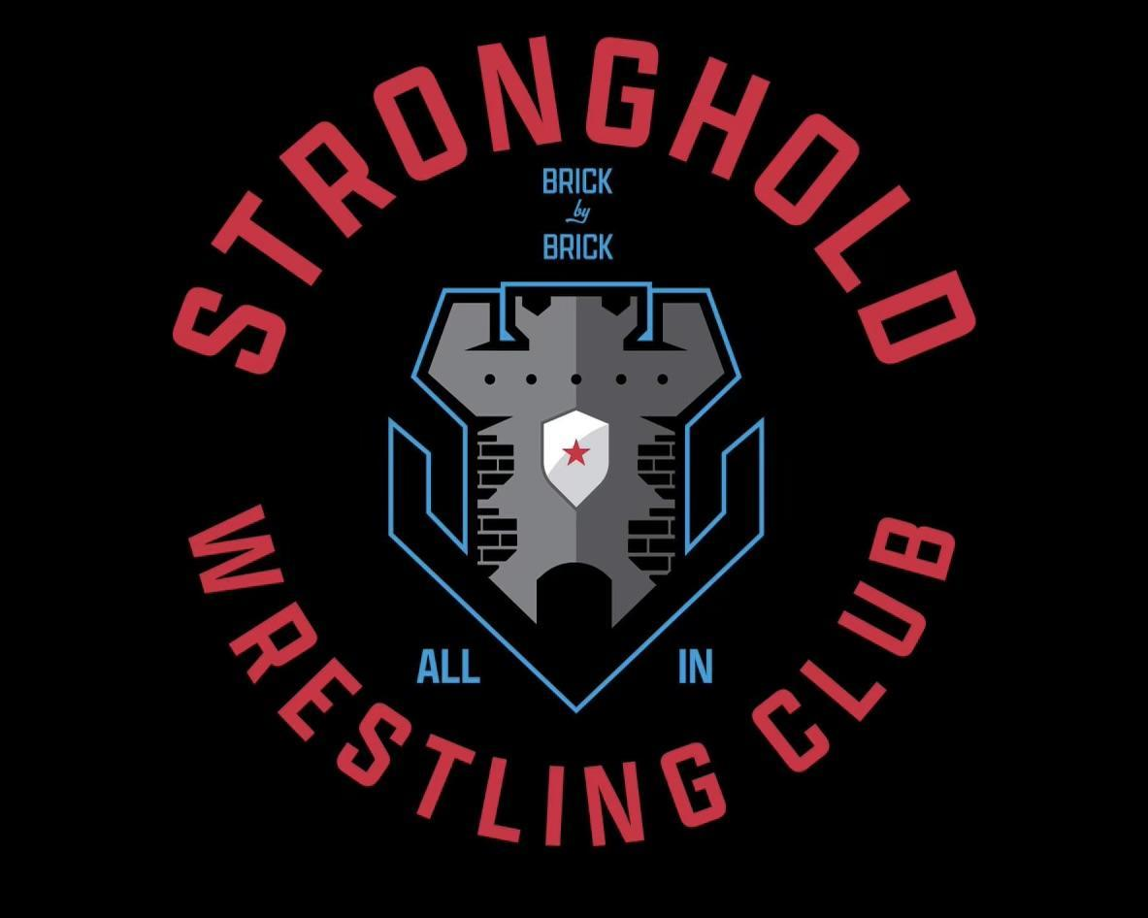

IN CONSIDERATION of being permitted to participate in any way in any event ("Activity") at any time for myself, my personal representatives, assigns, heirs, and next of kin:

1. ACKNOWLEDGE, agree, and represent that I understand the nature of the Activity and that I am qualified, in good health, and in proper physical condition to participate in such Activity. I further agree and warrant that if, at any time, I believe the conditions to be unsafe, I will immediately discontinue further participation in the Activity.

2. FULLY UNDERSTAND that: (a) THIS ACTIVITY INVOLVES RISKS AND DANGERS OF SERIOUS BODILY INJURY, INCLUDING PERMANENT DISABILITY, PARALYSIS, AND DEATH ("Risks"); (b) these Risks and dangers may be caused by my own actions or inactions, the actions or inactions of others participating in the Activity, the conditions in which the Activity takes place, or THE NEGLIGENCE OF THE "RELEASEES" NAMED BELOW; *(*c) there may be OTHER RISKS or SOCIAL AND ECONOMIC LOSSES either not known to me or not readily foreseeable at this time; and I FULLY ACCEPT AND ASSUME ALL SUCH RISKS AND ALL RESPONSIBILITY FOR LOSSES, COSTS, AND DA*M*AGES I incur as a result of my participation, or that of the minor, in the Activity.

3. HEREBY RELEASE, DISCHARGE, AND COVENANT NOT TO SUE the sanctioning organization(s), their administrators, directors, agents, officers, members, volunteers, and employees, other participants, officials, rescue personnel, sponsors, advertisers, owners and lessees of Premises on which the Activity is conducted, (each of the forgoing shall be considered one of the RELEASEES herein) FROM ALL LIABILITY, CLAIMS, DEMANDS, LOSSES, OR DAMAGES ON MY ACCOUNT CAUSED, OR ALLEGED TO BE CAUSED, IN WHOLE OR IN PART BY THE NEGLIGENCE OF THE RELEASEES OR OTHERWISE, INCLUDING NEGLIGENT RESCUE OPERATIONS; AND I FURTHER AGREE that if, despite this RELEASE AND WAIVER OF LIABILITY, ASSUMPTION OF RISK, AND INDEMNITY AGREEMENT I, or anyone on my behalf, makes a claim against any of the Releasees, I WILL INDEMNIFY, SAVE, AND HOLD HARMLESS EACH OF THE RELEASEES from any litigation expenses, attorney fees, loss, liability, damage, or cost which may be incurred as the result of such claim.

4. I am aware that my name or my picture or my voice may appear in a print advertisement or other promotional material or be shown on the internet on a AYWA Web site or other Web site on which my picture can be seen on my voice heard on a recording and I hereby grant permission to AYWA to use my picture, voice, or name for these purposes.

I ACKNOWLEDGE THAT I AM AGE 18 OR OLDER, HAVE READ THIS AGREEMENT AND FULLY UNDERSTAND ITS TERMS, UNDERSTAND THAT I HAVE GIVEN UP SUBSTANTIAL RIGHTS BY SIGNING IT, HAVE SIGNED IT FREELY AND WITHOUT ANY IN DUCEMENT OR ASSURANCE OF ANY NATURE, AND I INTEND IT TO BE A COMPLETE AND UNCONDITIONAL RELEASE OF ALL LIABILITY TO THE GREATEST EXTENT ALLOWED BY L*AW* AND AGREE THAT IF ANY PORTION OF THIS AGREEMENT IS HELD TO BE INVALID, THE BALANCE, NOTWITHSTANDING, SHALL CONTINUE IN FULL FORCE AND EFFECT.

**MINOR RELEASE: (must be completed by Parent*/*Guardian for any participant under the age of 18)**

AND I, THE MINOR'S PARENT AND/OR LEGAL GUARDIAN, UNDERSTAND THE NATURE OF THE ACTIVITY AND THE MINOR'S EXPERIENCE AND CAPABILITIES AND BELIEVE THE MINOR TO BE QUALIFIED, IN GOOD HEALTH, AND IN PROPER PHYSICAL CONDITION TO PARTICIPATE IN SUCH ACTIVITY. I HEREBY RELEASE, DISCHARGE, COVENANT NOT TO SUE, AND AGREE TO INDEMNIFY AND SAVE AND HOLD HARMLESS EACH OF THE RELEASEES FROM ALL LIABILITY, CLAIMS, DEMANDS, LOSSES, OR DAMAGES ON THE MINOR'S ACCOUNT CAUSED, OR ALLEGED TO BE CAUSED, IN WHOLE OR IN PART BY THE NEGLIGENCE OF THE “RELEASEES" OR OTHERWISE, INCLUDING NEGLIGENT RESCUE OPERATIONS AND FURTHER AGREE THAT IF, DESPITE THIS RELEASE, I, THE MINOR, OR ANYONE ON THE MINOR'S BEHALF MAKES A CLAIM AGAINST ANY OF THE RELEASEES NAMED ABOVE, I WILL INDEMNIFY, SAVE, AND HOLD HARMLESS EACH OF THE RELEASEES FROM ANY LITIGATION EXPENSES, ATTORNEY FEES, LOSS LIABILITY, DAMAGE, OR ANY COST THAT MAY OCCUR AS A RESULT OF ANY SUCH CLAIM.

PRINTED NAME OF PARTICIPANT: ______________________________________________DATE:___________________________________

PARTICIPANT'S SIGNATURE: ____________________________________________________________________________________________

PRINTED NAME OF PARENT*/*GUARDIAN: ________________________________________________________________________________

PARENT/GUARDIAN SIGNATURE (if participant is under the age of 18): _________________________________________________________

ADDRESS: ____________________________________________________________________________________________________________

(Street)  (City)  (State*)* *(Zip)*

EMAIL:_____________________________________________________PHONE: __________________________________________________