MARTY MASON SCHOLARSHIP FUND

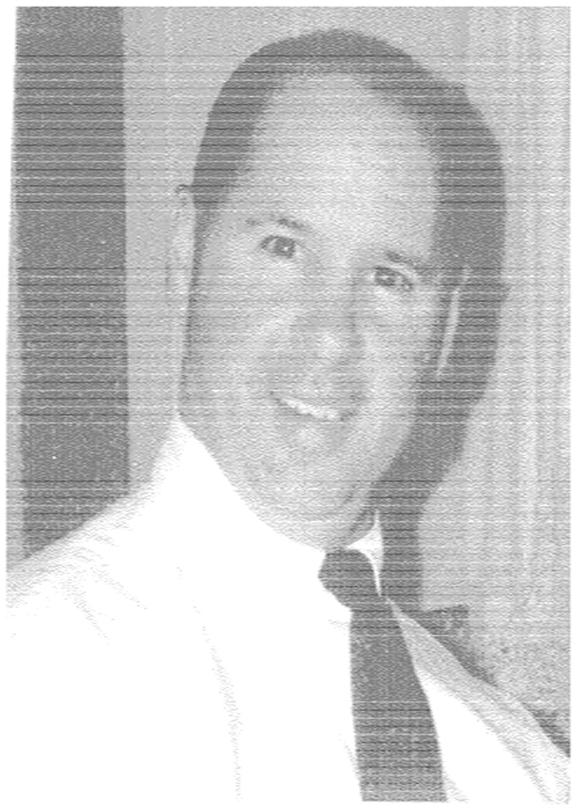

This award is being given to honor Mr. Marty Mason. Mr. Mason left a huge hole in the Bethel Park Boys Lacrosse Association with his sudden passing in October of 2006. By receiving this award, you have been selected as a person who strikes a balance between lacrosse and civic responsibilities. Please read the story below so you can become familiar with Mr. Mason and the beautiful story of his short, but well lived life.

Marty was involved in the Bethel Park High School lacrosse program since 1996, shortly after its inception. The program was quite different than it is today. There were no committees or volunteers. Marty lined fields, ran the clock, and just took care of all the activities involved in keeping the boys playing lacrosse as a team. As the program developed, Marty began to take on a leadership role. He served as vice president and president of the BPBLA. Marty along with his wife Linda used their own funds to expand the program to the middle school children in 2002.

Marty’s life consisted of more than lacrosse. He was a family man with a strong devotion to Linda and his sons. At his funeral the following eulogy was read:

“WHEN I THINK OF THE MASON FAMILY…….

What a wonderful HUSBAND Marty was – his respect for his beautiful wife was always evident. As a couple, they respected each other, worked so well together, and had fun along the way.

What a wonderful FATHER Marty was – his pride in his three sons was complete and unconditional. He was firm with discipline, but with so much love combined.

As a COACH, he made a positive mark on each and every young person he came in contact with. His energy was tireless. His knowledge of sports was shared so unselfishly.

As a ROLE MODEL – his generosity of time to family, worth ethic, time spent with son’s friends, were just the best.

Marty’s FAITH was important to him. He gave time to St Germaine’s School and Church, again with unselfishness and knowledge to help in any way he could.

He was a generous SON-IN-LAW – We were always impressed with how he kept Grandpa Kumer involved in everything the boys would be doing. An Oh was Grandpa always so proud of Marty, Linda and each and every son. He’d tell us many times over. You know how he could talk. Whatever sporting event we would be attending, we’d always enjoy sitting with him.

What a BEAUTIFUL LIFE he lived. He loved and was loved by many. He was respected by all who met him or spent time with him. He worked so hard to provide for his family. He made sure Josh and Matt received their college education. We first met Chris when very young, but have watched him turn into another Mason success as a Man.

MARTY AS A BROTHER…..

Marty was a brother and a friend……He was a natural leader that led by determination and with strength of conviction….He worked hard, was easily excitable, but was easily amused and found humor in most situations. He wasn’t afraid to show his feelings and was always easy to talk to. He made you feel comfortable, in that he always seemed in control of everything around him.

He was generous to his family and friends and had a special way of making others feel at ease…..

We watched him grow into one of the best Husbands….Father….Son…..and Brother. We are so proud to call Marty our Brother.”

It is the wish of the Mason family that this scholarship be awarded to a college or technical school bound student who has participated and benefited from Bethel Park Boys Lacrosse. The award recognizes academic prowess as well as player off-the-field community service in support of Marty’s core values - honesty, respect, willingness to help others, and a selfless attitude.

The criteria for the scholarship are:

- College or technical school bound high-school senior.

- Participated in Bethel Park Boys Lacrosse as a sophomore, junior, and senior.

- Demonstrated a commitment to lacrosse by participating in the fall (if not involved in another sport) and spring seasons and regularly attended practice sessions.

- Demonstrated leadership, teamwork, and good sportsmanship qualities around teammates and opposing players.

- Demonstrated caring, honesty, respect, and responsibility in daily life.

- Commitment to community service as a volunteer.

- GPA of 3.0 or higher.

Application forms can be downloaded from this Bethel Park Boys Lacrosse website. Applications must be submitted to Mike Hurley, Chairperson of the Selection Committee no later than May 15, 2007. The recipient of the one-year $1,000 Marty Mason Scholarship is determined by the Scholarship Selection Committee and will be announced at the lacrosse banquet on May 30, 2007.

Many people benefited directly or indirectly from Mr. Mason. By playing for the Bethel Park Boys Lacrosse Association, you too have benefited from his generosity. Thank you for carrying on a tradition of excellence, and best wishes for a successful future.

