Bath Lacrosse 2024
Name:________________________________ Contact #: ____________
Team Level:______________________
*All true to size, recommend sizing up on Adult Fleece Hoodie, especially if it will go in the dryer
T – Shirt & Long Sleeve: Screen Print Crew Neck: Screen Print
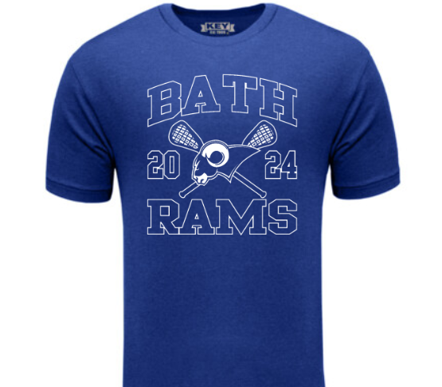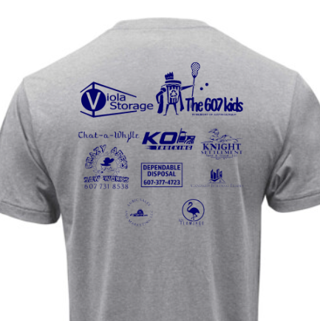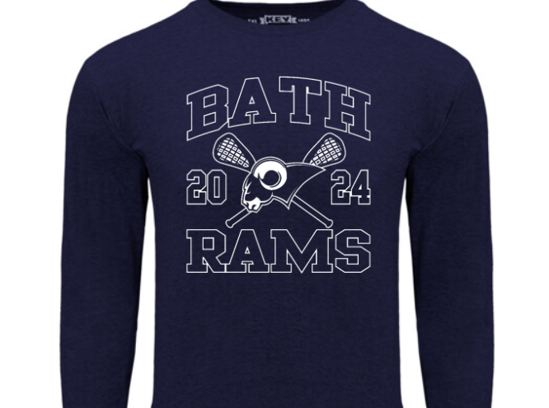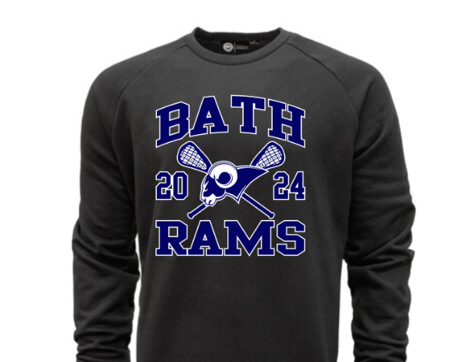
Polo: Embroidery ¼ Zip: Embroidery
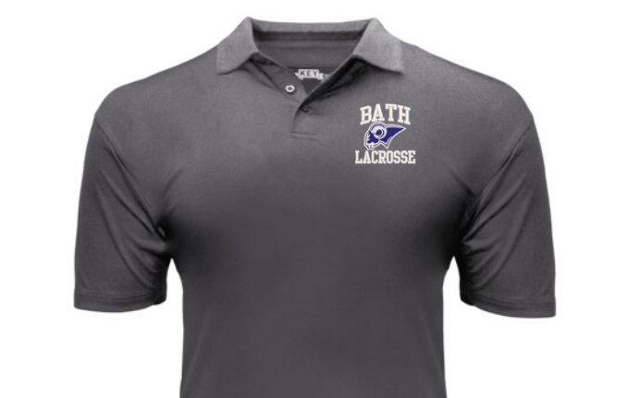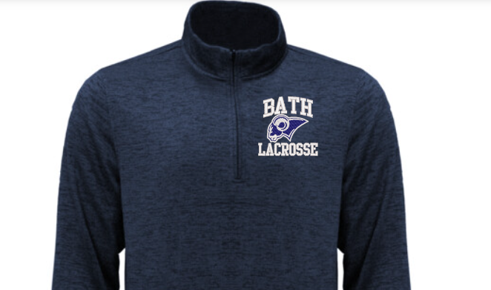
Hoodie: Screen Print *Tall Options available*
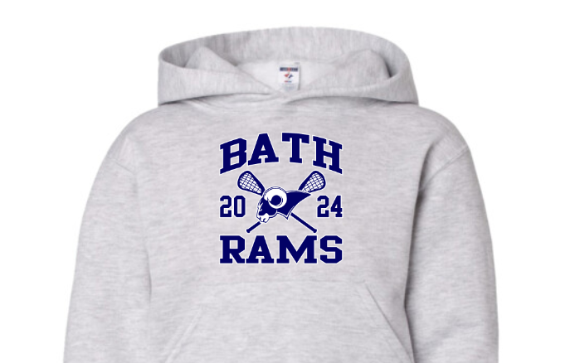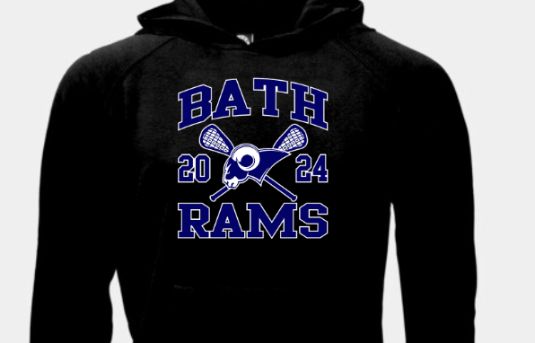
Hats: Embroidery 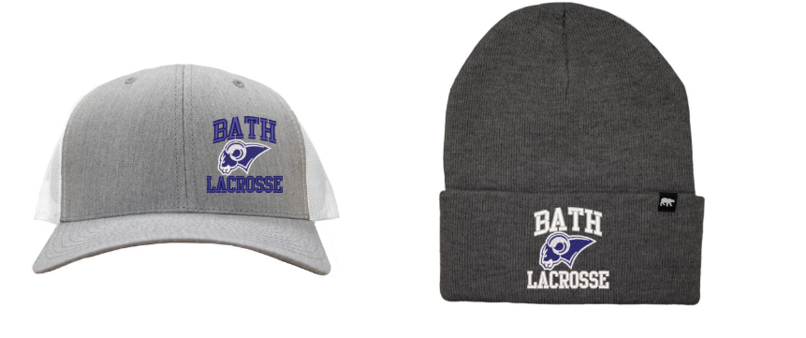
ALL ORDERS AND MONEY DUE APRIL 15TH
BATH LACROSSE ORDER FORM
Sell to all RAMS Family, Friends & Fans!
Item | Color | Price | XS | S | M | L | XL | 2XL | 3XL | 4XL
Adult T Shirt | Blue | $20
Adult T Shirt | Black | $20
Adult T Shirt | Gray | $20
Youth T Shirt | Blue | $18
Youth T Shirt | Black | $18
Youth T Shirt | Gray | $18
Adult Long | Navy | $25
Adult Long | Gray | $25
Adult Crew | Black | $35
Adult Crew | Gray | $35
Adult Polo | Black | $35
Adult Polo | Charcoal | $35
Adult Polo | LightGray | $35
Adult ¼ Zip | Charcoal | $45
Adult ¼ Zip | Navy | $45
Adult Hoodie | LightGray | $40
Adult Hoodie | Blue | $40
Adult Hoodie | Black | $40
Adult Hoodie | Charcoal | $40
YouthHoodie | LightGray | $35
Baseball Hat | Gray | $25
Winter Hat | Gray | $20

Example | Black | $40 |  | 1 |  | 3 |  | 2
6 items @ $40 = 240.00
Please call/text Branden at 607-368-7822 with any questions!
ALL ORDERS AND MONEY DUE APRIL 15TH

