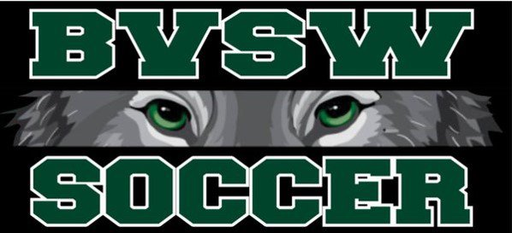

Blue Valley Southwest High School Team Soccer Camp
July: 11st-14th
Girls: 4:30-6:30
Boys: 6:30-8:30

Location: Blue Valley Southwest
Cost: $100
Payment Method Venmo or by Check
Check payable to:
Erik Jones
17600 Quivira Rd.
Overland Park, KS 66221
VENMO: @Erik-Jones-111

Scan to register Camp Registration


