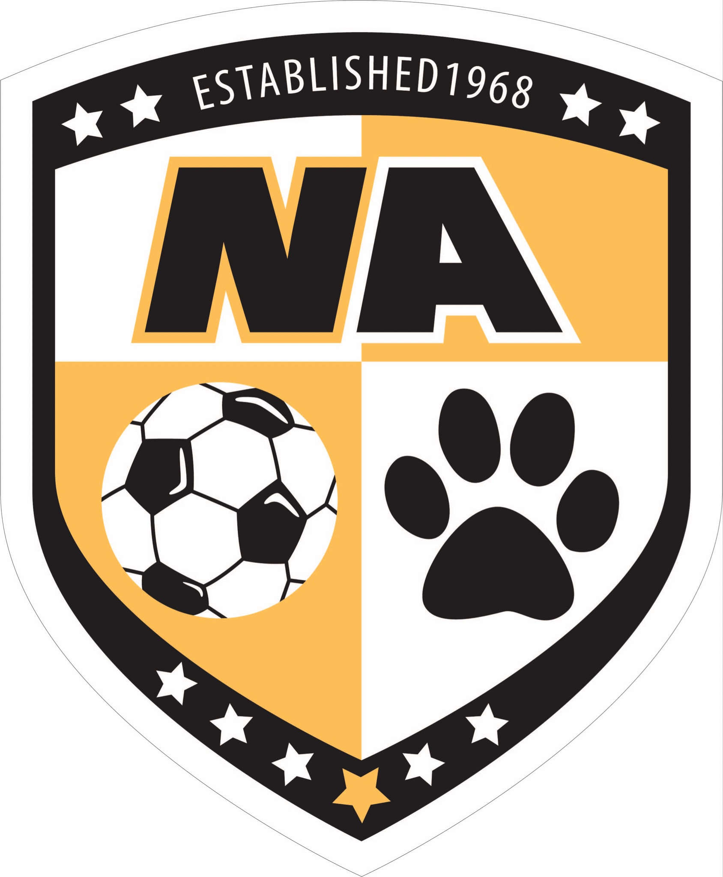
NA Boys Soccer Parent Orientation Meeting
June 2026

Introductions:

2026 Booster Board Members:
- President: Brian Sullenger (Contact info: 412-680-9768 or bmsullenger@gmail.com)
- Vice President: Micki Sanner
- Treasurer: Mike Herzog
- Concession Stand Coordinator: Jeff Vaders
- Special Events Coordinator: Need Volunteers
- Information Technology: Need Volunteer

Purpose of the Boosters:
- We are here to support the North Allegheny boys soccer program, athletes & coaches
- We are not involved with rostering, coaching or school administrative decisions
- We are a non-profit organization run by volunteers
- All Booster information can be found at https://www.naboyssoccer.com/

Communication:

- Email us with questions: natigersoccer@gmail.com
- Boosters website: https://www.naboyssoccer.com/
- All off-season communications will be through PlayMetrics.
  - Sign up at PlayMetrics.com
  - Coach Montero and the NABS Boosters will send periodic updates throughout the summer via PlayMetrics, so it is important you register
- All school-season communications will be through SportsYou.
  - Access is given to all families once NABS teams are announced.
- NA Athletics Boys Soccer website: http://athletics.northallegheny.org/boys-soccer
- NA Athletics App: Available to Download

Eligibility for Tryouts:

Complete the following by Saturday, August 1, 2026:
1. Completed ImPACT concussion test for rising 7th, 9th, 11th graders or those new to NA
2. Sports Physical (must be dated no earlier than 5/1/2026)
3. Family ID Registration (Opens on June 1st)
- Create an account if you are new or log in if you are a returning athlete
- Pay $75 participation fee

You can call the athletic office (724-934-7238) to verify you have completed all steps correctly because your son will not be able to try out without this being done.

Eligibility details: http://athletics.northallegheny.org/school-physical-information.

Tryouts:

- JV/Varsity tryouts are scheduled for August 17th, 18th & 19th
- Gold, Black & White Team tryouts will be held the Week of August 17th with the exact dates to be determined

Note: All NABS prospects must participate in all three days of tryouts

Summer Training Opportunities:

Coach Montero offers numerous opportunities for the boys to train over the summer through various training/conditioning sessions along with five summer camps. Attendance is not mandatory, nor will preferential treatment be given to boys who attend training sessions or camps when roster decisions are made, but the sessions/camps will improve players soccer skills and help the boys prepare for tryouts.

Montero Soccer Summer Camps

- Coach Montero has scheduled 5 summer camps (Weeks of June 8, July 20, July 27, Aug 3 and Aug 10).
- Attendance at camps is optional and requires registration fees
- Registration open NOW at https://monterosoccer.com/camps/
- Conducted by Head Coach Manuel Montero
- Email m.montero415@gmail.com with any questions
- Sessions will be included in the PlayMetrics calendar
- Rainout notifications will come from PlayMetrics.

Skills/Conditioning Clinics and Shooting Clinics

- Additional training sessions are scheduled throughout the summer
- Sessions will be included in the PlayMetrics calendar
- The full schedule can be found here.

Volunteer Opportunities & Needs:

The NABS Booster leadership team is a small group of volunteer officers with goals of supporting the North Allegheny Boys soccer teams during the upcoming season and helping to make the season memorable for the boys. The NABS Booster Board needs additional volunteers to achieve its goals and we would urge each family to consider getting involved and volunteering their time. PLEASE CONTACT BRIAN SULLENGER IF YOU ARE INTERESTED OR WILLING TO VOLUNTEER!!!

Key Volunteer positions the board is looking to fill include:

- Team Parents: A parent representative is needed for each of the five teams to assist with team management. Duties include managing the SportsYou account for that team and assisting with team pictures and uniform distribution and collection. A Team Parent is needed for: MS White, MS Gold, MS Black, Junior Varsity, and Varsity teams.

- Team Photographers: We are seeking a Team Photographer for each NABS team to provide action shots for our social media outlets, the NABS Yearbook, and Banquet presentations. If you’re a shutterbug and plan to attend most of your child’s matches, please consider volunteering for this role.

- Special Events Committee: We are seeking 3 - 5 volunteers to assist the Special Events Coordinators with duties related to planning NABS key events such as Elementary Night (Pack the Pitch), Middle School Recognition, Senior Night & End of Season Banquet.

