Beep Test Free. Free app available for download. Look for this icon.

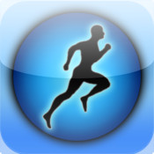 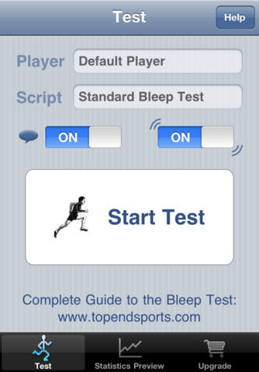

Tips:

-Go easy on the early levels.

-Turn exactly at the line, don’t go too far over.

-Turn on left foot at one end and right foot on the other to minimize repetitive injuries when training.

-Distance is 20 meters or 21.86 yards.