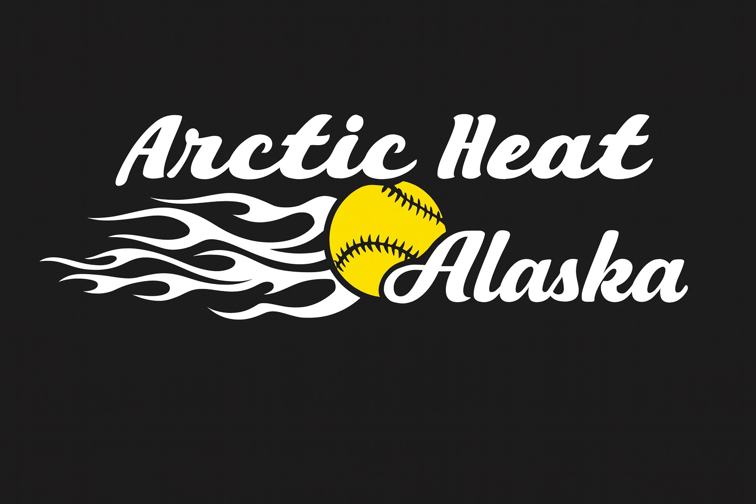
2025 SPONSORSHIP APPLICATION

NAME:_________________________________________________________________________________
ADDRESS:_____________________________________________________________________________
CITY/ZIP:______________________________________________________________________________
CONTACT PERSON:___________________________________ PHONE:_______________________
EMAIL:________________________________________________________________________________
SPONSORSHIP LEVELS AND REWARDS
____ $250 Single Your Business Logo posted on Heat Website
____ $500 Double Wall Plaque & Your Business Logo posted on Heat Website
____ $1,000 Home Run Wall Plaque, Business Logo on Team Banner, & on Heat Website
____ Please waive my Wall Plaque and put 100% of my donation towards the team’s needs
** Donations of $2,500 or more will also receive a banner on one of the fields for the season **
DONATION DESIGNATION OPTIONS (please check one or more):
____ Player: __________________________
____ Team: ____________________________
____ Organization Overall
____ Tournaments
Return completed application and your check to:
Arctic Heat Softball
c/o Vicky Seagroves
13226 Konrad Drive
Eagle River, AK 99577
Any questions email arcticheatsoftballorg@gmail.com
Tax ID #: 92-0172924
We thank you for your support!

