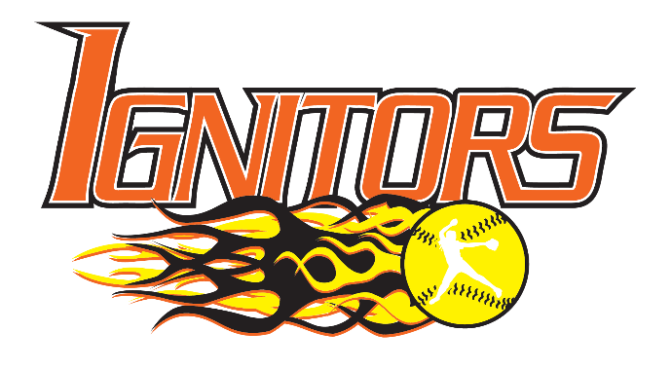

The mission of the IGNITORS Fastpitch Softball Program is to teach girls fastpitch skills while emphasizing team play and individual development, sportsmanship, cooperation, self-discipline, self-confidence, and personal responsibility. Our program is designed to provide all participants with the best possible softball experience. We strive to be good citizens through community involvement and interaction.
Your Sponsorship Covers: Your sponsorship covers annual league fees, insurance, tournaments, uniforms, practice facility rentals, and equipment.

Sponsorship Levels:

Platinum Sponsorship: $1,000

- A listing on our team banner, displayed wherever we play, under Platinum Sponsor
- Listing on a separate banner recognizing Platinum Sponsors to be displayed at any tournaments we host and at various fundraising events
- Team Plaque with team photo
- Listing on our website on the Home Page Banner, Rotating Sponsor Banner, and an ad on our Sponsor Page

Gold Sponsorship: $500

- A listing on our team banner, displayed wherever we play, under Gold Sponsor
- Team Plaque with team photo
- Listing on our website on the Home Page Banner, Rotating Sponsor Banner, and an ad on our Sponsor Page

Silver Sponsorship: $250

- A listing on our team banner, displayed wherever we play, under Silver Sponsor
- Team Plaque with team photo
- Listing on our website on the Home Page Banner and an ad on our Sponsor Page

Bronze Sponsorship: $100

- Listing on our website on the Rotating Sponsor Banner, and an ad on our Sponsor Page
- Team photo

*Team photo and plaque will become available during the 20240-2025 season.

If interested in sponsoring the Ignitors Fastpitch Softball, LLC, please complete the following form and mail your sponsorship to:

Ignitors Fastpitch Softball
c/o Robert Manke
2970 West Thorncrest Drive
Franklin, WI 53132

Should you need the Tax ID number for your charitable contribution reporting purposes, it is 46-0819173.

Please contact Robert Manke at mancow434@sbcglobal.net if you have any questions.

SPONSORSHIP FORM

Please complete this form and return it with your sponsorship check to the address listed below.
- Platinum Sponsorship: $1,000

- A listing on the team banner, displayed wherever we play, listed under Platinum Sponsor
- Listing on a separate banner recognizing Platinum Sponsors to be displayed at any tournaments we host and at various fundraising events
- Team Plaque with team photo
- Listing on our website, with a link to your business, on our Home Page, Rotating Sponsor banner, and our Sponsor page
- Gold Sponsorship: $500

- A listing on the team banner, displayed wherever we play, listed under Gold Sponsor
- Team Plaque with team photo
- Listing on our website, with a link to your business, on our Home Page, Rotating Sponsor banner, and our Sponsor page
- Silver Sponsorship: $250

- A listing on the team banner, displayed wherever we play, listed under Silver Sponsor
- Team Plaque with Team photo
- Listing on our website, with a link to your business, on our Home Page and our Sponsor page
- Bronze Sponsorship: $100

- Listing on our website, with a link to your business, on our Rotating Sponsor banner and our Sponsor page
- Team photo

- Contact me regarding a donation item

* Team photo and plaque will become available during the 2024-2025 season

Contact Name ______________________________________________________________________________

Company Name for Banner ___________________________________________________________________

URL for website link ________________________________________________________________________

Address ___________________________________________________________________________________

City____________________________________________________________ State_______ Zip__________

Contact email: ____________________________________________________

Contact phone: ___________________________________________________

Mail check to: Greenfield Ignitors Fastpitch Softball
c/o Robert Manke
2970 West Thorncrest Drive
Franklin, WI 53132
THANK YOU for supporting the Greenfield Ignitors

