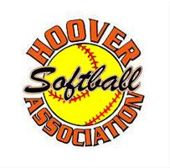Hoover Softball Association Sponsorship Banners

Friends and Businesses,

Please consider purchasing a sponsorship banner at Hoover Softball Association. Each banner will be four feet by six feet with a black background with white writing. The banner will hang on the outfield fence at Hoover Central Park and will be seen by thousands of players, parents and siblings. Hoover Softball Association hosts dozens of travel tournaments throughout the year from February through November which draws thousands of players to our area, some local and some from other states. Hoover Softball Association also has one of the largest recreational leagues in the state. Your purchase of a sponsorship banner will help buy new equipment for the girls. Please fill out the form and give to your favorite player and know your banner will be seen by thousands of people and the proceeds will go to help local players. We have six fields so you can put one on each field if you wish. Each banner costs $200.

Completed forms may be mailed to: HSA 1391 Eden Ridge Circle Hoover,AL 35244

Banner Information

Company as it should appear on banner_______________________________

Address, phone number or additional info wanted on banner

___________________________________________________________

___________________________________________________________

Please make checks payable to Hoover Softball Association. Number of signs______

Player’s name____________________________ 6u___ 8u___ 10u___12u___