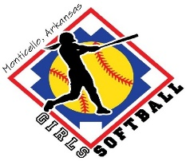
Monticello Girls Softball Association
  - 2026 Sponsorship Benefits
All banners will be displayed during spring and fall games/tournaments (April-October).

DIAMOND SPONSOR: $1000
Field + Team sponsor (Limited to three sponsors) – Sponsor name on team jerseys and pick of team colors; each sponsor name/logo will be displayed on a large banner on center field fence and a smaller banner hung on the back of a softball press box at the Monticello Sports Complex.
PLATINUM SPONSOR: $600
Dugout + Team sponsor (Limited to six sponsors) – Sponsor name on team jerseys and pick of team colors; sponsor name/logo will be displayed on their banner (4x8) hung from the back of a softball field dugout at the Monticello Sports Complex.
GOLD SPONSOR: $350
Team sponsor – Sponsor name on the team jerseys and pick of team colors; sponsor name/logo will be displayed on a banner (4x6) to be hung at the Monticello Sports Complex.
Note: Sponsorship does not guarantee that you will be able to sponsor your own child’s team. If the situation arises where multiple individuals or companies want to sponsor the same team, then names will be drawn.
SILVER SPONSOR: $200
Sponsor name/logo will be displayed on a banner (3x5) to be hung at the Monticello Sports Complex.
PLAYER SPONSOR: $75
Anonymous donations are made to benefit players who would be unable to play softball due to financial hardships. Awards to players will be determined by the MGSA board based on need.
I wish to sponsor Monticello Girls Softball Association at the _____ __ level.
_______________________________ ______ __________________
Signature Date

_________________________________________________________ _____
Name on Banner and/or Jerseys (shirt color if you wish to choose)

