Travel Coaches:  Steven Tillery 601-238-4974 mselite2023@yahoo.com  Billy McNeer 601-613-4406 billymcneer@gmail.com  Team Website: www.mselite2023gold.com  SportsRecruits:  https://sportsrecruits.com/athlete/faith_tillery | FAITH TILLERY  9  Email: fmtillery@gmail.com  3043 Louis Wilson Drive  Brandon MS. 39042  Cell Phone: 601-586-9905  Home Phone: N/A  Parents: Steven & Destiny Tillery  Parents Email: tillerys@bellsouth.net

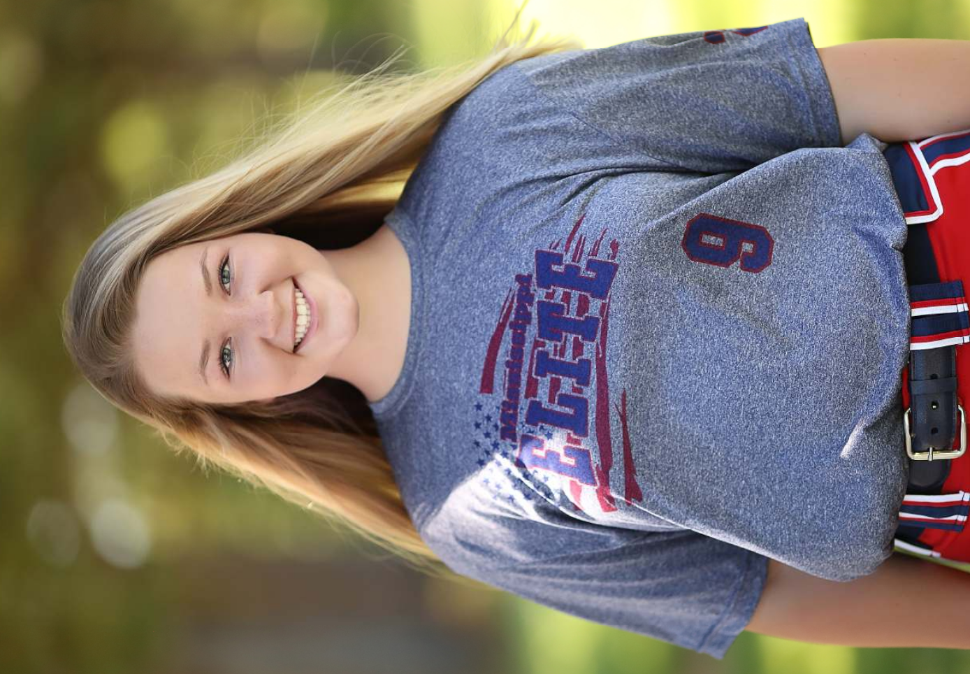   | AGE |  | BIRTH DATE |  | HEIGHT | WEIGHT
 | 15 |  | 11/17/06 |  | 5’8” | 170
 | DEFENSIVE POSITION(S)
 | Primary: 1st Secondary: 3rd/OF
 | BAT | THROWS |  | HOME  TO 1B |  |  | HOME TO HOME
 | R | R |  | 3.58 |  |  | 14.29
 | ACADEMIC INFORMATION
 | GRADUATION |  | GPA |  |  |  |  | PSAT / ACT
 | 2025 |  | 3.8 |  |  |  |  | N/A
 | PROBABLE EDUCATIONAL PURSUIT(S)
 | Undecided
 | High School: |  | Hartfield Academy - Flowood, MS
 | High School Coach: |  | Julie McKinnie
 | Athletic Director: |  | David Sykes
FAITH TILLERY RESUME
Hartfield Academy Park Place Christian Academy
Mississippi Elite 2023 Gold Mississippi Elite 2024
East Central CC Camp

AWARDS AND HONORS
Park Place Christian Academy Varsity Softball Most Improved Player
Park Place Christian Academy Varsity Softball Most Outstanding Bat Award
All A’s end of the year award
2021 MAIS Fastpitch State Champions with Hartfield Academy

