SUBMITTING SCORES
Log onto the league website, http://remaxfmmslopitch.ca
Scroll down to the bottom of the webpage and just below the “Number of Visitors:” counter, click on the “HTO Network” link.
This will bring you to the log-in screen below. Please enter your email address and password.
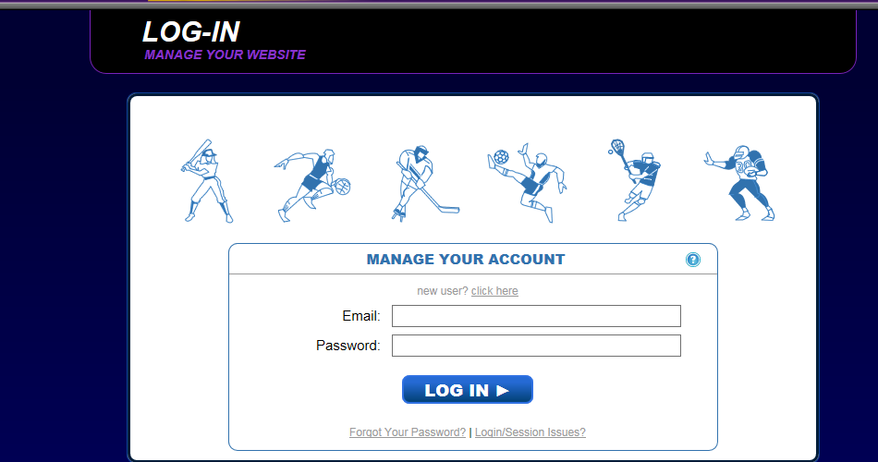
After logging in, you will be brought to your team page. Please click on the “Schedule & Results” tab.
From here you will now see your schedule. Please find the game you are submitting the score for and click on “Scores”
This will bring up the Scoreboard for your game. It is not necessary to fill in anything but the R column. Please fill in the final score for each team here and click save.
